BACTERIOLOGICAL ANALYSIS OF POTABLE WATER
AT LORMA COLLEGES - CAMPUS FOR HEALTH SCIENCES

Edward Dwight A. Angcual¹, Naiome Shane A. Carreon², Aminah J. De Guzman³, Arrianne Mae D. Frianeza⁴, and Areeya Norimay D. Mangagguey⁵
¹²³⁴⁵ Bachelor of Medical Laboratory Science, College of Health and Sciences, Lorma Colleges, San Fernando City, La Union¹ edwarddwight.angcual@lorma.edu ² naiomeshane.carreon@lorma.edu ³ aminah.deguzman@lorma.edu ⁴ arriannemae.frianeza@lorma.edu ⁵ areeyanorimay.mangagguey@lorma.edu

Abstract
This study assessed the microbiological quality of potable water from dispensers located at LORMA Colleges – Campus for Health Sciences (CHS) in Carlatan, San Fernando City, La Union. The objective was to evaluate bacteriological indicators such as total coliforms, heterotrophic plate counts (HPC), and fecal/thermotolerant coliforms to determine the extent of microbial contamination. A quantitative-experimental and descriptive approach was employed, focusing on dispensers in high-traffic areas (e.g., hallways), low-traffic areas (e.g., faculty and administrative offices), and standing water bottles (not yet dispensed). Water samples were collected and tested using standard microbiological methods, and results were statistically analyzed using a two-sample t-test to assess differences across locations and water sources. The findings revealed that all samples from high-traffic areas and standing water bottles tested negative for total coliforms, HPC, and thermotolerant coliforms. In contrast, 7 out of 10 samples from low-traffic areas tested positive for total coliforms, and 4 of these also contained thermotolerant coliforms. HPC values in low-traffic areas ranged from 0 to over 5,700 CFU/mL, with four samples exceeding acceptable limits. These results indicate potential contamination in seldom-monitored dispensers and emphasize the importance of regular maintenance and monitoring, particularly in low-traffic areas, to ensure the continued safety and quality of drinking water within academic institutions.

Keywords: potable water; bacterial contamination; HPC; total coliform; fecal coliform; water dispensers

1. Introduction
Water quality is a major public health concern, affecting the health outcomes of people worldwide. Poor drinking water threatens human health, primarily through waterborne diseases caused by harmful microorganisms like bacteria, viruses, and parasites (WHO, 2021). When consumed, these pathogens can lead to severe illnesses like cholera, dysentery, and gastrointestinal infections (CDC, 2020).
In many parts of the world, insects live or breed in water, carrying and transmitting diseases such as dengue fever. Some of these insects, known also as vectors, breed in clean rather than dirty water, and household drinking water containers can serve as breeding grounds. The impact of contaminated drinking water is particularly alarming as it can transmit diseases and expose individuals to preventable health risks. One million people are estimated to die each year from diarrhea as a result of unsafe drinking water, sanitation, and hand hygiene. In 2022, at least 1.7 billion people around the world used a drinking water source contaminated with feces. Microbial contamination of drinking water due to contamination of feces poses the most significant risk to water safety (WHO, 2023).
Escherichia coli and coliform bacteria are widely used to indicate fecal contamination in drinking water. According to Edberg et al. (2020), detecting these organisms is central to understanding water safety and assessing public health risks. Regular microbial monitoring in drinking water systems, especially in communal settings, can prevent outbreaks of diseases like diarrhea and typhoid. In the context of educational institutions, the microbial quality of drinking water is of particular concern. As institutions are high-density areas, contaminated water sources pose a heightened risk for disease transmission (Jung et al., 2021).
According to Dabrowska et al. (2024), diarrheal diseases linked to fecal contamination of water account for approximately one million preventable deaths annually, with a great burden in low-income countries. While progress has been made—over 687 million people have gained access to safely managed drinking water since 2015—this pace must increase more than sixfold to meet the United Nation's target of universal access to safe water by 2030. Microbiological water monitoring is crucial in improving humanitarian water, sanitation, and hygiene (WASH) interventions. Specifically, microbial water testing focuses on the enumeration of E. coli as an effective indicator of fecal contamination. The WHO guidelines stipulate that Escherichia coli must not be detected in any 100 ml drinking water sample.
In the Philippines, water quality is a significant public health issue, particularly in institutional and rural settings where access to clean and safe drinking water remains challenging. The impact of waterborne diseases is particularly severe, as many Filipinos are vulnerable to illnesses caused by contaminated sources. According to the Department of Health (DOH), waterborne diseases such as diarrhea, cholera, and typhoid fever are prevalent where sanitation and hygiene practices are inadequate (DOH, 2022).
A study by Mendoza and Rosales (2022) revealed that rural schools often struggle with microbial contamination in drinking water due to limited infrastructure and irregular maintenance of water sources. Similarly, a nationwide assessment conducted by Ramos et al. (2021) emphasized the role of improved sanitation systems in reducing the burden of waterborne diseases in public institutions, suggesting that targeted interventions are critical for ensuring water safety.
Research in academic environments often overlooks water dispensers as potential sources of contamination. Studies that do evaluate these dispensers typically focus on physical and chemical parameters, neglecting the vital microbiological assessments needed to identify harmful pathogens such as coliform bacteria and E. coli. For instance, a study by Luvhimbi et al. (2022) found that while E. coli and total coliform were not detected in some water samples, and many samples from street taps and household settings were contaminated with high levels of these bacteria, especially during the wet season.
Water dispensers are widely used in educational institutions across developing nations, making it crucial to evaluate factors affecting drinking water quality from these sources. Research conducted by Boonhok et al. (2021) highlighted that water dispensers in educational settings could be sources of microbial contamination. This study from Walailak University in Thailand found that 16.67% of water dispenser samples contained total coliform bacteria, while E. Coli was absent. Such findings illustrate the need for strict hygiene and maintenance requirements to prevent waterborne infections.
High-traffic areas within schools are locations where many individuals congregate or pass through regularly, such as hallways, cafeterias, and entryways. In contrast, low-traffic areas are characterized by limited usage, including faculty rooms and administrative offices (Cambridge University Press, 2024). This categorization is crucial for understanding how usage patterns influence bacterial contamination, as high-traffic areas may experience increased risks due to greater interaction and potential for cross-contamination.
In Nigeria, Ighalo et al. (2020) provided an in-depth evaluation of bacteriological contamination in water sources across rural communities. It identified significant levels of bacterial contamination, primarily attributed to the proximity of water sources to waste disposal sites. This linkage highlights the critical role that environmental management and infrastructure play in maintaining water quality. The research further emphasized the necessity for implementing sustainable and practical solutions to mitigate these challenges. Recommendations included point-of-use water treatment technologies, such as household filtration systems and chlorination, and improved source protection measures, like relocating water sources away from potential contamination sites and constructing proper waste management facilities. The study underscored the vulnerability of rural communities to waterborne diseases due to limited access to safe and treated water, compounded by inadequate sanitation infrastructure. By advocating for community-level education on safe water practices and investing in protective measures for water sources, the research provides a roadmap for addressing similar challenges in rural and underserved regions globally. These findings align with global initiatives aimed at improving access to safe drinking water and achieving sustainable development goals related to clean water and sanitation.
A study by Catacutan and Gascon (2020) in Quezon City assessed the microbial quality of water from public water dispensers, revealing alarming levels of bacterial contamination, particularly with coliform bacteria. Despite existing water treatment systems, the cleanliness of dispensers was often compromised due to irregular maintenance and poor hygiene practices. Their findings underscore the necessity for regular bacteriological testing of water dispensers in public settings.
Moreover, the study of Balaquit et al. (2024), titled "Bacteriological Assessment of Drinking Water Sources in Barobo, Surigao del Sur," focuses on evaluating the microbial quality of drinking water from various sources such as deep wells, water refilling stations, and community water supply systems. Utilizing bacteriological analysis techniques, the research identified the presence of coliform bacteria, including fecal coliforms, in some water samples, especially during rainy days. This highlighted the vulnerability of water sources to contamination due to environmental factors such as runoff and inadequate water treatment processes. The research emphasizes the need for seasonal monitoring, stricter sanitation practices, and the implementation of localized water treatment solutions to reduce health risks associated with contaminated drinking water. These findings contribute to a broader understanding of how water quality fluctuates in rural communities in the Philippines and underscore the importance of compliance with the Philippine National Standards for Drinking Water (PNSDW).
Furthermore, a detailed investigation by Dela Cruz et al. (2019) of water quality in public schools across Cavite uncovered significant microbial contamination in water dispensers used by students and staff. Their study found that 22% of water samples tested positive for E. coli and other coliform bacteria, key indicators of fecal contamination and potential pathogenic organisms. E. coli raises serious public health concerns, especially in school settings where large populations are in close contact. The researchers attributed this contamination primarily to poor maintenance practices and irregular cleaning of dispensers, with many units being inadequately or infrequently cleaned, allowing for bacterial growth and biofilm formation.
Despite the extensive research on water quality, there remains a significant gap in assessing water dispensers in academic settings, particularly in health and sciences colleges, where safety standards should be particularly stringent due to the heightened risk of microbial contaminants. This gap is troubling, as the academic community—students, faculty, and staff—are particularly vulnerable to waterborne illnesses from frequently used dispensers, often without sufficient knowledge of potential hazards. Dispensers, while convenient, can become vectors for bacterial growth if not properly maintained or tested, leading to health risks like gastrointestinal infections. Yet, few studies have comprehensively evaluated physical and microbial water quality in dispenser systems within academic institutions.
This study aimed to fill that gap by conducting an in-depth investigation of the water quality in dispensers at the LORMA Colleges — CHS, using both microbial and physical assessment techniques. The findings addressed the current lack of data and provided essential insights for enhancing water safety measures, directly benefiting the health and well-being of the college community.

2. Objectives
The objectives of this study are to assess the bacteriologic quality of drinking water from dispensers within the institution and to determine the presence of total and fecal coliform contamination in the collected samples. It also aims to identify possible sources of microbial contamination, particularly related to the handling, refilling, and maintenance of water dispensers. Additionally, the study seeks to recommend effective strategies for eliminating contamination, raise awareness among students and staff about safe water practices, and establish a sustainable system for regular water quality monitoring, accountability, and reporting.

3. Materials and methods
Observational method tools were used before and during the laboratory tests to observe and record the physical environment of the dispensers and the procedures conducted for water analysis. This method involved the use of mobile phones for tracking time, taking photos, and recording the procedures. Note-taking was also employed to document detailed observations and ensure that each step was followed and recorded accurately. In addition, checklists were used to support systematic observation and proper documentation of both the physical environment and laboratory processes.
The researchers collected water samples from potable water dispensers located in both high-traffic and low-traffic areas across the campus, as well as from standing water sources. For each sampling site, 300 mL of water was collected using 500 mL sterile glass containers with screw caps, which had been autoclaved at 121°C for 15 minutes to ensure sterilization and prevent contamination. This ensured consistent volume and reliability during analysis. Water collection from potable water dispensers was done when the gallon of water was half-full.
To standardize the process, the halfway point of each dispenser was determined through prior visual inspection and marking. In high-traffic areas, researchers observed that water levels typically reached the halfway mark between 9:00 and 10:00 a.m. Based on this observation, sample collection in these areas was conducted within that specific time frame. Staff members responsible for replacing water gallons confirmed that dispensers in high-traffic areas had their gallons changed earlier that same day, ensuring consistency in water freshness. Conversely, in low-traffic areas, water gallons were only replaced when they were completely empty or upon request by the staff residing in those offices. Faculty members and office staff were asked to monitor water usage and report how long the gallon had been in use prior to sample collection. This approach helped ensure accuracy in determining water age and maintained consistency across different sampling locations.
Water samples were only collected from dispensers where the water had been in use for a maximum of seven days, as determined by monitoring logs or participant reports. Standing water was also collected with care to ensure consistency of water quality across different sources. Each container was labeled and assigned a unique alphanumeric code corresponding to its designated dispenser.
A cooler with ice packs maintained sample temperatures below 10°C during transport, ensuring bacterial integrity was preserved until laboratory analysis, which was performed within one hour of collection. Before sampling, all operational dispensers were identified and cataloged. Researchers sanitized their hands and wore disposable gloves and masks to minimize contamination risks. Gloves were replaced immediately if torn or soiled. The dispenser nozzle was cleaned using a 70% ethanol solution, and flaming was also performed, followed by allowing water to run for 30 seconds to flush out stagnant water.
Samples were then carefully collected, ensuring that neither the neck of the bottle nor the inside of its cap was touched to avoid contamination. Immediately after filling, each container was sealed and labeled using micropore tape and pencil to ensure legibility and durability even under cold storage conditions. Additionally, the mouths of the dispensers and the glass containers were briefly exposed to a flame both before and after sample collection to avoid contamination. By following this meticulous process, the goal was to obtain accurate and uncontaminated samples for assessing potable water quality.
Upon arrival at the laboratory, a laboratory code was assigned to maintain anonymity. If analysis could not be initiated immediately, samples were stored at 4°C for no more than two hours.Three primary tests were conducted: the Heterotrophic Plate Count (HPC), the Total Coliform Test, and the Fecal/Thermotolerant Coliform Test. Together, they provided a comprehensive evaluation of bacterial contamination levels and the presence of particulate matter, thereby verifying the microbiological and physical safety of the potable water.
Total Coliform Test. The total coliform test was conducted using the multiple tube fermentation (MTF) technique to detect the presence of total coliform bacteria in water samples—an indicator of possible microbial contamination.
A total of 35.60 grams of Lauryl Tryptose Broth (LTB) was suspended in 1000 mL of distilled water. The mixture was stirred thoroughly and gently heated as needed to ensure complete dissolution of the medium. Afterward, 10 mL of the broth was dispensed into 90 fermentation tubes, each containing an inverted Durham tube for detecting of gas produced. These tubes were sealed with cotton plugs or caps, arranged in wire baskets, and covered with brown manila paper. The tubes were sterilized by autoclaving at 15 lbs pressure (121 °C) for 15 minutes, then cooled for 4–5 hours. The pH of the finished media was checked and verified to be within the acceptable range before storing the tubes at refrigeration temperature until use.
Water samples were thoroughly mixed before inoculating five fermentation tubes per sample to ensure even bacterial distribution and enhance statistical accuracy. The inoculated tubes were incubated at 35 °C to 37 °C for 24 hours. After incubation, the tubes were examined for turbidity and gas formation in the Durham tubes, which indicated a presumptive positive result for coliforms. All tubes showing presumptive positivity were submitted for the confirmation phase using Brilliant Green Lactose Bile (BGLB) broth. For each presumptive positive tube, five BGLB tubes were prepared. Using a sterile loop, one or more loopfuls of the culture were transferred into the BGLB tubes and incubated at 35 °C for 48 hours.
For media preparation of BGLB, 40.01 grams of the Brilliant Green Bile Broth medium was suspended in 1000 mL of purified distilled water, stirred until dissolved, and gently heated if necessary. Ten (10) mL of the prepared medium was distributed into 90 fermentation tubes, each containing an inverted Durham tube. The tubes were sealed with either cotton plugs or caps, labeled with autoclave tape or sterility paper, and sterilized at 15 lbs pressure (121 °C) for 15 minutes. After sterilization, tubes were cooled to room temperature and stored in a cool, dry place until use. The BGLB tubes were examined for gas production at any time within the 48-hour incubation, which confirmed the presence of coliform bacteria.
A positive result in the BGLB confirmation test validated the presence of total coliform bacteria, indicating possible contamination and necessitating further testing for fecal coliforms or Escherichia coli. A negative result signified the absence of detectable coliforms in the sample. The most probable number (MPN) of coliforms was determined by analyzing the number of positive BGLB tubes, using standard MPN tables to calculate a quantitative estimate of microbial contamination in the water sample.
Heterotrophic Plate Count (HPC). The Heterotrophic Plate Count (HPC) test was performed to determine the overall bacterial population present in water samples. For media preparation, 23.5 grams of Plate Count Agar was dissolved in 1000 mL of distilled water, stirred well, and heated gently if necessary. The medium was sterilized by autoclaving at 15 lbs pressure (121 °C) for 15 minutes, then cooled to 45–50 °C. It was mixed thoroughly and poured into sterile Petri dishes, which were stored in a cool, dry place until use. Water samples were collected aseptically, and analysis was initiated within 8 hours to minimize changes in bacterial content. Prior to inoculation, each plate was labeled with the sample number, dilution, date, and other necessary information. Two replicate plates were prepared per dilution or sample volume, ensuring consistent results.
Serial dilutions were performed by transferring 1 mL of the water sample into a sterile diluent, creating 10-fold dilutions (e.g., 10⁻², 10⁻³) for accurate bacterial enumeration. Samples were thoroughly mixed using 25 rapid back-and-forth movements, and no more than 2.0 mL of sample was pipetted into each plate. Pipetting was done at an angle of approximately 25 degrees, with the plate lid slightly lifted to avoid contamination. After adding the sample, the melted culture medium was poured and mixed carefully with the sample. It was ensured that no more than 20 minutes passed between pipetting and pouring. Plates were then incubated at 35 °C–37°C for 48 hours, following the US EPA Surface Water Treatment Rule for compliance monitoring.
After incubation, bacterial colonies were counted using a Dark-Field Colony Counter, and results were reported as Colony Forming Units (CFU)/mL. Ideally, only plates with 30–300 colonies were used for accurate results. If all plates had fewer than 30 colonies or more than 300, estimates were made using counting guides based on the size and type of plate. For example, if colonies were fewer than 10 per cm², counts were made from 13 or 19 squares, and calculations were adjusted for the area of the plate. If colony density exceeded 100 colonies/cm², results were reported as “>6,500 est. CFU/mL” for glass plates or “>5,700 est. CFU/mL” for plastic plates. All sterility controls were recorded, and any deviations were documented. Lower HPC values indicated better water quality, while elevated counts suggested possible contamination, requiring further investigation.
Fecal/Thermotolerant Coliform Test. The Fecal/Thermotolerant Coliform Test is designed to detect fecal contamination by identifying coliform bacteria that can thrive at elevated temperatures. Presumptive positive cultures from the Total Coliform Test were submitted for the confirmation phase, where they were inoculated into Escherichia coli Medium (EC broth) tubes. For media preparation of Escherichia coli broth, 37.0 grams of Escherichia coli powder was suspended in 1000 mL of distilled water, stirred until dissolved, and gently heated if necessary. Five Escherichia coli tubes were prepared for each presumptive positive, and using a sterile loop, one loopful of the sample was transferred into each Escherichia coli broth tube. The tubes were then incubated in a water bath at 44.5 °C ± 0.2 °C for 24 hours.
After the 24-hour incubation period, which occurred on Day 4, the Escherichia coli medium tubes were examined for gas production in the inverted vial. The presence of gas in any amount within 24 hours confirmed the presence of fecal coliform bacteria, primarily Escherichia coli, indicating potential fecal contamination of the water sample. This result requires immediate corrective actions to ensure water safety and mitigate health risks. A negative result is characterized by the absence of gas production in the Escherichia coli broth tube after 24 hours of incubation, suggesting the absence of fecal coliforms and confirming that the water sample is free from fecal contamination and safe for consumption.
The Most Probable Number (MPN) of fecal coliforms was calculated based on the positive results observed in the Escherichia coli medium tubes, providing a quantitative estimate of contamination levels. This calculation allowed for the assessment of the potential health risks associated with the water sample, guiding the appropriate response measures to protect public health.

4. Results
This chapter presents the data gathered, along with the analysis and interpretation of the experimental results. The sample utilized in the study is potable water from LORMA Colleges— CHS. The results to be shown below have been interpreted with the basis coming from the reference material of the 22nd edition of the Standard Methods for the Examination of Water and Wastewater (SMEWW).
The microbiological tests done to analyze the water quality of the potable water of LORMA Colleges— CHS, includes the following: The Pour or Spread Plate Method (Heterotrophic Plate Count (HPC) Test), which is used to measure the overall number of heterotrophic bacteria in water; Multiple Tube Fermentation Technique (Total Coliform Test) used to detect total coliforms; and another Multiple Tube Fermentation Technique (Fecal/Thermotolerant Coliform Test) which is used to confirm the presence of the fecal/thermotolerant coliforms. The interpretation of the results would be from zero to five, zero as the negative, one as the slight positive, two as the moderately positive, three as the positive, four as very positive, and five as extremely positive. This interpretation is based on the Likert scale, as this will interpret the results from the MPN index per 100 mL.
Heterotrophic Plate Count (Pour Plate Method) Results. To evaluate the level of perceived accuracy in observing bacterial colonies on the culture plate, a standardized scale from the 22nd edition of the Standard Methods for the Examination of Water and Wastewater (SMEWW) was employed. This scale served as a reliable reference to ensure consistency and objectivity in the observations made during the study.
The microbiological testing conducted in high-traffic areas of LORMA Colleges – CHS utilized Pour Plate method, which is the standard technique for assessing bacterial presence in environmental samples. Upon careful incubation and observation, the results revealed no visible bacterial colonies, indicating a negative outcome for microbial contamination in the areas tested. Additionally, the total coliform test, which serves as a key indicator of potential fecal contamination and overall sanitary quality, also returned a negative result. This further supports the conclusion that the sampled high-traffic areas were free from coliform bacteria and maintained acceptable levels of microbiological safety at the time of testing.

Table 1 Water Quality Status of Heterotrophic Count Test in High-Traffic Areas in LORMA Colleges - Campus of Health Sciences
AREAS | RESULTS | INTERPRETATION
HT 001 | <1.0 | Negative
HT 002 | <1.0 | Negative
HT 003 | <1.0 | Negative
HT 004 | <1.0 | Negative
HT 005 | <1.0 | Negative
HT 006 | <1.0 | Negative
Unit is CFU/mL and Control is <1.0
Table 2 Results of the Standing Water in Heterotrophic Count Test in High-Traffic Areas in LORMA Colleges - Campus of Health Sciences
AREAS | RESULTS | INTERPRETATION
HT 007 | <1.0 | Negative
Unit is CFU/mL and Control is <1.0
The results of the HPC test for the standing water in the high-traffic areas returned a negative outcome, as no visible bacterial colonies were detected after the incubation period. This absence of bacterial growth indicated that the water did not harbor any significant population of viable bacteria at the time of testing. A negative result in this context means that the microbial load in the standing water was within an acceptable range, and no harmful levels of bacteria were present.
The absence of bacterial contamination in the standing water in high-traffic areas highlights the effectiveness of sanitation measures in place during the testing period. However, these results should not be seen as a guarantee of constant water quality, as environmental conditions, such as changes in weather or sanitation practices, could impact the microbiological safety of the water in the future. Regular monitoring is crucial to ensure continued compliance with safety standards.
The findings from LORMA Colleges' high-traffic areas strongly align with the recommendations provided in the Water, Sanitation, and Hygiene (2023) review, which emphasizes the critical importance of regular microbial monitoring in schools to protect the health of students. The WASH (2023) review noted that routine microbial testing is essential for identifying potential waterborne pathogens, including bacteria that can compromise the safety and hygiene of school environments. This aligns with the global health goals outlined in Sustainable Development Goal 6 (Clean Water and Sanitation), which highlights the necessity of clean, safe drinking water and sanitary facilities in educational settings.
Table 3 Water Quality Status of Heterotrophic Count Test in Low-Traffic Areas in LORMA Colleges - Campus of Health Sciences
AREAS | COLONIES | RESULTS | INTERPRETATION
LT 001 | 9 | 9 | Slightly above the range
LT 002 | 371 | >5,700 | Above the range
LT 003 | 0 | <1.0 | Negative
LT 004 | 90 | 90 | Slightly above the range
LT 005 | 430 | >5,700 | Above the range
LT 006 | 0 | <1.0 | Negative
LT 007 | 203 | 203 | Slightly above the range
LT 008 | 0 | <1.0 | Negative
LT 009 | 461 | >5,700 | Above the range
LT 010 | 440 | >5,700 | Above the range
Unit is CFU/mL and Control is <1.0
The Heterotrophic Plate Count (HPC) results obtained from potable water dispensers in low-traffic areas of LORMA Colleges – CHS revealed varying levels of microbial presence. Using the standard control limit for potable water of <1.0 CFU/mL, the results were analyzed to determine the safety and microbial quality of drinking water provided to students and staff.
Out of the ten dispensers tested, three samples—LT 003, LT 006, and LT 008—returned results of 0 colony-forming units per milliliter (CFU/mL), indicating no detectable heterotrophic bacterial growth. These results suggest that the water from these dispensers meets acceptable microbiological standards for potable water and is safe for human consumption.
However, three other samples—LT 001 (9 CFU/mL), LT 004 (90 CFU/mL), and LT 007 (230 CFU/mL)—showed microbial counts slightly above the acceptable limit. While these levels may not pose immediate health threats, they suggest a potential lapse in water dispenser hygiene or biofilm buildup within the internal components. Regular maintenance and disinfection may be needed to ensure consistent water safety.
More concerning were the samples from LT 002, LT 005, LT 009, and LT 010, which recorded extremely high heterotrophic counts exceeding 5,700 CFU/mL. These values are significantly above the allowable range and indicate a strong presence of microbial contamination. Such results may be attributed to improper cleaning protocols, stagnant water within the dispensers, or internal contamination that could compromise the safety of the potable water. The high bacterial load in these samples raises a public health concern and underscores the urgent need for immediate cleaning, regular monitoring, and potentially replacing contaminated dispenser components.
The results of the Heterotrophic Plate Count (HPC) test using the pour plate method revealed varying microbial qualities among the different sources of potable water tested at LORMA Colleges – CHS. Water samples from dispensers located in high-traffic areas yielded negative results for bacterial growth. This indicates that the water from these dispensers met microbiological safety standards, with a 0% prevalence of contaminants. The absence of bacterial growth in these areas may be attributed to frequent usage, which prevents water stagnation and biofilm formation, as well as possibly better maintenance due to higher visibility and regular cleaning.
Water samples collected from standing water bottles—typically referring to unopened or unused gallons—also yielded negative results for bacterial growth, indicating 0% prevalence of microbial contamination. These findings suggest that, when properly stored and sealed, bottled water retains its microbiological safety even when not immediately consumed. When comparing the three sources, it was evident that significant bacterial presence was only observed in the potable water from low-traffic area dispensers. Both high-traffic area dispensers and standing water bottles showed no signs of bacterial contamination. This emphasizes the importance of regular dispenser usage and maintenance in preventing microbial proliferation in water systems.
Furthermore, there is a significant difference in the presence of bacteria between dispensed water from low-traffic dispensers and standing water bottles. While the source water may have been initially clean, the contamination in low-traffic dispensers points to the dispensing mechanism as a potential source of microbial growth. Internal parts of dispensers, such as spouts or reservoirs, may accumulate bacterial colonies over time, especially when not flushed regularly.
Girolamini et al. (2021) provides significant support for our findings, particularly in relation to the impact of the usage on the microbial quality of water dispensers. Their research examined microfiltered drinking water dispensers and found that some dispensers, despite having filtration systems in place, still exhibited heterotrophic plate counts (HPC) that exceeded the acceptable limits. This was primarily attributed to the usage of the dispensers, which allowed stagnant water to accumulate within the system. As a result, bacteria could thrive and multiply, even in systems designed to prevent contamination. In a similar vein, our study at LORMA Colleges observed that water dispensers located in low-traffic areas—where usage is infrequent—showed elevated HPC levels. For instance, samples from LT 001 (9 CFU/mL) and LT 004 (90 CFU/mL) were slightly above the acceptable threshold of <1.0 CFU/mL, signaling a potential lapse in water quality. These findings suggest that the dispensers in low-traffic areas at LORMA Colleges may also be susceptible to microbial contamination due to stagnant water. Over time, when water sits in the dispensers without regular use or flushing, it can lead to the formation of biofilm microbial communities that adhere to surfaces and serve as reservoirs for bacteria. This biofilm formation, combined with insufficient cleaning and maintenance, further exacerbates the bacterial buildup, as seen in our study's elevated HPC values. Thus, both studies highlight the importance of regular use and maintenance to prevent microbial contamination and ensure the safety of drinking water, particularly in areas where dispensers are less frequently accessed.
Total Coliform Test using Multiple Tube Fermentation Method Results. The first microbiological test used to test the water coming from the water dispensers located in the High traffic and Low traffic areas is the Total Coliform test, utilizing the Multiple Tube Fermentation Technique. There are two phases done in order to identify the presence of total coliform bacteria, namely, the Presumptive Phase and the Confirmatory Phase. These phases have similar procedures yet use different broth media to isolate the bacteria. In the Presumptive phase of the experiment, it utilized the Lauryl Tryptose Broth (LTB) test to identify the possible coliform contamination across various water dispensers.
After 24 hours, it is observed that some have already become turbid and produced gas on the durham tube. Some of the test tubes coming from LT-001, LT-002, and LT-005 have turned turbid and produced gas, indicating a positive result in the presumptive phase.
It is also noted that after 24 hours, the negative control remained clear and have no presence of gas. After the 48 hours incubation, it is observed that several samples from different locations aside from the ones that turned positive in the last 24 hours, have tested positive for the presumptive phase, with varying numbers of positive tubes out of the total tested per sample. And still, the negative control did not turn turbid nor produce gas, thus indicating a negative result.

Presumptive Test for Total Coliform Test
Table 4 Results of Presumptive test for Total Coliform Test in High-Traffic Areas in LORMA Colleges - Campus of Health Sciences
AREAS | RESULTS  MPN Index/  100 mL | INTERPRETATION
HT 001 | <1.0 | Negative
HT 002 | <1.0 | Negative
HT 003 | <1.0 | Negative
HT 004 | <1.0 | Negative
HT 005 | <1.0 | Negative
HT 006 | <1.0 | Negative
Unit is MPN/mL and Control is <1.0
The result of the presumptive phase in all of the samples from the High Traffic Areas after the 48 hours incubation at 37 degrees celsius resulted in no turbidity and no gas formation inside the durham tube, which then interpreted as negative.
Table 5 Results of Presumptive test for Total Coliform Test in Low-Traffic Areas in LORMA Colleges - Campus of Health Sciences
AREAS | RESULTS  MPN Index/  100 mL | INTERPRETATION
LT- 001 | >8.0 | Extremely Positive
LT- 002 | >8.0 | Extremely Positive
LT- 003 | <1.1 | Negative
LT- 004 | 1.1 | Slightly Positive
LT- 005 | 1.1 | Slightly Positive
LT- 006 | <1.1 | Negative
LT- 007 | 1.1 | Slightly Positive
LT- 008 | <1.1 | Negative
LT- 009 | 8.0 | Very Positive
LT- 010 | 8.0 | Very Positive
Negative Control | <1.1 | Negative
Unit is MPN/mL and Control is <1.0

However, the results of the Presumptive phase of total coliform test on the samples from Low Traffic Areas have resulted in having both positive and negative results. After the 48 hours incubation time, it is observed that there are many to few of the test tubes from some samples have turned turbid and produced gas, indicating a positive result for the presumptive phase of total coliform test.
Out of all the 10 samples obtained from different low traffic areas, Seven have shown reactions, while the remaining three samples resulted in negative. Six test tubes out of 10 test tubes containing Lauryl Tryptose Broth, have resulted positive from the water sample obtained on LT 001, while all 10 test tubes have turned positive for LT 002, which according to the MPN Index/1-00mL, they both resulted for >8.0, interpreted as extremely positive.
The samples from both LT- 009 and LT-010 both have the same results of having four test tubes out of 10 turned positive, resulting in having 8.0 in their MPN Index/1-00mL, interpreted as Very positive. As for LT-004, LT-005, and LT-007, they also have the same results of having one test tube out of 10 turned positive, resulting in having 1.1 in their MPN Index/1-00mL, interpreted as slightly positive.

Table 6 Results of Presumptive test for Total Coliform Test in Standing Water in LORMA Colleges - Campus of Health Sciences
AREAS | RESULTS  MPN Index/  100 mL | INTERPRETATION
HT 007 | <1.0 | Negative
Unit is MPN/mL and Control is <1.0
The result of the Presumptive test for total coliform test in Standing water or the water bottle that has not been dispensed did not show any turbidity in the sample nor produced gas formation in the durham tube, which are the two indicators of a positive result, hence, the sample from the standing water resulted negative.
The results between Low traffic areas and High Traffic areas are in contrast with one another, whereas the result of the samples from High Traffic Areas all turned negative, while the result of the samples from Low traffic areas have shown reactions, specifically the turbidity of the broth, and the gas formation inside the durham tube, which leads for most of the samples to be interpreted as positive for the presumptive phase. On the other hand, the standing water did not show any turbidity and gas formation during the presumptive phase, which is then resulted as negative in the presumptive test. As for the quality control, the test tube that served as the negative control resulted as negative.
Confirmatory Test for Total Coliform Test. After being subjected to the presumptive test of the total coliform test, the samples have undergone the confirmatory test for Total Coliform Test. The samples that have turned positive were inoculated to 10 test tubes each containing 5mL of Brilliant Green Bile Broth and a durham tube. On the other hand, instead of being inoculated, the samples that tested negative were subjected to an additional 24-hour incubation period.

Table 7 Results of Confirmatory test for Total Coliform Test in High-Traffic Areas in LORMA Colleges - Campus of Health Sciences
AREAS | RESULTS  MPN Index/  100 mL | CONTROL | UNIT | INTERPRETATION
HT 001 | <1.0 | <1.0 | MPN/mL | Negative
HT 002 | <1.0 | <1.0 | MPN/mL | Negative
HT 003 | <1.0 | <1.0 | MPN/mL | Negative
HT 004 | <1.0 | <1.0 | MPN/mL | Negative
HT 005 | <1.0 | <1.0 | MPN/mL | Negative
HT 006 | <1.0 | <1.0 | MPN/mL | Negative
Unit is MPN/mL and Control is <1.0
The confirmatory test for the results that turned negative on the presumptive test for total coliform has been subjected to an additional 24-hour incubation period that includes all the samples of the High traffic areas. After incubating again for another 24 hours to further confirm the result, the samples still did not show any turbidity and did not produce gas formation in the durham tubes, this then confirmed that the samples from the high traffic areas did not contain any total coliform bacteria, hence, it will no longer undergo the confirmatory phase, and are reported as negative.

Table 8 Results of Confirmatory test for Total Coliform Test in Standing Water in LORMA Colleges - Campus of Health Sciences
AREAS | RESULTS  MPN Index/  100 mL | CONTROL | UNIT | INTERPRETATION
HT 007 | <1.0 | <1.0 | MPN/mL | Negative
Unit is MPN/mL and Control is <1.0
Being reported as a negative result in the presumptive test, the Standing water sample is then subjected to an additional 24-hour incubation period. After the 24-hour incubation period, the sample still did not show any turbidity or produced gas on the Durham tube, which confirmed that the standing water resulted negative for the Total Coliform Test.

Table 9 Results of the Confirmatory test for the Low Traffic Area Dispensers Potable Water for Total Coliform Test
AREAS | RESULTS  MPN Index/  100 mL | CONTROL | UNIT | INTERPRETATION
LT- 001 | >8.0 | <1.0 | MPN/mL | Extremely Positive
LT- 002 | >8.0 | <1.0 | MPN/mL | Extremely Positive
LT- 004 | >8.0 | <1.0 | MPN/mL | Extremely Positive
LT- 005 | >8.0 | <1.0 | MPN/mL | Extremely Positive
LT- 007 | 1.1 | <1.0 | MPN/mL | Slightly Positive
LT- 009 | <1.1 | <1.0 | MPN/mL | Negative
LT- 010 | >8.0 | <1.0 | MPN/mL | Extremely Positive
Negative Control | <1.1 | <1.0 | MPN/mL | Negative
Unit is MPN/mL and Control is <1.0

After the 48 hours incubation time, it has been observed that almost all the samples have turned turbid and produced gas formation, which is a clear indication of a positive result.
On the sample LT-001, five out of ten test tubes have been observed to have the presence of gas formation, as well as the turbidity on the broth, indicating a positive result for the confirmatory test. The result in the MPN index/100mL is greater than 8.0, which is interpreted as extremely positive.
On the sample LT-002, it is observed that out of ten test tubes, five test tubes have also shown turbidity and gas formation, which is then interpreted as extremely positive due to its MPN index/100mL which is greater than 8.0. On the sample’s LT-004, LT-005, and LT-010, both have the same results with LT-001 and LT-002, having five out of ten samples to turn the broth into turbid and have the presence of gas, indicating positive results for the confirmatory test, having an MPN index/100mL of greater than 8.0, and interpreted it as extremely positive.
On the sample LT-004, though two samples does not show gas formation, yet, it is still indicated as positive result for the confirmatory test due to its turbidity, thus it has an MPN index/100mL of greater than 8.0, interpreting as extremely positive. On the sample LT-007, only one sample out of 10 have shown turbid broth but with no gas formation, indicating only one positive result for the confirmatory test, having an MPN index/100mL result of 1.1, interpreted as slightly positive. On the other hand, only LT-009 and the negative control have not shown any turbidity nor gas formation, indicating a negative result for its confirmatory test.
After getting the results from the confirmatory phase of the total coliform test, it is concerning how numerous have come out as positive, indicating a possible contamination of those places, specifically the dispensers coming from the low traffic areas. Out of all the samples being tested, it is even more concerning how prominent are the reactions shown on the sample’s LT-002 and LT-005.
Having negative results on the high traffic areas indicates that there is no possible contamination on the water coming from the dispensers, marking it as safe for the daily consumption of the students as well as the personnel passing by the dispensers. This result is likely due to the day to day consumption of the students and personnel who are passing through that hallways, refilling their bottles each day.
The Minnesota department of Health have emphasized that a negative total coliform result indicates that the water is safe for consumption from a bacteriological standpoint, and this is often achieved through regular system flushing and maintenance, and the frequent usage of potable water, which prevents the water from being stagnant.
The researchers have also asked the personnel from the clinic who monitors the dispensers regarding its maintenance and its consumption, and they said that most dispensers on the high traffic areas, specifically those dispensers located on the hallways where students passed by, are always emptied at the end of the day, sometimes even half the day. It is being cleaned before the refilling of water bottles, making sure that what they provide to the students are clean.
On the other hand, the results from the test conducted on the potable water from the low traffic areas have the opposite outcome. Most of the samples have turned positive, making it a concerning issue as it is the one being consumed by the personnel and professors of the LORMA Colleges-CHS.
Unlike the water dispensers from the high traffic areas that are emptied at the end of the day, it is said that the water from the dispensers from the low traffic areas typically takes days or sometimes a week of consumption, thus it remains stagnant for the whole duration of consumption. This could contribute to potential contamination, as the Centers for Disease Control and Prevention state that prolonged water stagnation can accelerate disinfectant decay due to increased water age in unused zones, it leads to the loss of residual disinfectants like chlorine that usually keeps the bacterial levels in check, which further enables opportunistic pathogens to colonize the system, making those drinkable water to be prone for pathogens if left stagnant for hours or even a day or so.
A study by Huang, C.K. et al (2023) has also shown similar results to the findings that we have achieved. Their study is about the extended water stagnation in buildings during the COVID-19 pandemic which increases the risks posed by opportunistic pathogens. Their results showed that buildings with extended levels of stagnation had higher and diverse levels of microbial growths, as observed in taxonomic structures and composition of the microbial communities. Similarly, their results are similar to the results we obtained in the potable water in low-traffic areas where many water bottles were left stagnant for days. This shows that low traffic water sources can test positive for coliforms, which is due to stagnation or natural contamination.
There is even a study of bottled-water coolers that have found out that the surfaces of bottles and dispensers components significantly favored bacterial growth and biofilm formation, with plastic parts supporting more growth than glass or stainless steel. Ambient bodies of standing water within the water bottle may provide the ideal conditions for bacteria to grow and propagate.
The clinic also said that the cleaning of dispensers usually takes monthly or sometimes, when it is being requested by the personnel who are residing in the specific room. It was observed during the sample collection how unmaintained most of the dispensers are, having some stains outside and even inside the nozzles of the dispensers.
Another factor that might have contributed to the result, as said by a microbiologist, Dan Stafford, is that the Water coolers that haven't been correctly maintained, it is not uncommon to see visible bacteria inside the bottle. Neglecting maintaining the cleanliness of the dispensers might allow for microbial growth, physical contamination, and mechanical failures which compromise water safety, taste, and equipment reliability.

Fecal/Thermotolerant Coliform Test Results
Table 10 Results of Water Quality in Fecal/Thermotolerant Test (Confirmatory Phase)
SAMPLE | RESULTS  MPN Index/100 mL | INTERPRETATION
LT 001 | <1.1 | Negative
LT 002 | >8.0 | Extremely Positive
LT 004 | >8.0 | Extremely Positive
LT 005 | >8.0 | Extremely Positive
LT 007 | <1.1 | Negative
LT 010 | >8.0 | Extremely Positive
Unit is MPN/mL and Control is <1.0
To evaluate the microbial quality of potable water from dispensers at LORMA Colleges – CHS, the Multiple Tube Fermentation Technique was also employed to detect the presence of fecal/thermotolerant coliforms.
Among the 6 samples—all from low-traffic areas (LT 001, LT 002, LT 004, LT 005, LT 007, and LT 010)—tested positive during the presumptive phase of total coliform testing. These presumptive positive samples were then subjected to confirmatory testing using the Fecal/Thermotolerant Coliform test. The results revealed that 4 out of the 7 samples (LT 002, LT 004, LT 005, and LT 010) tested positive for fecal/thermotolerant coliforms, with an MPN index of >8.0/100 mL, categorized as Extremely Positive. The remaining 2 samples (LT 001 and LT 007) tested negative in the confirmatory phase, with an MPN index of <1.1, and were thus classified as Negative. This results in a 40% contamination rate among the dispensers located in low-traffic areas.
The negative control remained negative, showing no gas formation or turbidity. Positive results were indicated by gas formation and turbidity in Durham tubes. In contrast, the negative samples exhibited no gas production. Some samples, such as LT 007 and LT 009, displayed slight turbidity but did not show gas formation. Since turbidity alone is not considered a confirmatory indicator, these samples were not deemed positive for coliforms.
The positive total coliform samples were subjected to further testing for fecal/thermotolerant coliforms, which are stronger indicators of direct fecal contamination and pose a higher public health risk. All 4 samples remained positive in this confirmatory testing, indicating that the contamination was not only general bacterial but also of fecal origin. This finding is particularly concerning in a communal academic setting where water is shared by many individuals. The E. coli broth used for fecal/thermotolerant coliform testing is a selective enrichment broth specifically designed to detect and isolate coliform bacteria, including E. coli, from water and food samples. This confirmed the presence of fecal contamination in the dispensers.

Table 11 Results for Descriptive Statistics Using Frequency and Percentage
PARAMETERS/Values | f | %
Total Coliform-Low Traffic
<1.1 | 3 | 30.0
1.1 | 3 | 30.0
8 | 2 | 20.0
>8.0 | 2 | 20.0
Total | 10 | 100.0
Heterotrophic Plate Count - Low Traffic
<1.0 | 3 | 30.0
9 | 1 | 10.0
90 | 1 | 10.0
230 | 1 | 10.0
>5,700 | 4 | 40.0
Total | 10 | 100.0
Most Probable Number- Low Traffic
<1.0 | 4 | 50.00
>8.0 | 4 | 50.00
Total | 8 | 100.00

5. Discussion
Notably, none of the samples collected from high-traffic areas tested positive for either total coliforms or fecal/thermotolerant coliforms. To understand this contrast, the researchers consulted with the staff responsible for managing the water dispensers. According to the staff, dispensers located outside offices—typically in high-traffic or common areas—are cleaned every time the water container is replaced, and replacements are done frequently, resulting in more regular cleaning. On the other hand, dispensers located inside offices are usually replaced as needed, but their routine cleaning is often left to the discretion of the office occupants. As a result, these internal dispensers may not receive consistent or thorough sanitation, possibly contributing to the higher contamination rates observed in low-traffic locations.
The presence of fecal/thermotolerant coliforms in drinking water is a significant public health risk. These pathogens, such as E. coli, are direct indicators of fecal contamination and can lead to severe gastrointestinal diseases, including diarrhea, cholera, and dysentery. The ingestion of water contaminated with these pathogens can result in outbreaks of waterborne diseases, particularly affecting vulnerable populations such as children, the elderly, and immunocompromised individuals Chala, B., & Asefa, Z. (2023). Moreover, the presence of these pathogens suggests the potential for other harmful microorganisms, including enteric viruses and protozoa, further amplifying the health risks. The survival of these pathogens in water for extended periods increases the risk of widespread contamination, especially in communal environments like schools, where the water is used by many people. Therefore, the detection of fecal contamination in the dispensers highlights a critical need for immediate corrective actions to prevent further health risks.
Based on the analysis of bacterial load in water dispensers from different locations, it revealed notable differences between high-traffic and low-traffic areas. Using the Heterotrophic Plate Count (HPC) test, all samples from high-traffic areas (e.g., hallways, restrooms) showed no bacterial growth, indicating that these dispensers were free from significant heterotrophic contamination. In contrast, 7 out of 10 samples collected from dispensers in low-traffic areas (e.g., faculty rooms, administrative offices, health offices) tested positive, suggesting higher bacterial presence. Similarly, the Total Coliform test supported this trend, with no coliform bacteria detected in high-traffic area dispensers, while 6 out of 7 low-traffic area samples yielded positive results. The Fecal/Thermotolerant Coliform test further confirmed potential microbial contamination in low-traffic areas, as 4 out of 6 samples tested positive, indicating possible fecal pollution. While on the other hand, the Standing Water also showed no positive results from all the three tests. These findings suggest that water dispensers located in low-traffic areas may be more prone to bacterial contamination, possibly due to irregular maintenance, or stagnant water within the system. In contrast, potentially better oversight of high-traffic area dispensers may contribute to their lower contamination levels. These results underscore the importance of routine microbial monitoring and maintenance of all water dispensers, regardless of their location, to ensure safe water consumption.
The findings of this study revealed the presence of fecal coliforms in several drinking water dispenser samples, indicating microbial contamination that poses a public health risk. These results are consistent with previous studies that attribute contamination to poor dispenser maintenance, irregular cleaning schedules, and environmental exposure during water replacement. Even in low-traffic areas—where usage is presumed minimal—dispenser spouts, reservoirs, or filters may still harbor harmful bacteria when routine sanitation is neglected.
Balaquit et al. (2024) and Dela Cruz et al. (2019) highlighted that microbial contamination is often caused by improper cleaning procedures and infrequent replacement of water containers, especially in institutional settings. This is especially concerning in health institutions, where waterborne pathogens may compromise vulnerable populations. Similarly, Catacutan and Gascon (2020) reported high bacterial counts in water dispensers despite the presence of filtration systems, suggesting that contamination typically occurs at the point of use, such as the dispenser spout or reservoir.
These observations are reinforced by international studies. Kita, Sihabut, and Tantrakarnapa (2020) investigated drinking water from vending machines in Bangkok and found coliform bacteria in 28.5% of samples. The study linked contamination with infrequent filter replacement and poor sanitation, underscoring the critical role of routine maintenance in water safety.
Ravadchai et al. (2020) analyzed water dispensers in secondary schools in Nakhon Ratchasima Province, Thailand. While chemical parameters met safety standards, 5.17% of samples had coliform levels above acceptable limits. This finding emphasized the need for regular microbiological monitoring, even in seemingly controlled environments like schools.
Further supporting this, Koysap et al. (2022) assessed the microbiological quality of drinking water dispensers in schools and a public health college in Chonburi, Thailand. Although most samples met physical and chemical standards, some contained elevated levels of total coliforms, fecal coliforms, and E. coli, signaling a clear threat to public health due to insufficient maintenance.
Chala and Asefa (2023) further emphasized the role of poor hygiene in water handling and container sanitation. Their study from Ethiopia detected E. coli, Salmonella, and Shigella in drinking water samples from local establishments, with many strains showing resistance to common antibiotics—intensifying the public health risk.
Locally, a comparative study conducted at Mapúa University in the Philippines assessed the drinking water quality of tap water, bottled water, and dispenser water. The findings indicated that dispenser water had higher microbial contamination compared to tap and bottled sources. The study recommended consistent cleaning and maintenance of dispensers to ensure water safety on campus (Comparative Study, n.d.).
In a study at the University of Eastern Philippines, Balanquit et al. (2024) found that while E. coli was absent, total coliforms were present in all drinking water sources tested—emphasizing the importance of regular sanitation, even when chemical standards are met. Similarly, in Barobo, Surigao del Sur, Patorgo and Magtibay (2021) reported that 34% of water samples exceeded acceptable levels for fecal coliforms, attributing this to poor sanitary practices and insufficient water treatment.
Senapilo et al. (2024) examined tank and water fountain sources at Liceo de Cagayan University and found that while they met quality standards, continuous monitoring was still necessary to prevent microbial buildup. In another local study, Cuadra et al. (2019) found drinking fountains in selected Cavite schools to be free of total coliforms, but recommended routine inspections to maintain safety. Similarly, Tabotabo-Picardal et al. (2018) found microbial contamination in school water vending machines in Cebu City, suggesting lapses in sanitation despite accessibility to treated water.
These studies collectively support the findings of the present research, which indicate that drinking water dispensers—especially when poorly maintained—pose a potential health risk due to microbial contamination.
In conclusion, the detection of fecal coliforms in drinking water dispensers represents a serious public health concern and constitutes a direct violation of both the World Health Organization (WHO) guidelines and the Philippine National Standards for Drinking Water (PNSDW), which categorically state that Escherichia coli and other fecal coliforms must not be present in any 100 mL of drinking water. These pathogens are reliable indicators of fecal contamination and pose immediate health risks, especially to vulnerable populations such as children, the elderly, and immunocompromised individuals.
The findings of this study underscore the urgent need for stricter implementation of sanitation protocols, including the regular cleaning and disinfection of dispenser components—particularly the spout and reservoir, which are commonly identified as contamination points. Moreover, institutions should establish routine microbiological testing programs to proactively detect contamination before it poses a significant health threat.
Public awareness campaigns must also be launched to educate users and facility managers about the risks associated with poorly maintained dispensers and the importance of hygiene in shared water sources. In schools, hospitals, and other public spaces where dispensers are widely used, maintaining water safety is not just a matter of compliance—it is a matter of public responsibility and health protection.
Ultimately, these findings reinforce the critical role of proper water safety management systems and policy enforcement. Without consistent maintenance and monitoring, even the most advanced filtration systems can fail at the point of use. Ensuring clean and safe drinking water through dispensers requires a coordinated effort among administrators, health officers, and end-users to uphold the highest standards of hygiene and public health.

6. Conclusion
The study revealed a clear disparity in the bacteriological quality of potable water from dispensers located in different areas of LORMA Colleges – CHS.
The analysis of water samples from high-traffic area dispensers revealed a low prevalence of microbial contamination. Using the Pour Plate Method for Heterotrophic Plate Count (HPC), all six samples (100%) were within the acceptable limit of <1 CFU/mL, indicating absence of contamination. The Multiple Tube Fermentation Technique showed similar results, with 6 out of 6 samples (100%) testing negative for total coliforms, eliminating the need for the Fecal/Thermotolerant Coliform Test. These findings suggest that frequent disinfection and maintenance of the dispensers in high-traffic areas contribute significantly to the reduction of microbial contaminants in drinking water.
Water samples from dispensers located in low-traffic areas showed comparatively higher contamination levels. Through the HPC test, 7 out of 10 samples (70%) exceeded the standard limit; 3 slightly above the range and 4 above the range. For total coliforms, 7 out of 10 samples (70%) were also found to be contaminated, and only 4 out of 7 samples (57%) tested positive for fecal or thermotolerant coliforms. These results imply that lower foot traffic may reduce the risk of microbial contamination, though it does not eliminate it entirely, highlighting the need for ongoing monitoring and sanitation regardless of location.
The sample from the standing water bottle—those not yet dispensed—also did not exhibit significant microbial contamination. All three samples (100%) were within the acceptable limit in the HPC test, demonstrating the absence of heterotrophic bacteria. Furthermore, the sample from the standing bottle also tested negative for total coliforms, removing the need for the Fecal/Thermotolerant Coliform Test. These results suggest that the contamination is introduced during the time the water is dispensed where it can pose a potential health risk to consumers.
Dispensers in high-traffic areas and standing water bottles consistently met microbiological safety standards, showing no evidence of contamination across all tests conducted. In contrast, dispensers situated in low-traffic areas exhibited significant microbial contamination, including the presence of total coliforms, fecal coliforms, and elevated heterotrophic plate counts—some exceeding acceptable limits by a wide margin.
These findings suggest that irregular cleaning and stagnant water contribute to bacterial proliferation in low-traffic dispensers. The study confirms a statistically significant difference in contamination levels based on dispenser location and usage frequency, highlighting the need for stricter maintenance protocols and regular bacteriological monitoring, particularly in lesser-used areas. Ensuring consistent hygiene practices across all dispensers is essential to protect the health and safety of the campus community.

7. Acknowledgements
We, the researchers, express our profound gratitude to the individuals who selflessly dedicated their time and efforts to ensure the success of this study. This research would not have been possible without their invaluable support. We sincerely intend to acknowledge and appreciate the following by expressing our heartfelt thanks:
We extend our deepest gratitude to our dedicated research adviser, Mr. Tyson L. Orpiano, RMT, MLS (ASCPi), for his unwavering support, patience, and commitment. His guidance was instrumental in every stage of our study, and we are especially grateful for the times he stayed with us late at night in school just to ensure our experiments were completed successfully.
We are also sincerely thankful to the faculty and staff of LORMA Colleges who supported and guided us throughout this journey. In particular, we would like to express our appreciation to Dean Josephine C. Milan, RMT, MSMT, Mr. Mark Ericson B. Baladad, RMT, MMPHA, Mr. Jerome P. Vera, LPT, Mr. Jose Enrico M. Sumaya, RMT, Ms. Haizel B. Bening, RMT, and Mr. Raeulle Ken G. Novero, RMT. Your support, encouragement, and belief in our abilities have been a great source of motivation.
We would also like to thank the individuals outside LORMA Colleges who generously extended their expertise and assistance despite their busy schedules. We are especially grateful to Dr. Mario B. Mendoza, PhD, for serving as our statistician and helping us with data analysis; Dr. Marcela T. Caluscosin, PhD, for assisting us with grammar and reviewing our manuscript; and Mr. Alexis Balderas Cerezo, RMT, for sharing his knowledge and helping us conduct our experimental procedures as a water analyst.
To our beloved parents, words will never be enough to express how thankful we are for your unconditional love and endless support. You have stood by us through our sleepless nights, long days in the laboratory, and stressful deadlines. Your unwavering faith in our potential gave us the courage to push forward, even when things became overwhelming. Thank you for the sacrifices you’ve made, for your encouragement, and for always believing in us even when we doubted ourselves. Your emotional strength, moral guidance, and financial support were the backbone of this research journey. This achievement is as much yours as it is ours.
Above all, we give back all the glory and thanks to our Almighty God for making all of this possible. Soli Deo Gloria!

8. References
Example:
Clark, Baumgartner, A., & Grand, M. (2006). Bacteriological Quality of Drinking Water from Dispensers (Coolers) and Possible Control Measures. Journal of Food Protection, 69(12), 3043–3046. https://doi.org/10.4315/0362-028x-69.12.304
Balanquit, G. T. J., Dagalea, F. M. S., & Alvarez, M. L. C. (2024). Water Quality Assessment of Drinking Water, Communal Faucets, and Traditional Water Pump Inside a University Campus. South Asian Journal of Research in Microbiology, 18(4), 16–25. https://doi.org/10.9734/sajrm/2024/v18i4355
Balaquit, R. M., Santos, J. B., & Lim, A. P. (2024). Water quality assessment in academic institutions. Philippine Journal of Environmental Health, 8(1), 12–21.
Boonhok, R., Borisut, S., Chuklin, N., Katzenmeier, G., & Srisuphanunt, M. (2021). Drinking water quality assessment from water dispensers in an educational institution. ‘ Water Science & Technology Water Supply, 21(8), 4457–4464. https://doi.org/10.2166/ws.2021.189
Cambridge University Press. (2024). HIGH-TRAFFIC definition. Cambridge University Press & Assessment 2024. Retrieved October 15, 2024, from https://dictionary.cambridge.org/us/dictionary/english/high-traffic
Catacutan, J., & Gascon, M. (2020). Microbial quality of public water dispensers in Quezon City.Journal of Environmental Health, 34(2), 78–85.
Centers for Disease Control and Prevention. (2020). Water-related diseases and contaminants in public water systems.https://www.cdc.gov/healthywater/drinking/public/water_diseases.html
Centers for Disease Control and Prevention. (n.d.). Considerations for reducing risk: Water in Healthcare Facilities. Centers for Disease Control and Prevention. https://www.cdc.gov/healthcare-associated-infections/php/toolkit/water-management.html
Centers for Disease Control and Prevention. (n.d.-b). Monitoring building water. Centers for Disease Control and Prevention. https://www.cdc.gov/control-legionella/php/guidance/monitor-water-guidance.html
Chala, B., & Asefa, Z. (2023). Bacteriological quality and antimicrobial susceptibility profile of. d. drinking water from food and drinking establishments in Shashemane town, E Ethiopia. Environmental Health Insights, 17, 11786302231216864. https://doi.org/10.1177/11786302231216864
Clemente, L., & Navarro, P. (2021). "Sanitation practices and microbial contamination of water dispensers in local colleges in Pampanga." Journal of Public Health in the Philippines, 19(2), 98-105.
Comparative study on the drinking water quality of tap water, bottled water, and water from water dispenser in Mapúa University, Philippines. (n.d.). Retrieved from https://www.researchgate.net/publication/342134312_COMPARATIVE_STUDY_ON_THE_DRINKING_WATER_QUALITY_OF_TAP_WATER_BOTTLED_WATER_AND_WATER_FROM_WATER_DISPENSER_IN_MAPUA_UNIVERSITY_PHILIPPINES
Cuadra, A. A. P., Dejos, J. Z. M., Matias, Z. E. G., Nabor, M. A. N., & Nardo, J. R. F. (2019, July). Detection of total coliform bacteria in drinking fountains from selected schools in Dasmarinas, Cavite. [Research project, De La Salle Medical and Health Sciences Institute]. GreenPrints. https://greenprints.dlshsi.edu.ph/grade_12/6/
Dabrowska, A., Lewis, G. R., Atlabachew, M., Salter, S. J., Henderson, C., Ji, C., Ehlers, A., Stirling, J., Mower, S., Allen, L., Lay, E., Stuart, K., Appavou, L., Bowman, R., Zhao, T., Patel, N., Patto, A., Holmes, M. A., Baumberg, J. J., & Mahdi, S. (2024). Expanding access to water quality monitoring with the open-source WaterScope testing platform. Npj Clean Water, 7(1). https://doi.org/10.1038/s41545-024-00357-y
Dela Cruz, M., et al. (2019). "Microbial water quality assessment of school dispensers in Cavite." Philippine Journal of Environmental Science, 16(1), 45-58.
Department of Health (DOH). (2017). Philippine National Standards for Drinking Water (PNSDW). Retrieved from https://www.doh.gov.ph
Department of Health (DOH). (2022). Annual report on water quality and sanitation. Philippine H. Health Statistics. Retrieved from https://doh.gov.ph
Edberg, S., Rice, E. W., & Karlin, R. J. (2020). Fecal indicators in drinking water: Monitoring and p. prevention of waterborne diseases. Environmental Health Perspectives, 128(6), 1–10.
Farhadkhani, M., Nikaeen, M., Akbari Adergani, B., Hatamzadeh, M., Nabavi, B. F., & Hassanzadeh, A. (2014, May). Assessment of drinking water quality from bottled water coolers. Iranian journal of public health. https://pmc.ncbi.nlm.nih.gov/articles/PMC4449416/
Gcu. (2021, November 22). Types of quantitative research methods and designs. GCU. https://www.gcu.edu/blog/doctoral-journey/types-quantitative-research-methods-designs
Girolamini, L., Lizzadro, J., Mazzotta, M., Iervolino, M., Dormi, A., & Cristino, S. (2019). Different Trends in Microbial Contamination between Two Types of Microfiltered Water Dispensers: From Risk Analysis to Consumer Health Preservation. International Journal of Environmental Research and Public Health, 16(2), 272. https://doi.org/10.3390/ijerph16020272
Health, Civilization and the State: A History of Public Health from Ancient to Modern Times. (1998b, February 12). Routledge & CRC Press. https://www.routledge.com/Health-Civilization-and-the-State-A-History-of-Public-Health-from-Ancient-to-Modern-Times/Porter/p/book/9780415200363?srsltid=AfmBOop6gXSQclGR6PDq7gT_tuCC451Dm9sYm6CfpvNu3mbj_jAxAkBi
Huang CK. et. al. (2023, December 1). Extended water stagnation in buildings during the COVID-19 pandemic increases the risks posed by opportunistic pathogens. Water research X. https://pubmed.ncbi.nlm.nih.gov/38098883/#:~:text=premise%20plumbing%20microbiome,culture%20demonstrated%20prevalent%20and%20higher
Ighalo, J. O., & Adeniyi, A. G. (2020). A comprehensive review of water quality monitoring and assessment in Nigeria. Chemosphere, 260, 127569. https://doi.org/10.1016/j.chemosphere.2020.127569
Jung, S. H., et al. (2021). Addressing microbial risks in educational institutions: Water safety s. t. strategies for student health. Global Water Safety Journal, 15(4), 223–232
Kenton, W. (2024, August 28). What is the Pearson Coefficient? Definition, benefits, and history. Investopedia.https://www.investopedia.com/terms/p/pearsoncoefficient.asp#:~:text=The%20Pearson%20coefficient%20is%20a%20mathematical%20correlation%20coefficient%20representing%20the,and%200%20representing%20no%20relationship.
Kita, A., Sihabut, T., & Tantrakarnapa, K. (2020). Factors influencing the quality of drinking water from vending machines in the inner city of Bangkok. Public Health of Indonesia, 6(2), 59–65. https://doi.org/10.36685/phi.v6i2.338
Koysap, L., et al. (2022). Physical and microbiological quality of drinking water from water dispensers at schools in Bang Sai Sub-district and Sirindhorn College of Public Health Chonburi. Koch Cha Sarn Journal of Science, 44(3), 1–10. https://li01.tci-thaijo.org/index.php/kochasarn/article/view/261859
LibGuides: Statistics Resources: Spearman’s. (n.d.). https://resources.nu.edu/statsresources/Spearmans
Luvhimbi, N., Tshitangano, T. G., Mabunda, J. T., Olaniyi, F. C., & Edokpayi, J. N. (2022). Water quality assessment and evaluation of human health risk of drinking water from source to point of use at Thulamela municipality, Limpopo Province. Scientific Reports, 12(1). https://doi.org/10.1038/s41598-022-10092-4
McClenaghan, E. (2024, May 21). Post-Hoc tests in statistical analysis. Neuroscience From Technology Networks. https://www.technologynetworks.com/neuroscience/articles/post-hoc-tests-in-statisticl-analysis-371174
Mendoza, R., & Rosales, A. (2022). Rural school water safety in the Philippines: An assessment of c. compliance with DOH guidelines. Philippine Journal of Water Quality, 10(1), 12–19.
Mishra, P., Singh, U., Pandey, C. M., Mishra, P., & Pandey, G. (2019). Application of student's t-test, analysis of variance, and covariance. Annals of cardiac anaesthesia, 22(4), 407–411. https://doi.org/10.4103/aca.ACA_94_19
National Reference Laboratory - East Avenue Medical Center:
National Reference Laboratory - East Avenue Medical Center. (n.d.). Official laboratory guidelines and procedures. Department of Health, Republic of the Philippines.
Parkes, E. (2013). Mode of Communication of Cholera. By John Snow, MD: Second Edition - London, 1855, pp 162. International Journal of Epidemiology, 42(6), 1543–1552. https://doi.org/10.1093/ije/dyt193
Patorgo, K. C., & Magtibay, C. M. (2021). Bacteriological assessment of drinking water sources of selected barangays of Barobo, Surigao del Sur, Philippines. Asia Pacific Journal of Allied Health Sciences, 4(1), 1–7.
Philippine National Standards for Drinking Water (PNSDW), 2017: Department of Health. (2017). Philippine National Standards for Drinking Water 2017.Department of Health, Republic of the Philippines.
PNSDW (2023). Philippine National Standards for Drinking Water.
Overstr&ouml;m, B. &amp; (2023, November 13). A microbiologist’s view on bottle-fed water cooler safety. Borg & Overström. https://www.borgandoverstrom.com/en/blog/bottlefed-watercooler-safety/
Ravadchai, N., et al. (2020). Water quality and sanitation of drinking water dispensers of. secondary school in Mueang District, Nakhon Ratchasima Province. UBRU Journal for Public Health Research, 9(2), 1–12. https://he02.tci-thaijo.org/index.php/ubruphjou/article/view/249433
Ramos, P. D., et al. (2021). The role of sanitation systems in reducing waterborne diseases in public institutions: A nationwide assessment. Philippine Journal of Public Health Research, 15(3), 45–60.
Report on the sanitary condition of the labouring population of Great Britain ; Sanitary condition of the laboring population of Great Britain ; a supplementary report on the results of a special inquiry into the practice of interment in towns : made at the request of Her Majesty’s principal Secretary of State for the Home Department. (n.d.). Contagion - CURIOSity Digital Collections. https://curiosity.lib.harvard.edu/contagion/catalog/36-990056894140203941
Senapilo, H. P., et al. (2024). A comparative analyses of physicochemical and microbial content of water from the tank source and water fountain quality and filtration effectivity in Liceo De Cagayan University – Main Campus. American Journal of Water Resources, 12(3), 71–76. https://www.sciepub.com/AJWR/abstract/16064
Sosnowski, S. (2024, July 1). What do HPC test results actually mean?. SimpleLab Tap Score. https://mytapscore.com/blogs/tips-for-taps/what-do-hpc-test-results-actually-mean?fbclid=IwZXh0bgNhZW0CMTAAAR04HfI3SEO7hedID-tKvp-jSy98hExKYjydN0imBSzAkl0D3FeQpr0Y9Nc_aem_mgtXLg9wS3HC10Hq7la3Ng
Standard Methods for the Examination of Water and Wastewater (SMEWW), 23rd Edition: A. American Public Health Association (APHA), American Water Works Association (AWWA), & & Water Environment Federation (WEF). (2017). Standard methods for the examination o. of water and wastewater (23rd ed.). American Public Health Association.
Tabotabo-Picardal, M., et al. (2018). Drinking water quality from water vending machines in selected public schools in Cebu City, Philippines. Environmental Science & Sustainable Development, 3(2), 1–9. https://press.ierek.com/index.php/ESSD/article/view/253
The Editors of Encyclopaedia Britannica. (2024, November 5). Germ theory | Definition, Development, & Facts. Encyclopedia Britannica. https://www.britannica.com/science/germ-theory
Scherer, T. (2022, February 24). Drinking water quality: Testing and interpreting your results. NDSU Agriculture. https://www.ndsu.edu/agriculture/extension/publications/drinking-water-quality-testing-and-interpreting-your-results
Tulchinsky, T. H. (2018b). John Snow, Cholera, The Broad Street Pump; Waterborne diseases then and now. In Elsevier eBooks (pp. 77–99). https://doi.org/10.1016/b978-0-12-804571-8.00017-2
Understanding heterotrophic plate count (HPC) in process water: a key to quality assurance. (2024, July 10). https://www.surebiochem.com/blog/understanding-heterotrophic-plate-count-hpc-in-process-water-a-key-to-quality-assurance
Understanding total coliform testing in drinking water. Understanding Total Coliform Testing in Drinking Water. (2024, June 13). https://www.surebiochem.com/blog/understanding-total-coliform-testing-in-drinking-water-a-comprehensive-guide?fbclid=IwZXh0bgNhZW0CMTAAAR3A8404_tSHbrxnyAELznZGehIc4hvGmqJxMR-Ixh8iKITEi5ypEUV2OM4_aem_b23rKSWr1Q0j23vuSW39rQ
Vaishali, P. M., & Boopathy, N. (2024). Edwin Chadwick: a pioneer of public health reform and his role in sanitary awakening. Cureus. https://doi.org/10.7759/cureus.68858
WASH and Drinking Water Quality Considerations in Schools: A Global Review. (2023). ResearchGate. Retrieved from https://www.researchgate.net/publication/372928366_WASH_and_drinking_water_quality_considerations_in_schools_in_reflection_of_the_sustainable_development_goals_-_a_review
World Health Organization. (2021). Guidelines for drinking-water quality. Geneva: WHO.
World Health Organization. (2022). Guidelines for drinking-water quality (5th ed.). https://www.who.int/publications/i/item/9789240045064
World Health Organization. (2023.). Drinking-water. World Health Organization. https://www.who.int/news-room/fact-sheets/detail/drinking-water#:~:text=Contaminated%20water%20and%20poor%20sanitation,hepatitis%20A%2C%20typhoid%20and%20polio.

9. Appendices

Appendix A: Alphanumeric codes assigned to specific locations to
distinguish high-traffic and low-traffic areas
Code | High-Traffic Areas | Code | Low-Traffic Areas
HT 001 | S2 Hallway | LT 001 | Pharmacy Faculty Room
HT 002 | SAO | LT 002 | Accounting Office
HT 003 | CR Hallway | LT 003 | Clinic
HT 004 | NB CR Electrical | LT 004 | Physical Therapy Faculty
HT 005 | Gym | LT 005 | X-Ray Lab Room
HT 006 | Hallway Nursing | LT 006 | MLS (Dean's Office)
HT 007 | Stagnant Water | LT 007 | Pavillion Staff Room
 |  | LT 008 | Nursing Faculty (S3-201)
 |  | LT 009 | FB-202
 |  | LT 010 | FB-302

Appendix B: Experiment Proper Photo Documentation
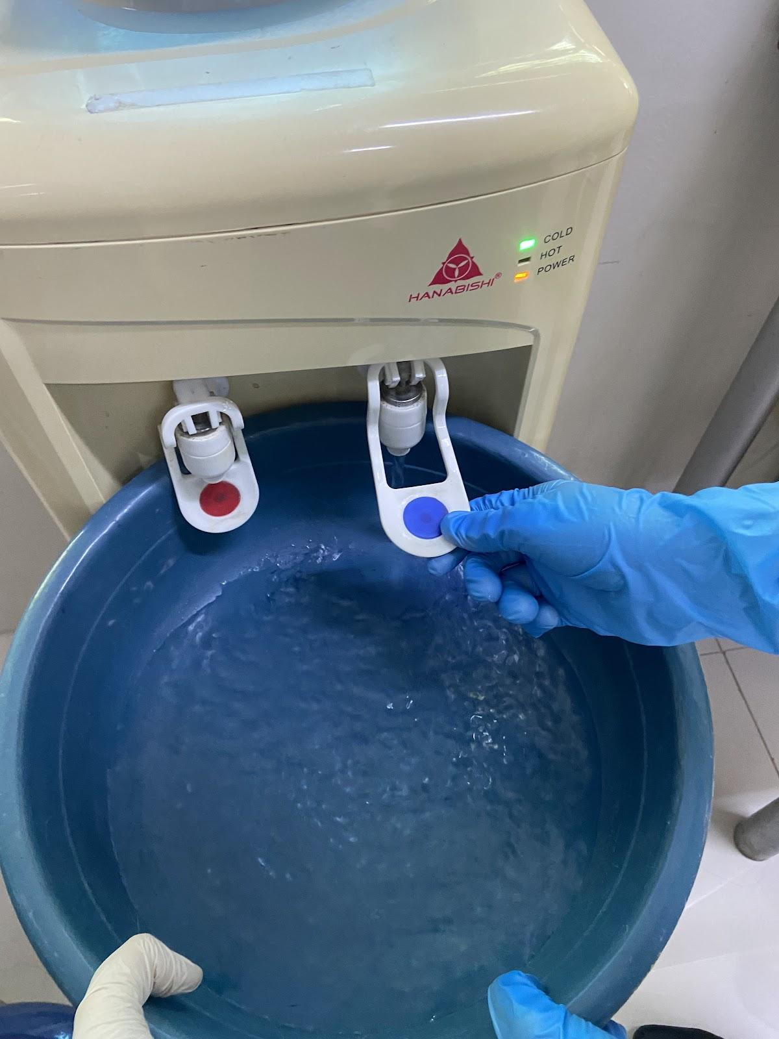
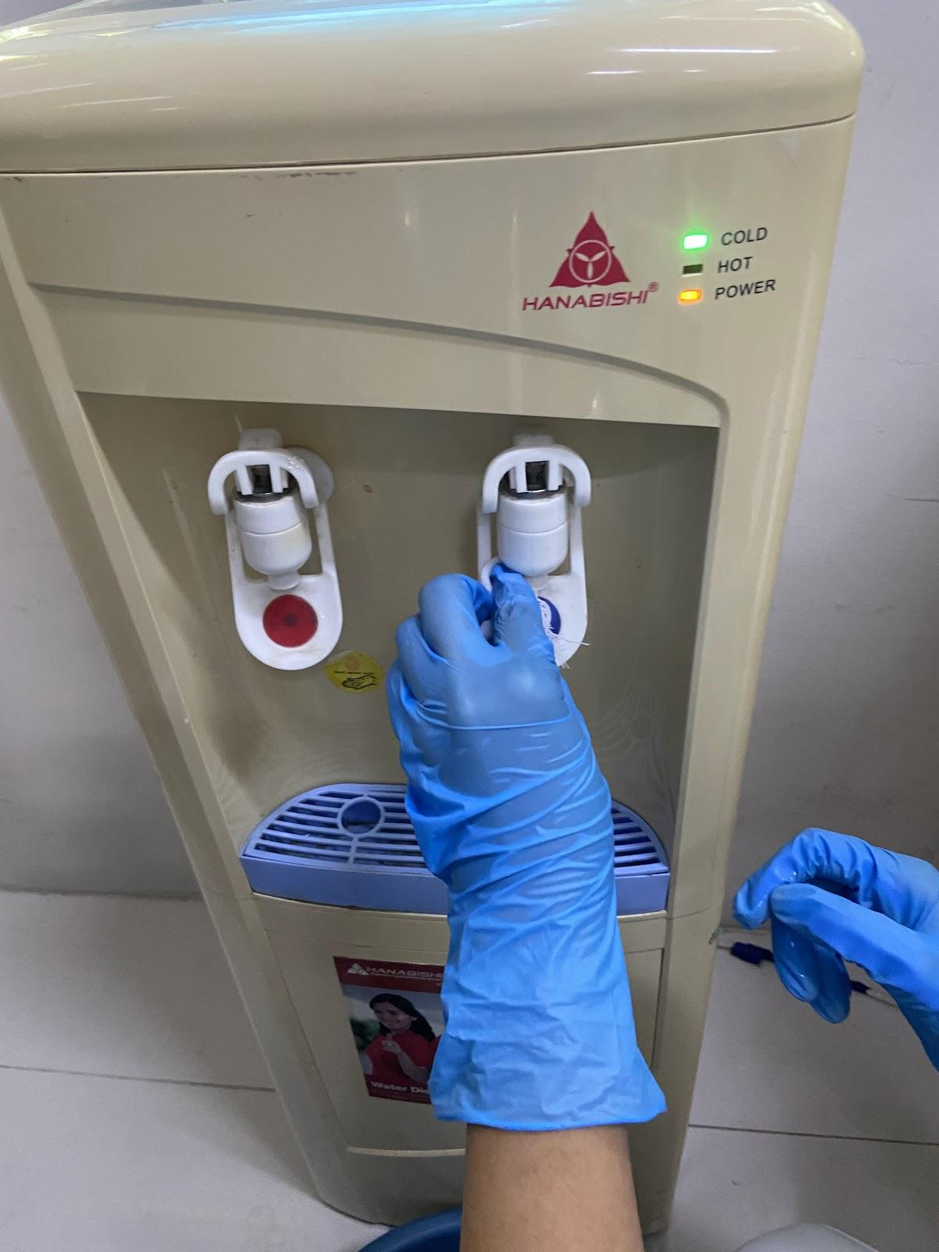
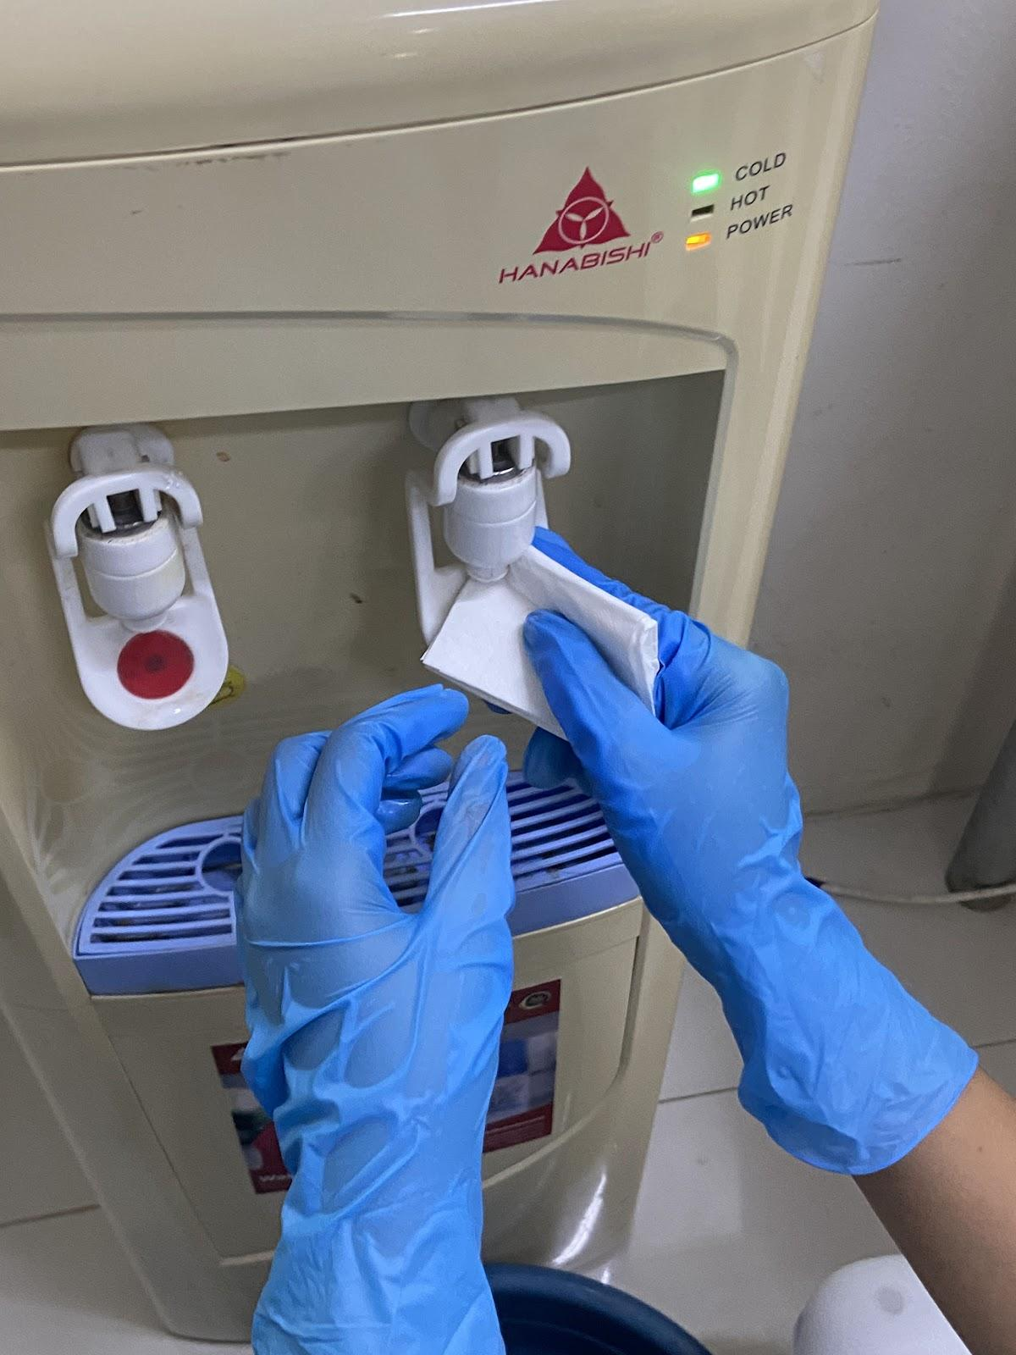
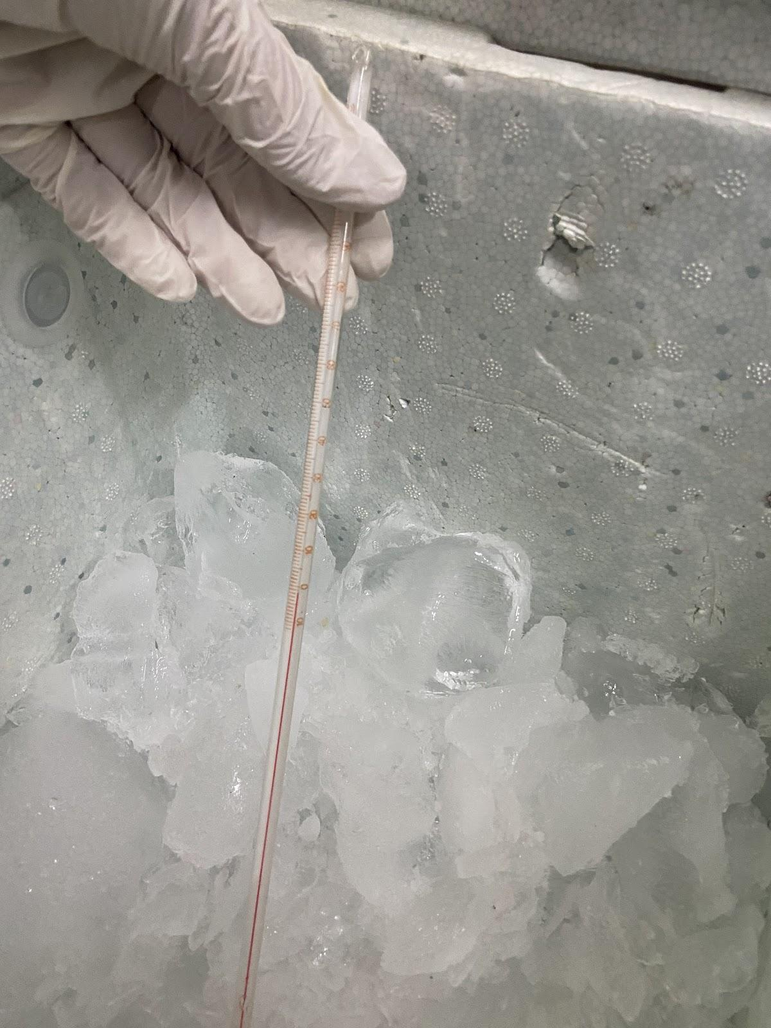
Total Coliform Test - Sample Collection

Before collecting the water samples, the researchers prepared all necessary materials, including glass bottles, gloves, disposable lab gowns, hairnets, and coolers. The bottles were autoclaved to ensure sterility and avoid contamination. The researchers flushed the water source for 30 seconds to remove any standing water before sample collection. The dispenser spout was cleaned with a 70% ethanol solution to ensure it was free from contaminants. The opening of each bottle was heated to prevent contamination. The coolers were set to a temperature below 10°C to keep the samples safe during transport.

10 Samples from Low Traffic
ALPHANUMERIC CODE: LT 001 to LT 010
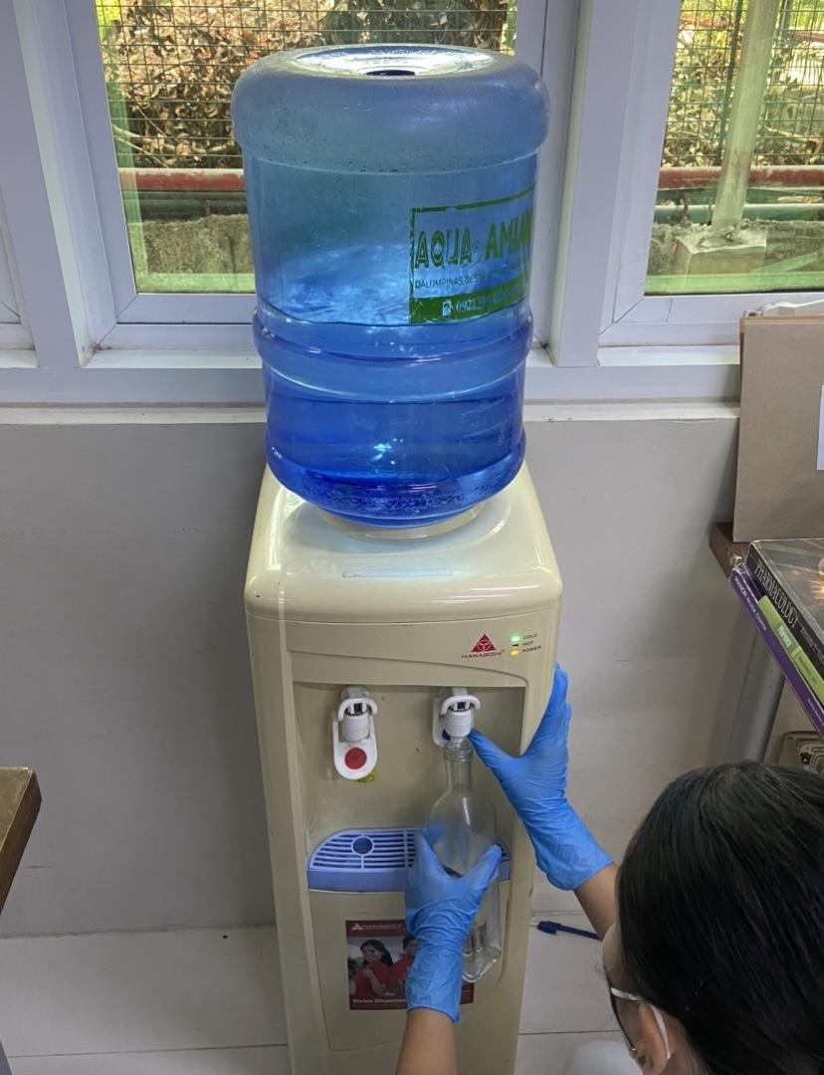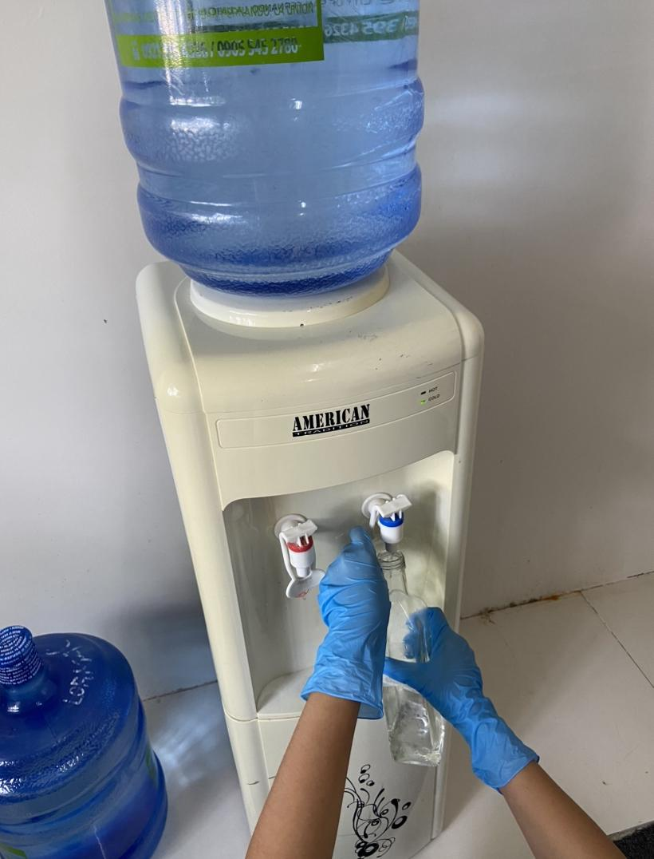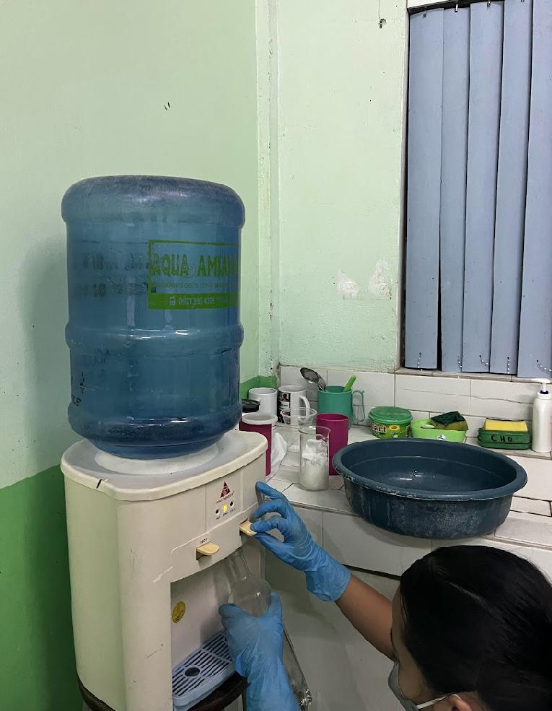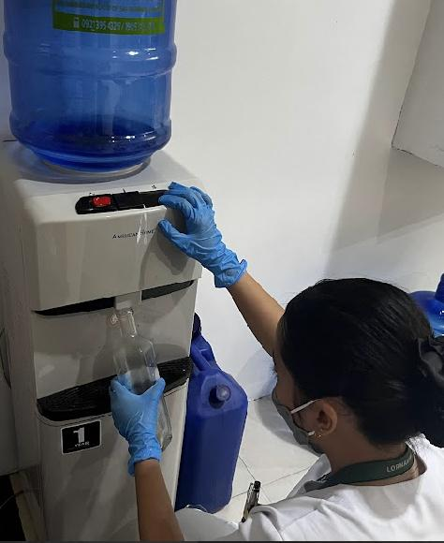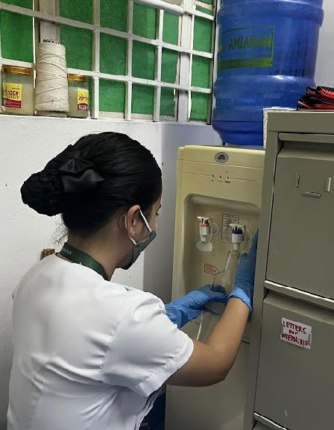
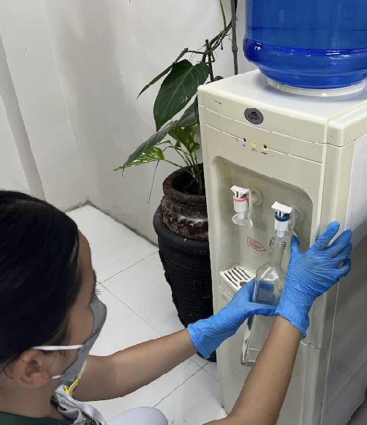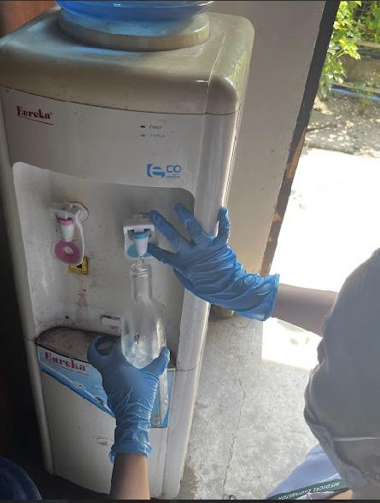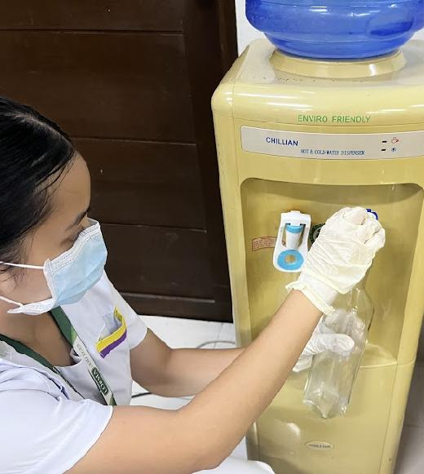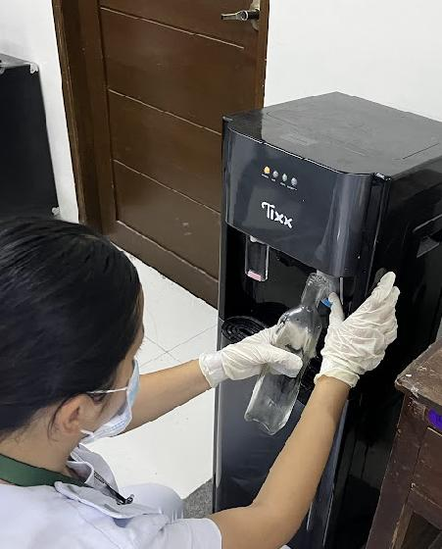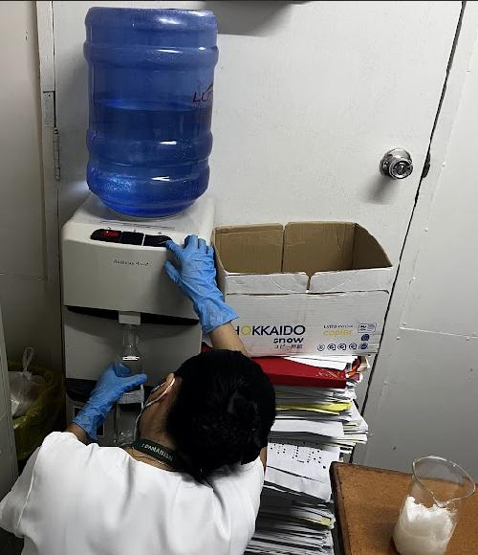

6 Samples from High Traffic
ALPHANUMERIC CODE: HT 001-006
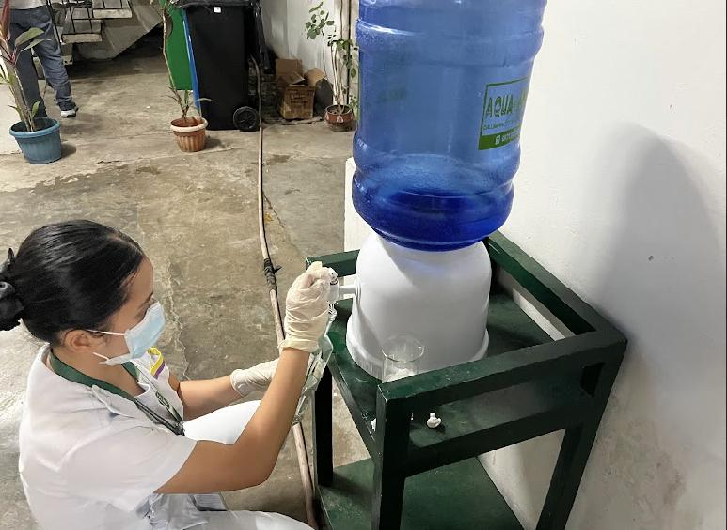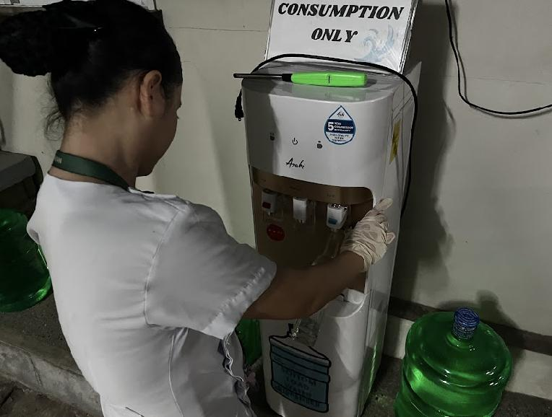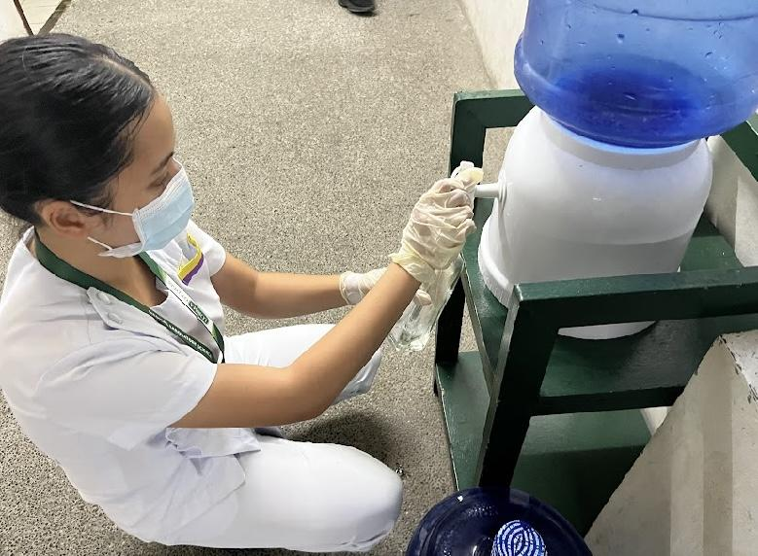
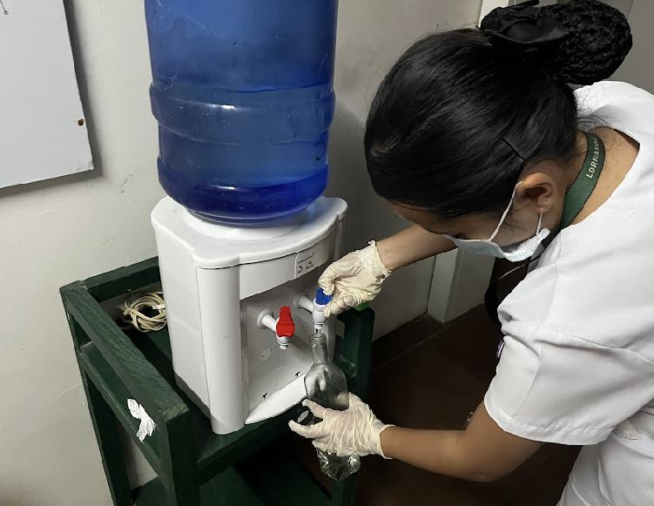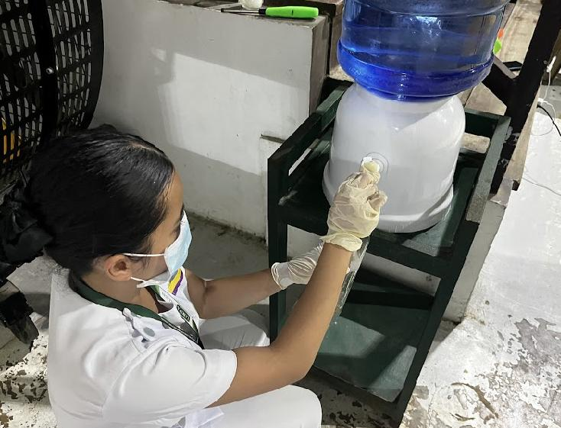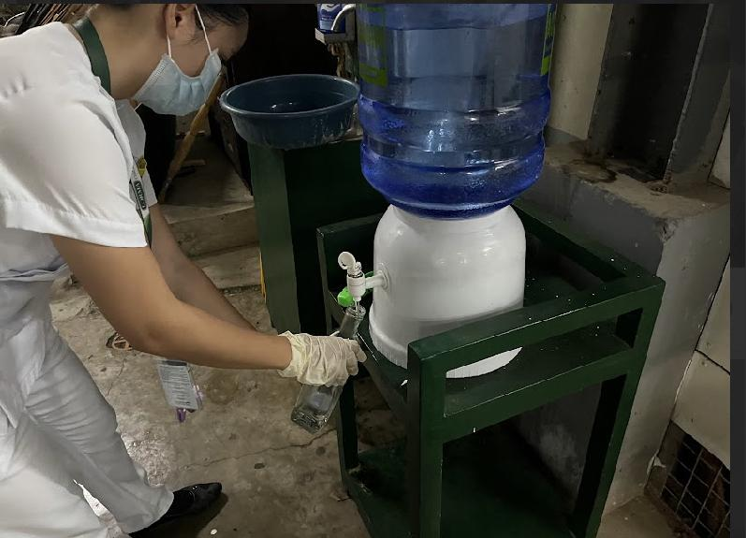

1 Sample from Standing Water
ALPHANUMERIC CODE: HT 007
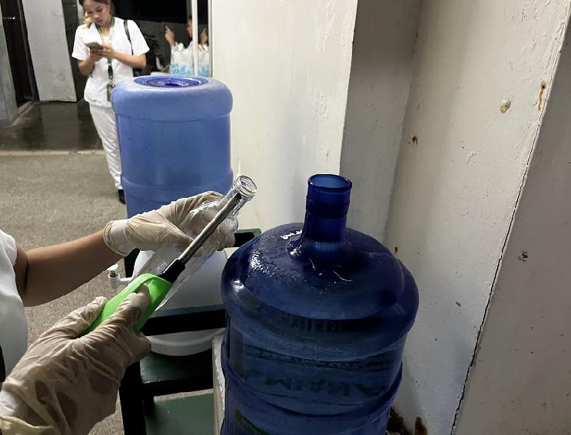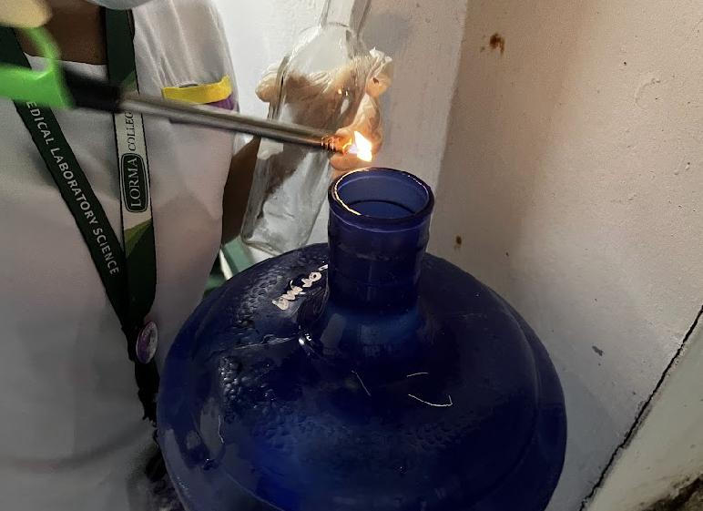
The collection of water samples began in the low-traffic areas, where the samples were randomly selected from various locations. These samples were tested immediately to ensure they were as fresh as possible. After three hours, water samples from the high-traffic areas were collected. Once all high-traffic area samples were gathered, the standing water sample was collected for further analysis.

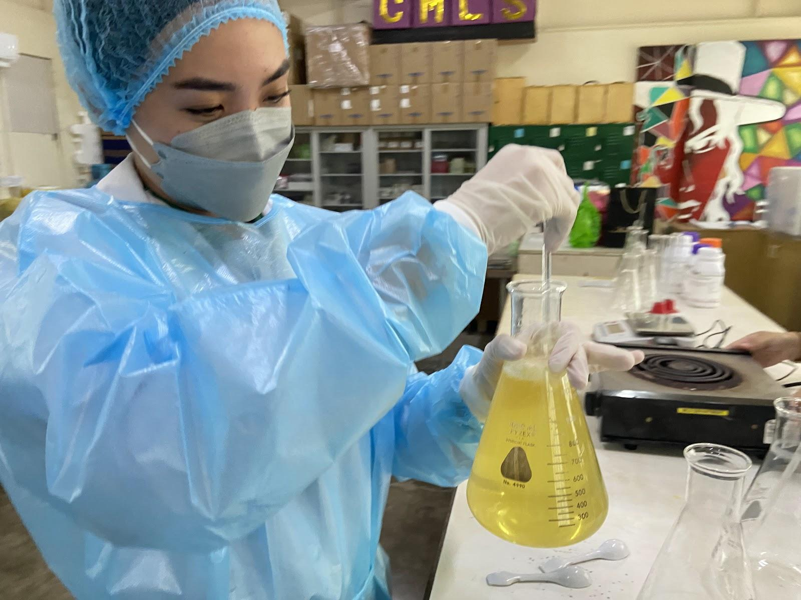
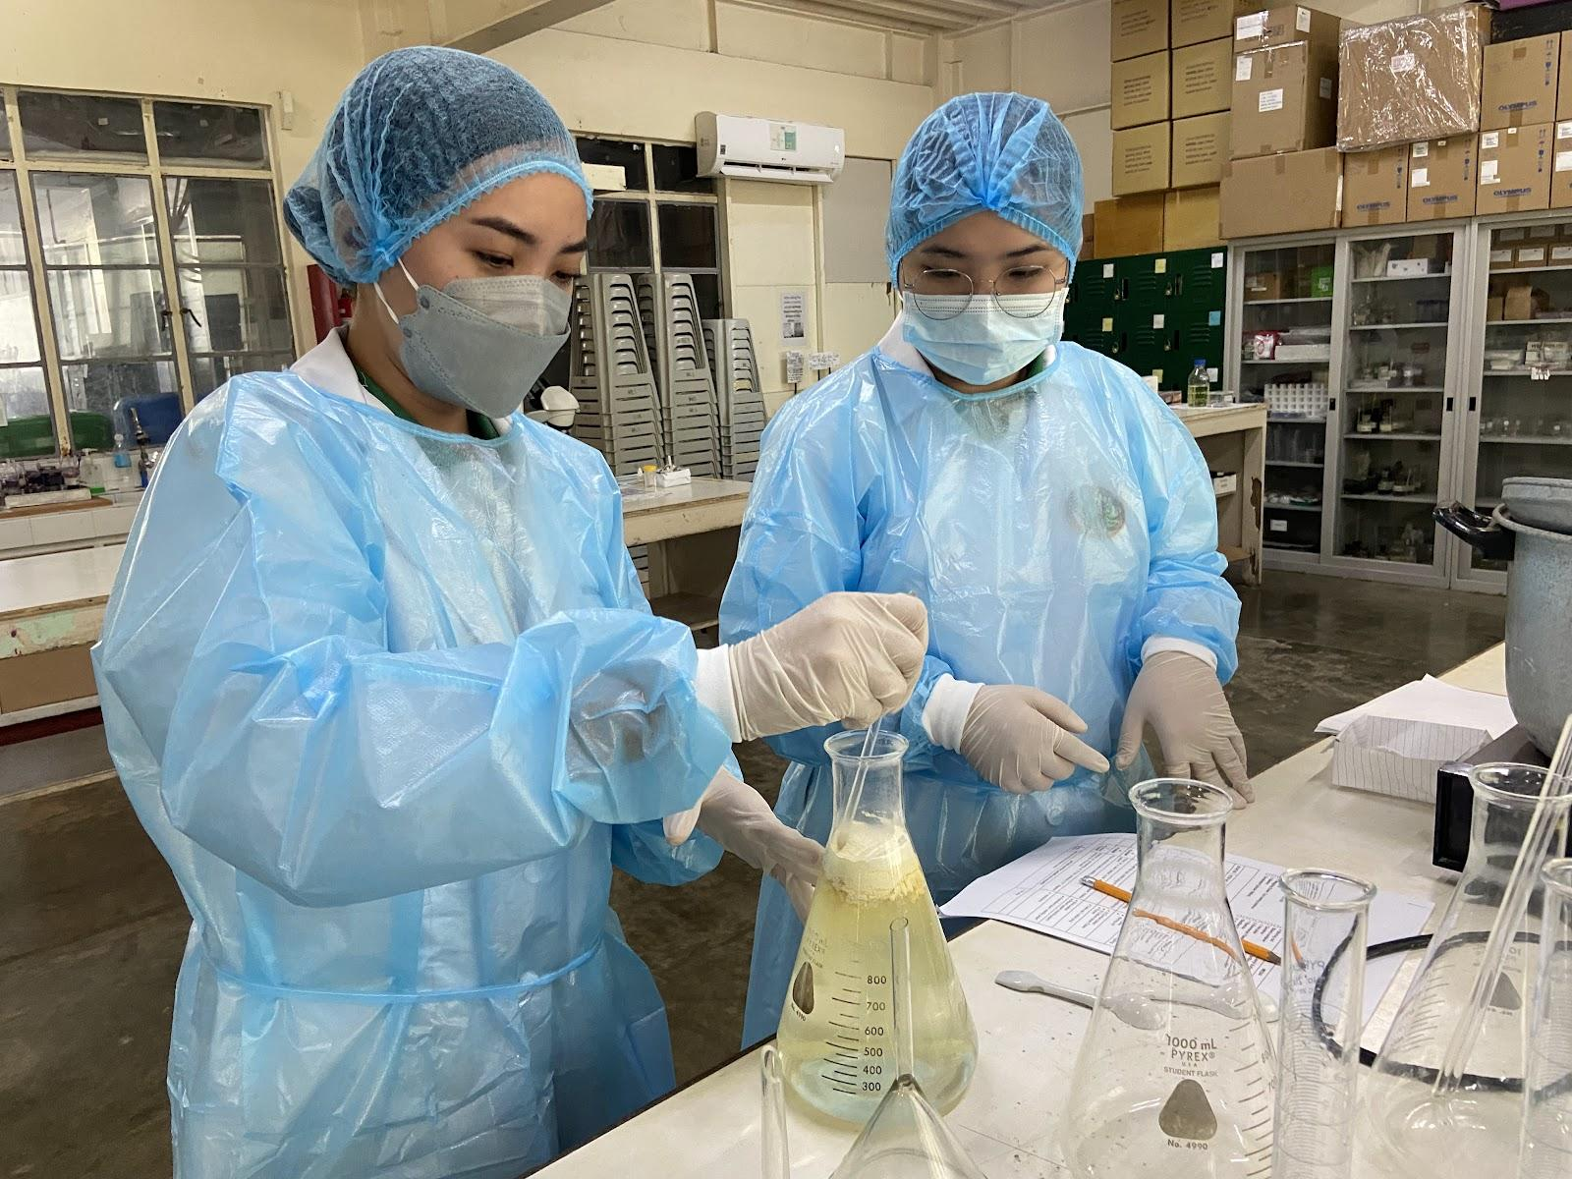
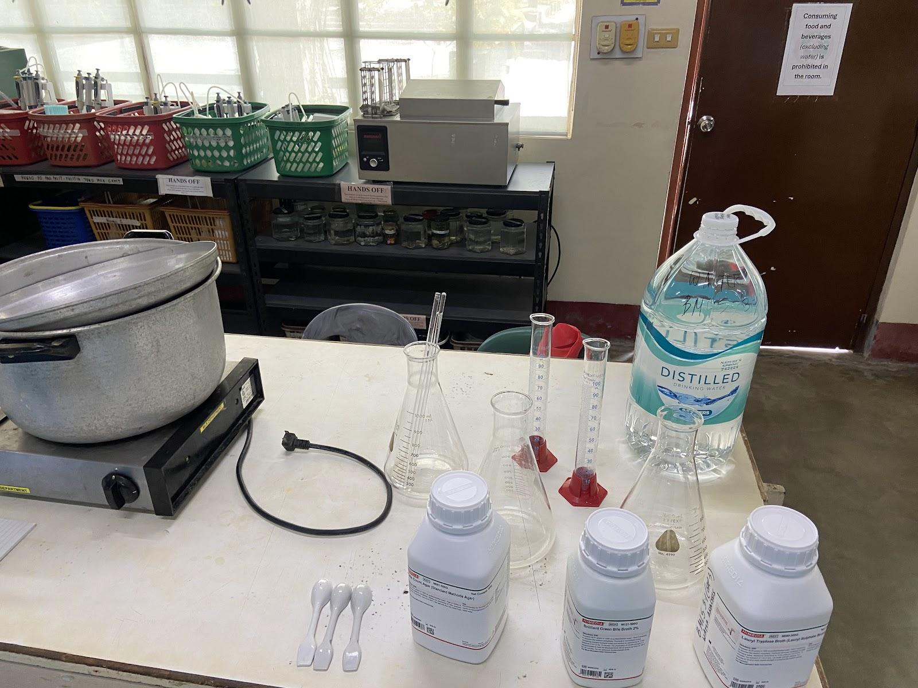
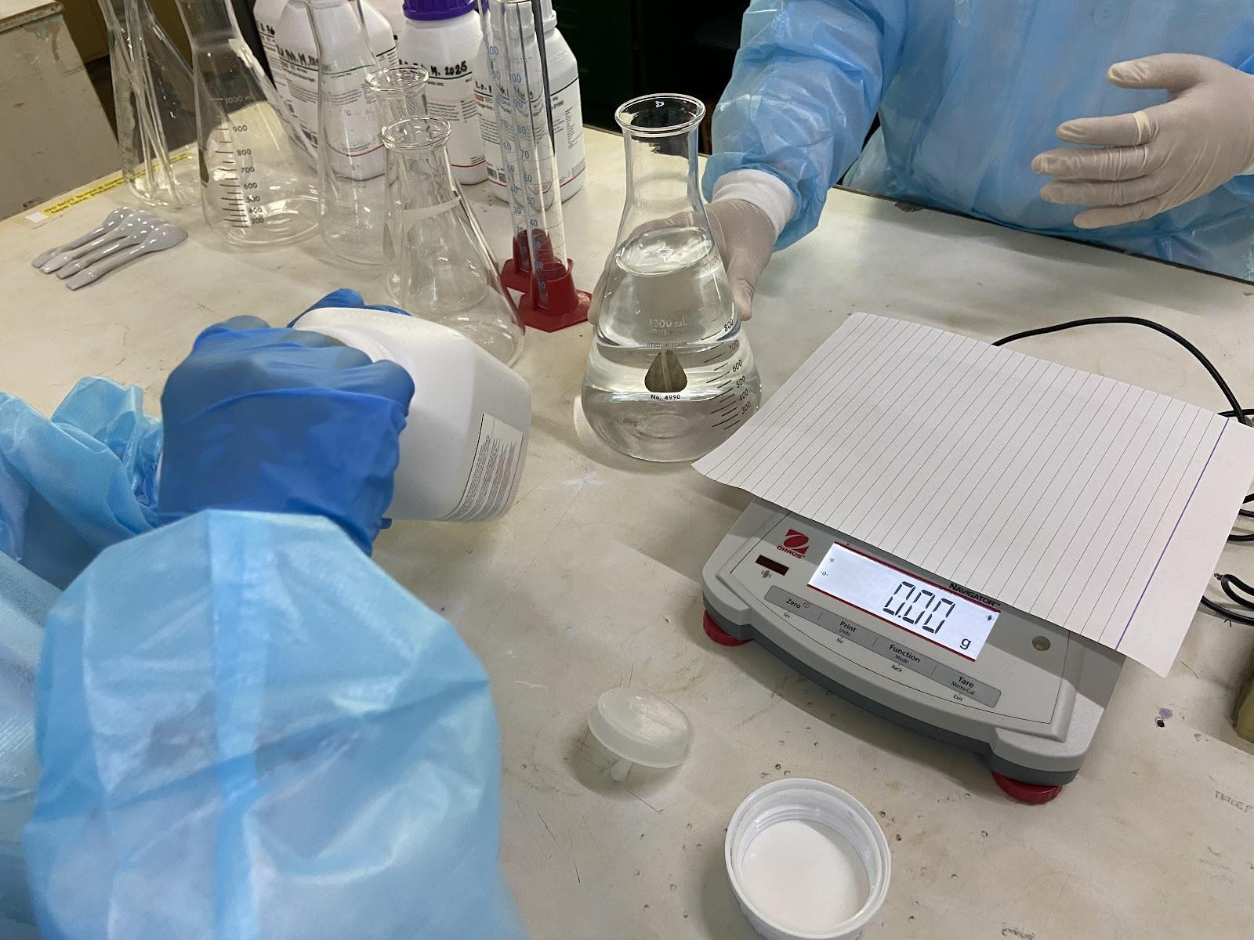
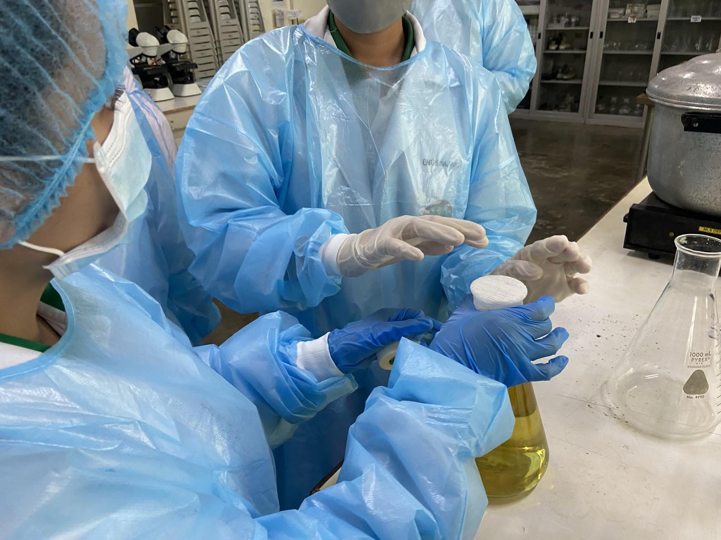
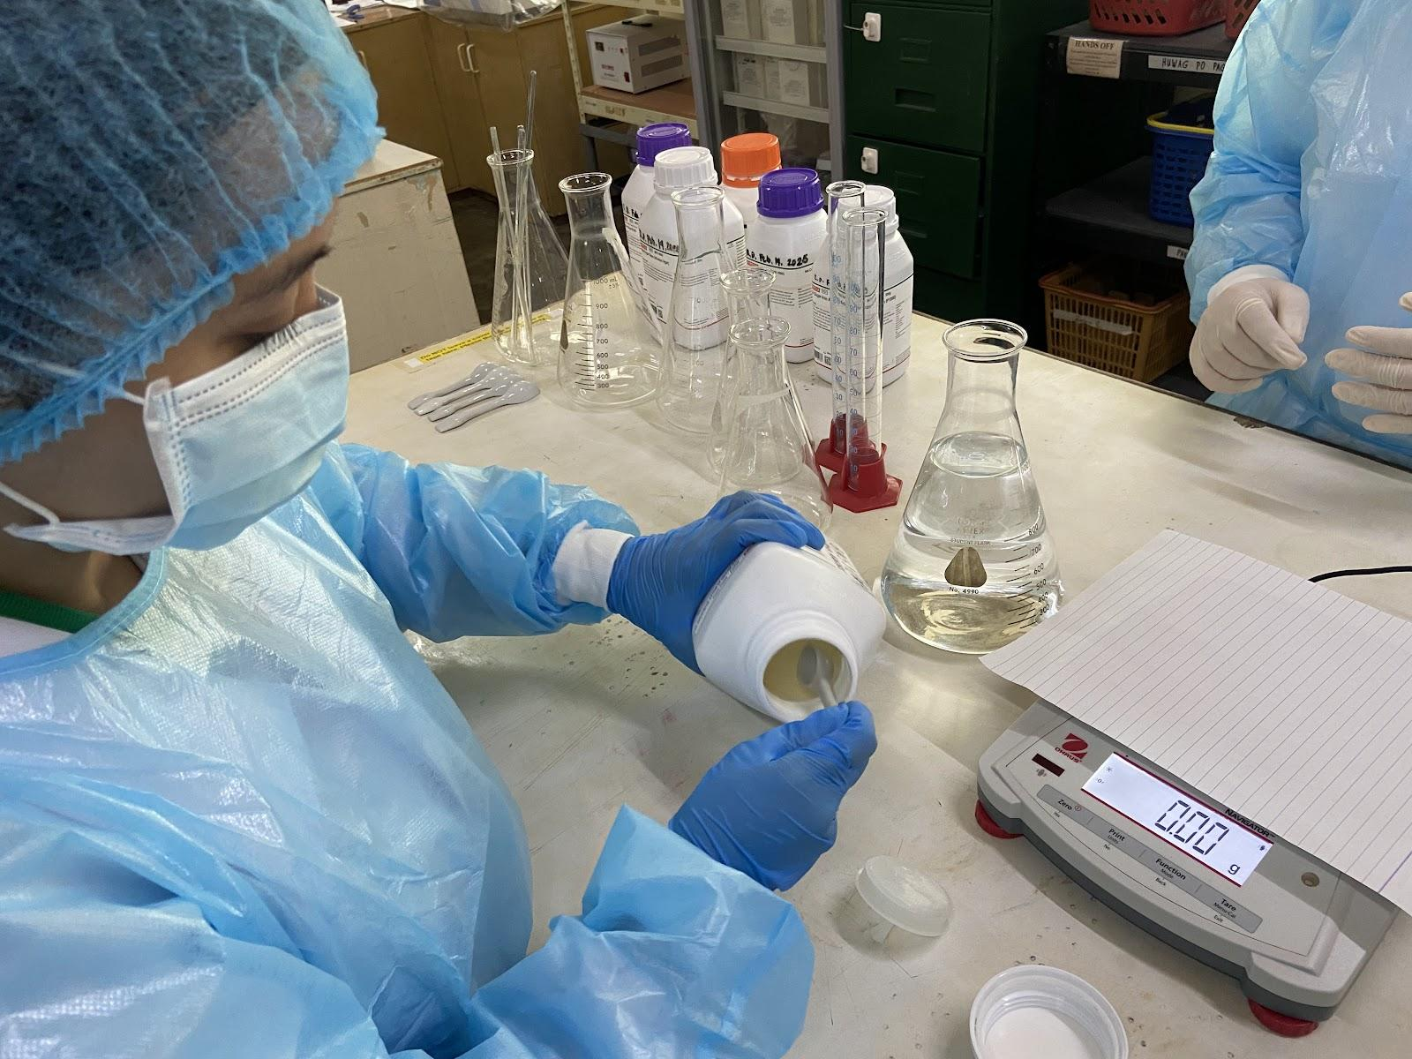
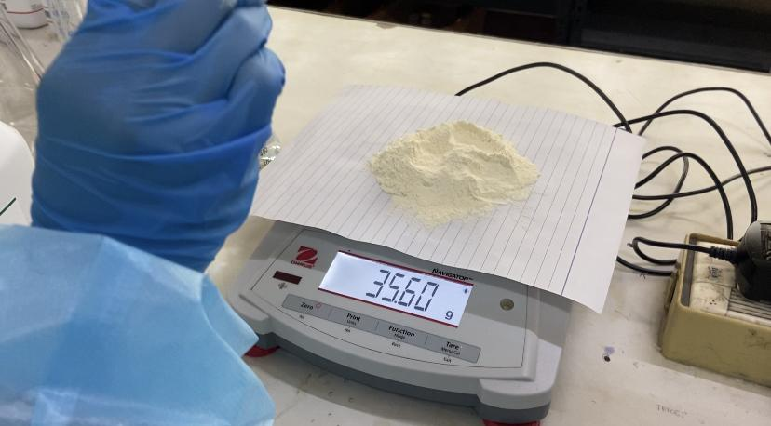
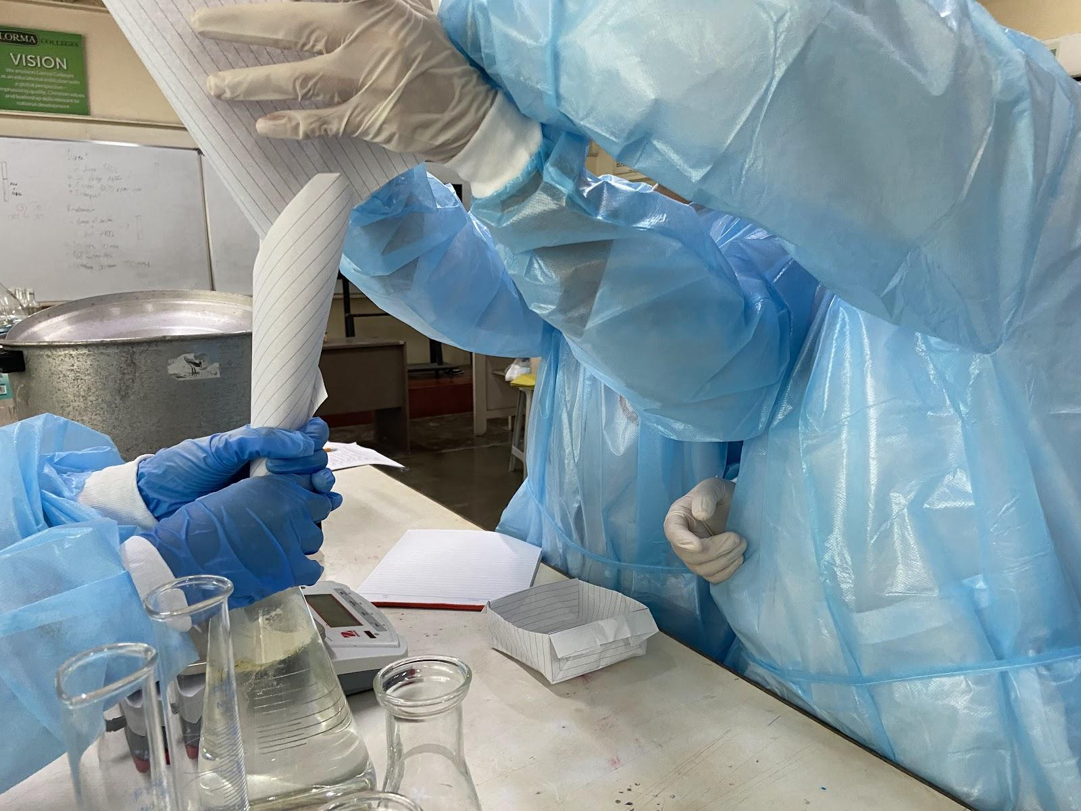
Presumptive Phase (Total Coliform Test)

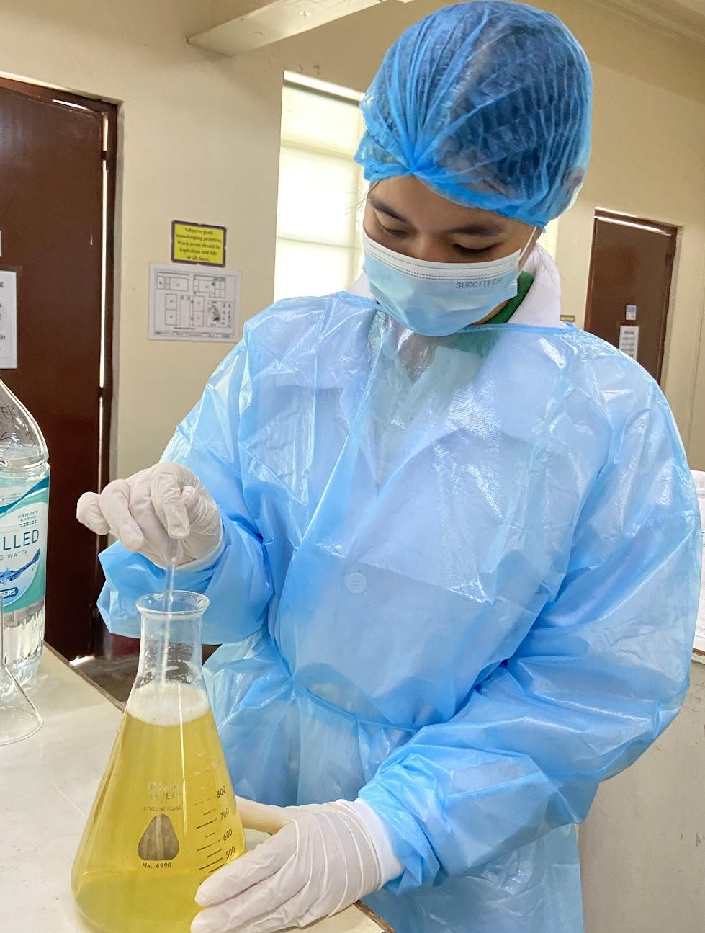
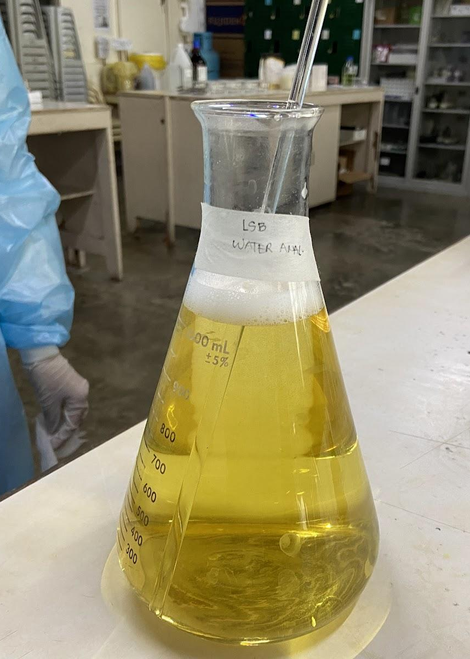
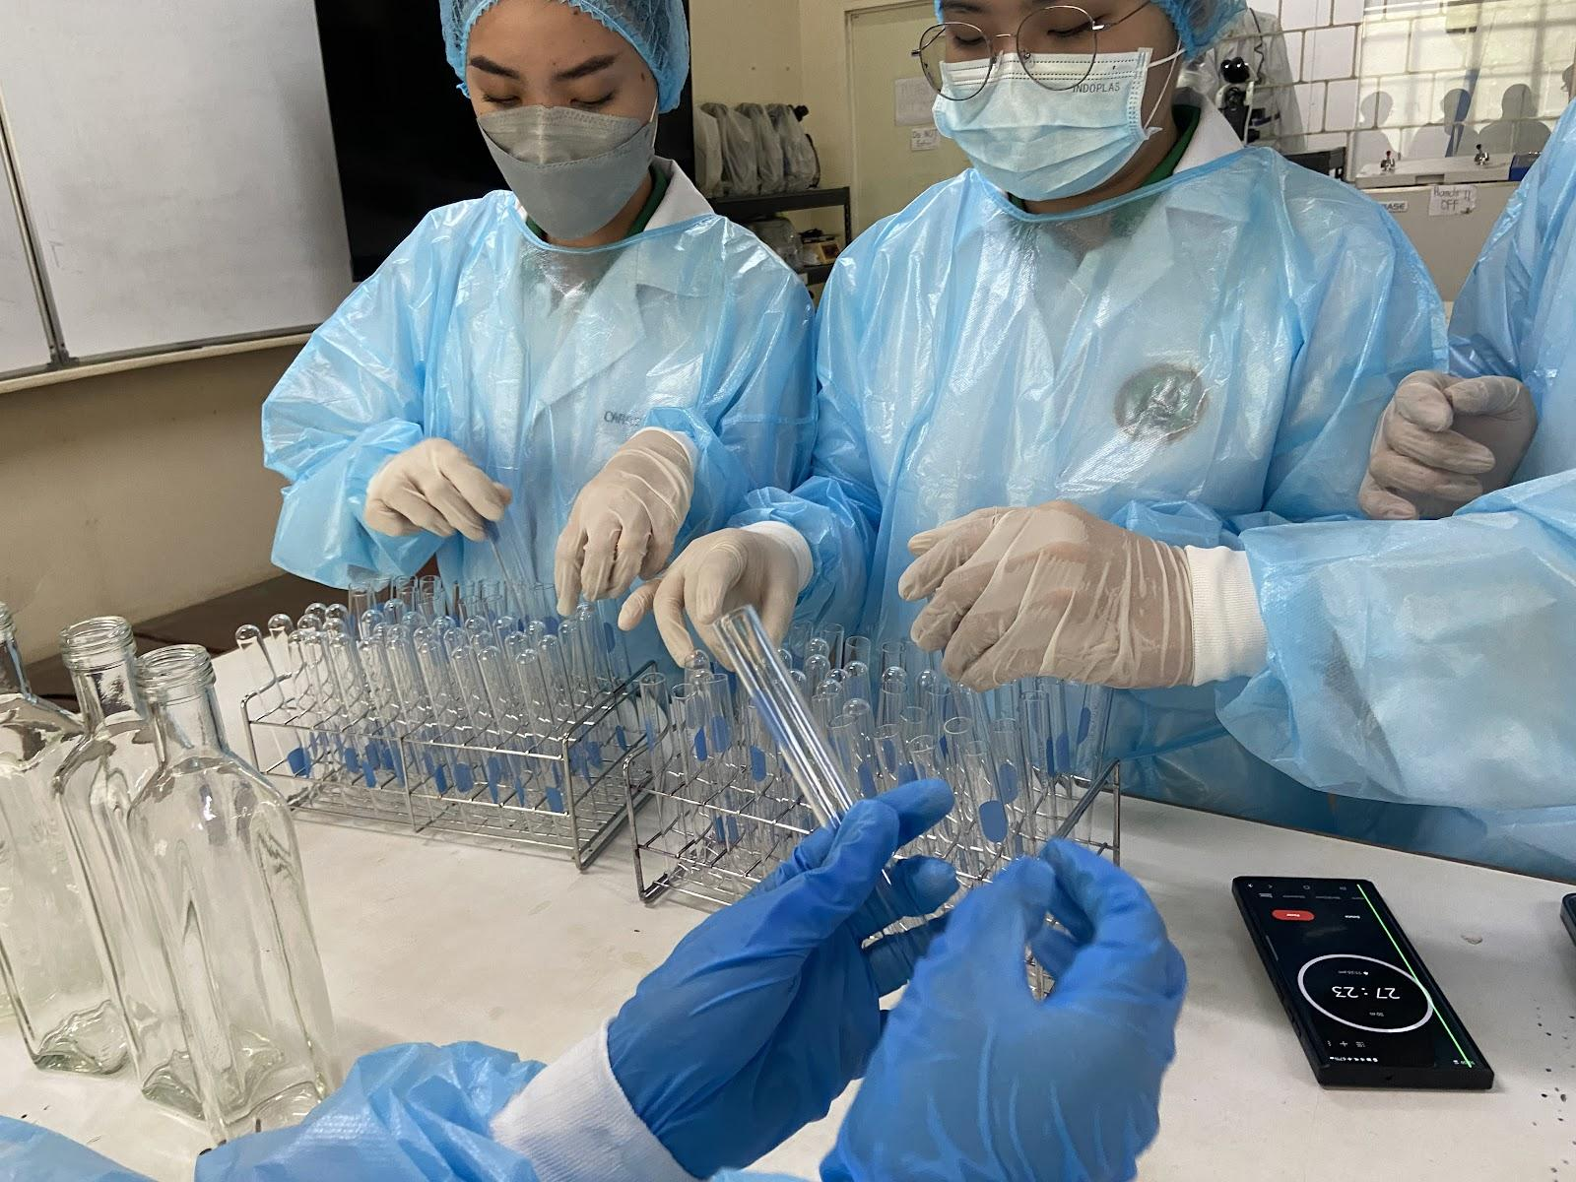

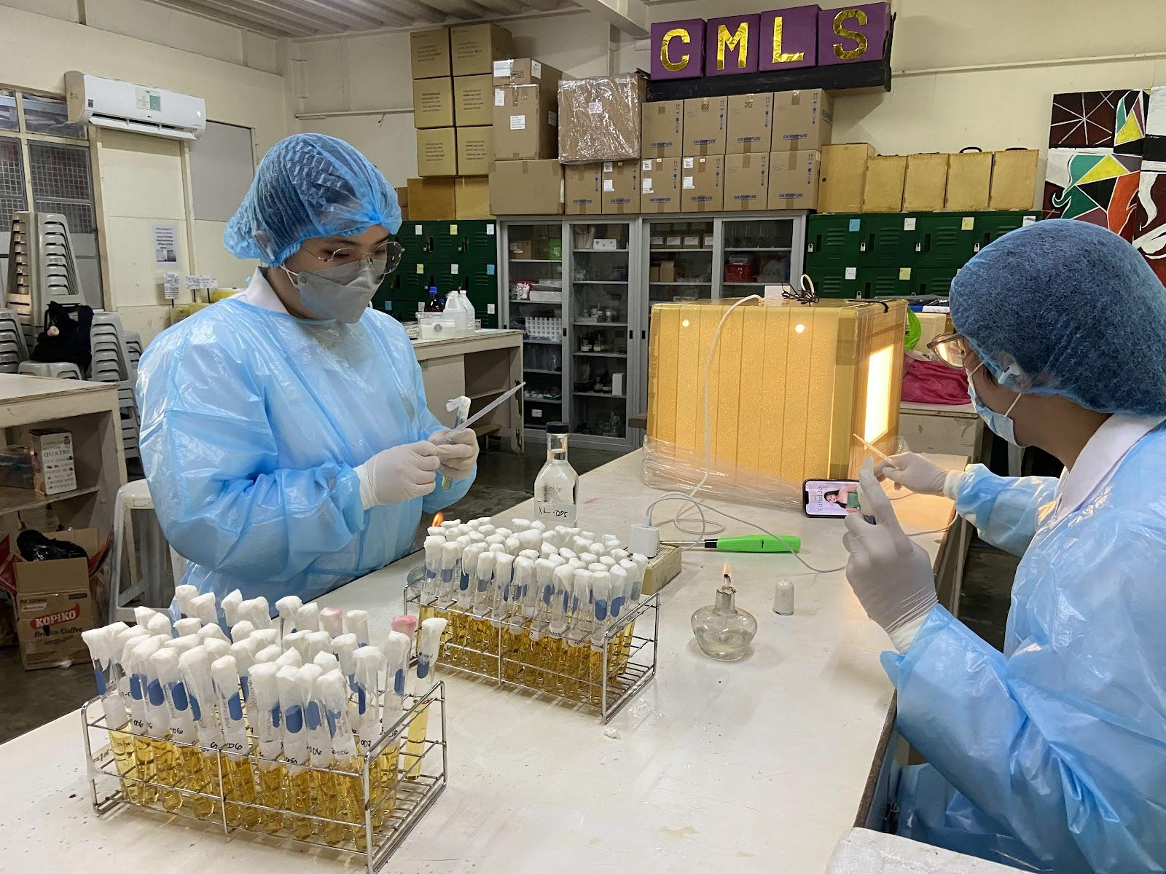
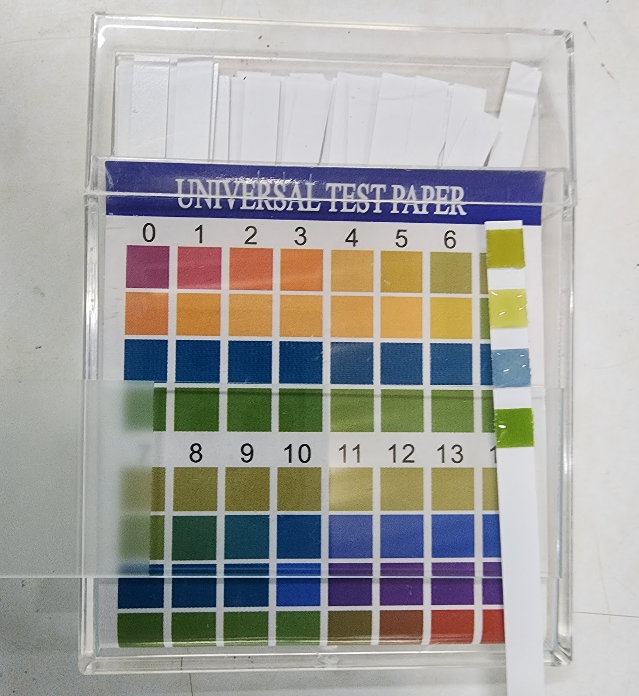

After the water samples were collected, they were transported to the laboratory. The researchers then prepared the total coliform test, following proper procedures in the biosafety cabinet (BSC) to avoid contamination. The water samples were first tested with a universal pH test paper, which showed a pH of 6.0. The samples were then monitored for the total coliform test results.

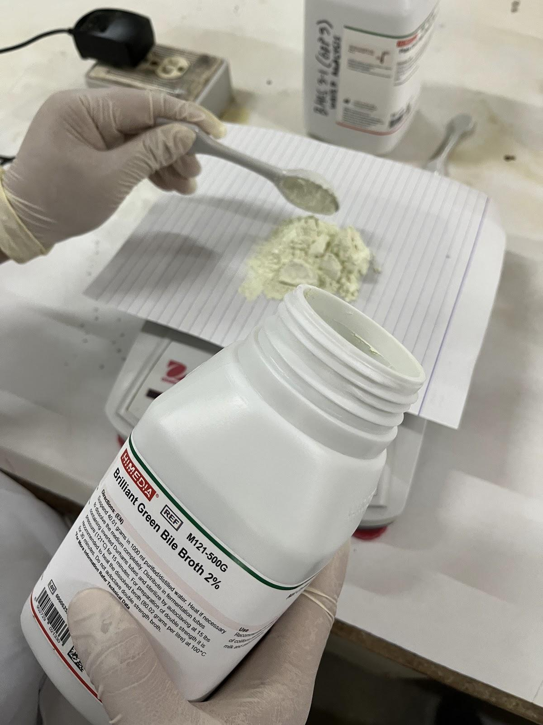
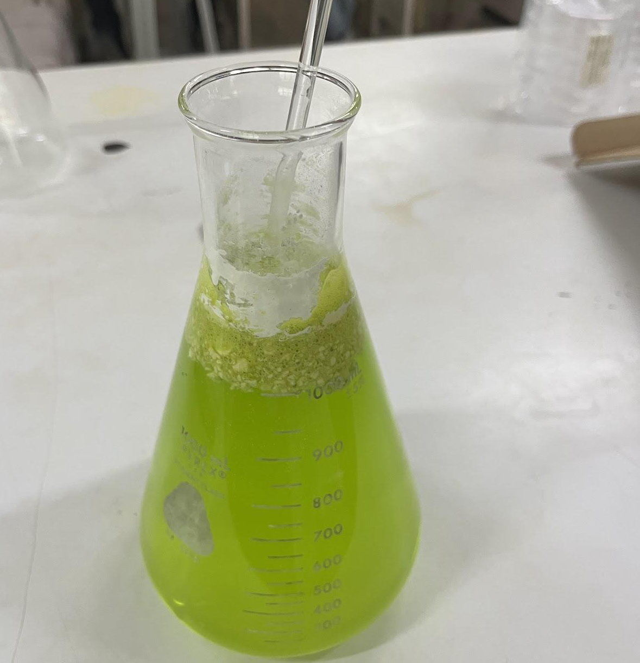
Confirmatory Phase (Total Coliform Test)

Preparation of Brilliant Green Bile Broth for Confirmatory Phase of Total Coliform Test.
For the confirmatory phase, Brilliant Green Bile Broth (BGLB) was prepared to verify the presence of total coliforms detected in the presumptive test. The medium was carefully measured, dissolved in distilled water, and gently heated to ensure full mixing. It was then distributed into fermentation tubes with inverted Durham tubes for gas detection. Each tube was sealed with a cotton plug or cap, labeled, and sterilized by autoclaving at 121 °C for 15 minutes. After cooling, the tubes were stored properly until use. Presumptive positive samples from the first phase were transferred into the BGLB tubes using sterile techniques inside the biosafety cabinet (BSC) to avoid contamination. The tubes were incubated at 35 °C for 48 hours and monitored for gas production, which confirmed the presence of coliform bacteria in the sample.

Heterotrophic Plate Count (HPC)
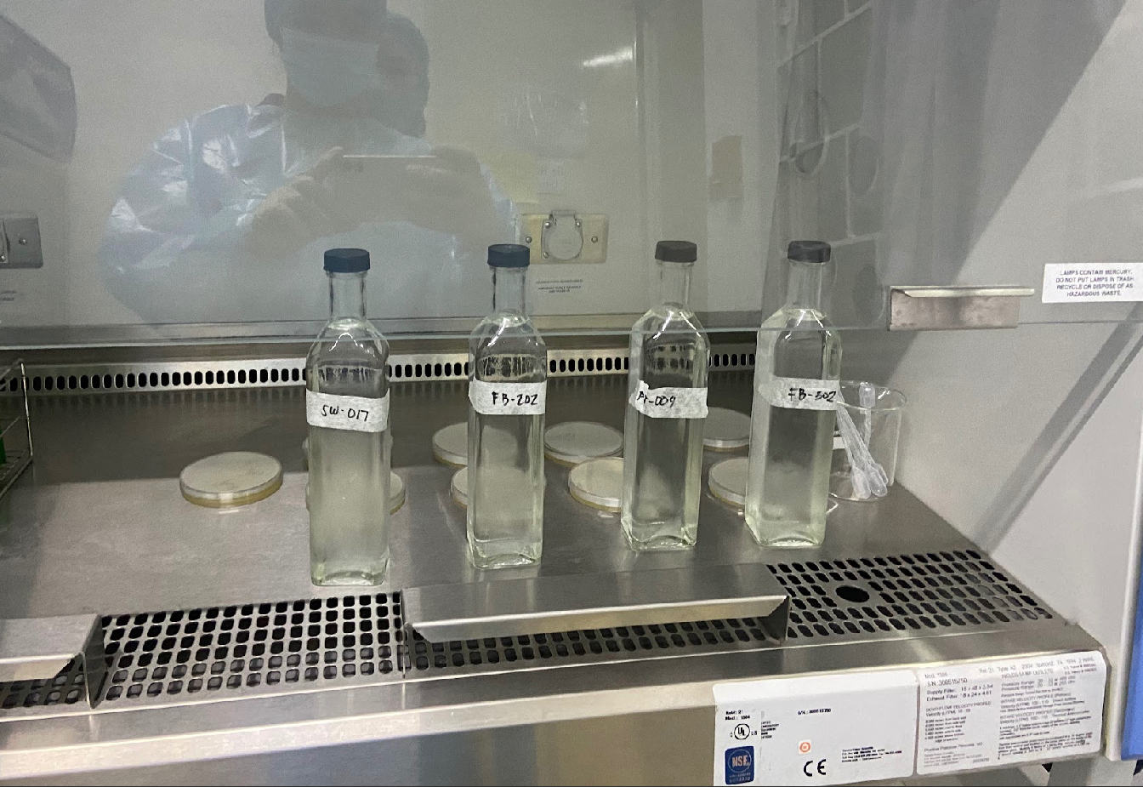
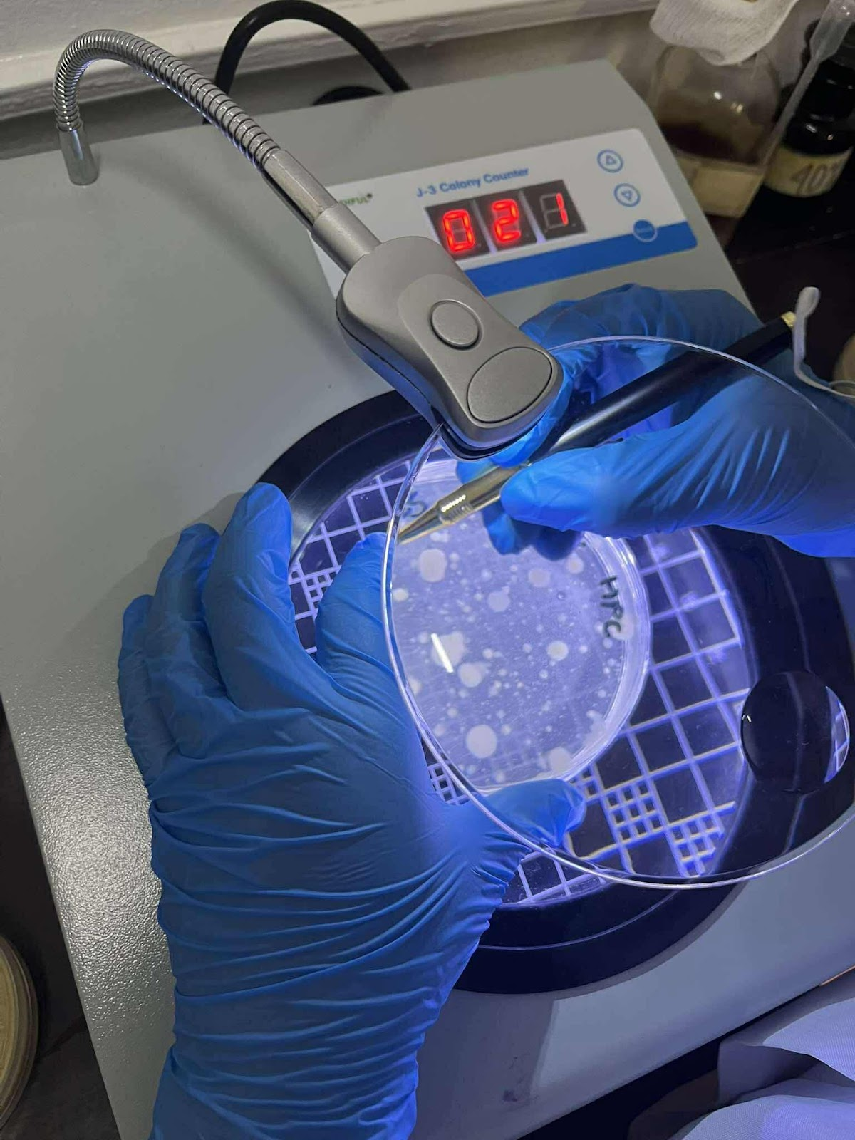
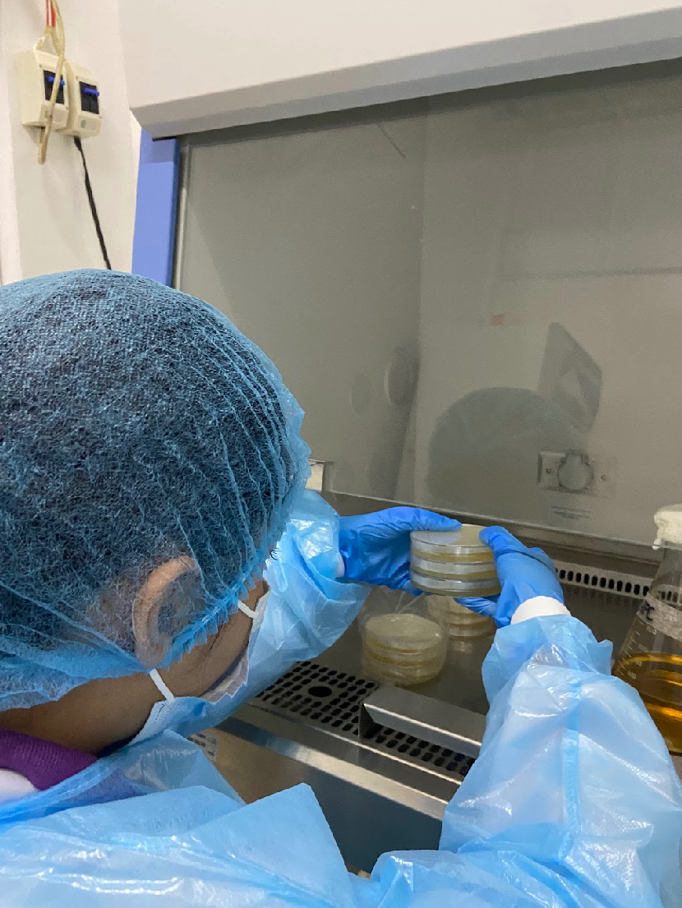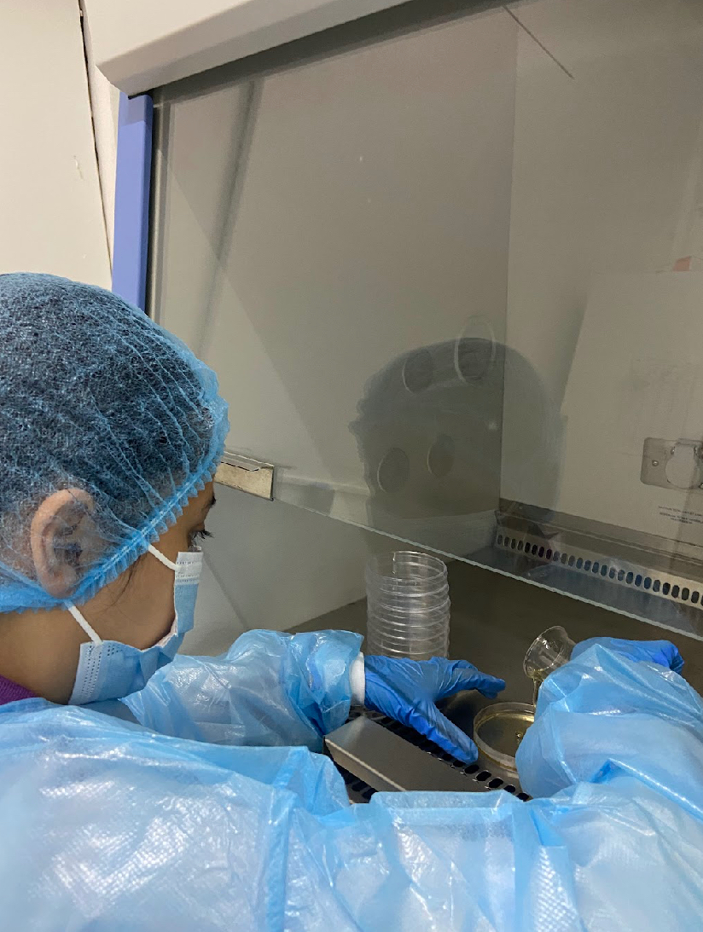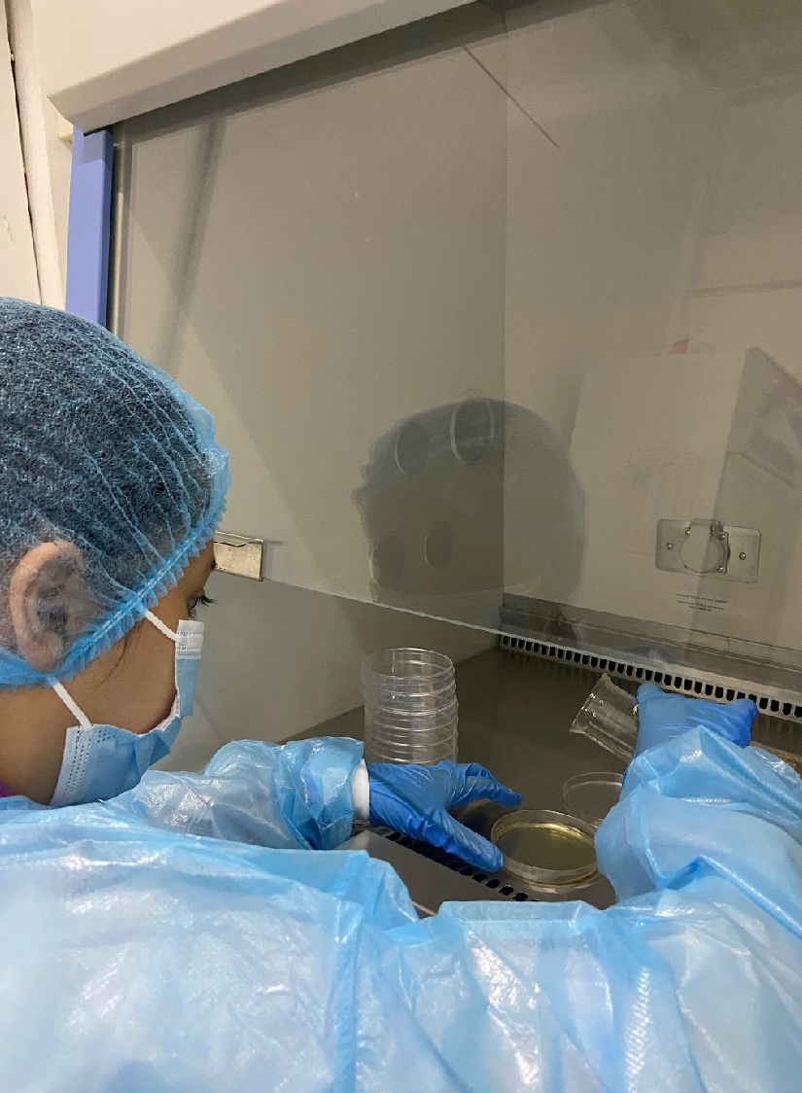

After aseptically collecting the samples, we used pre-sterilized disposable plastic petri dishes and prepared two replicate plates for each sample volume tested. Each sample was thoroughly mixed by performing approximately rapid up-and-down or back-and-forth motions. For counting and documentation, we utilized a colony counter and promptly counted all colonies on the selected plates after incubation.

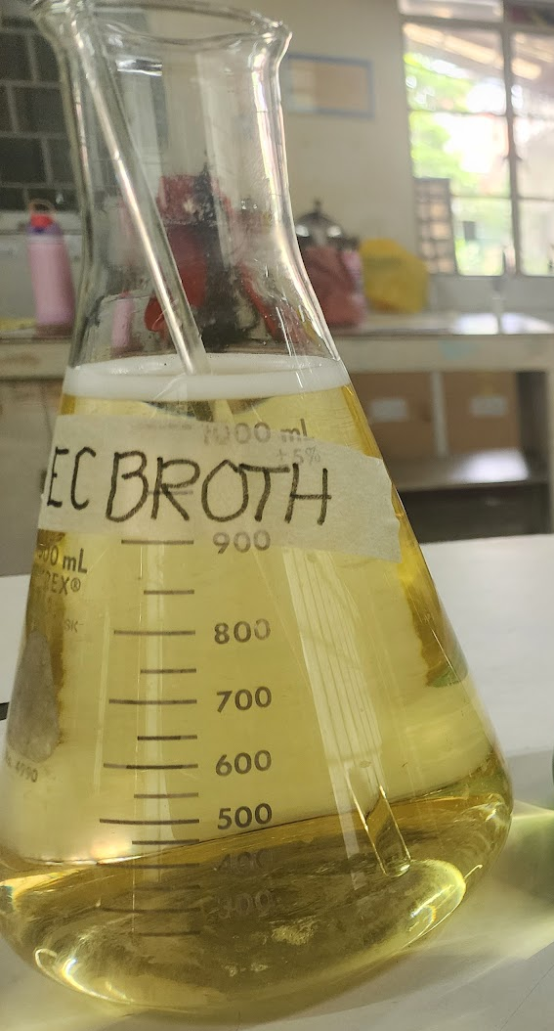
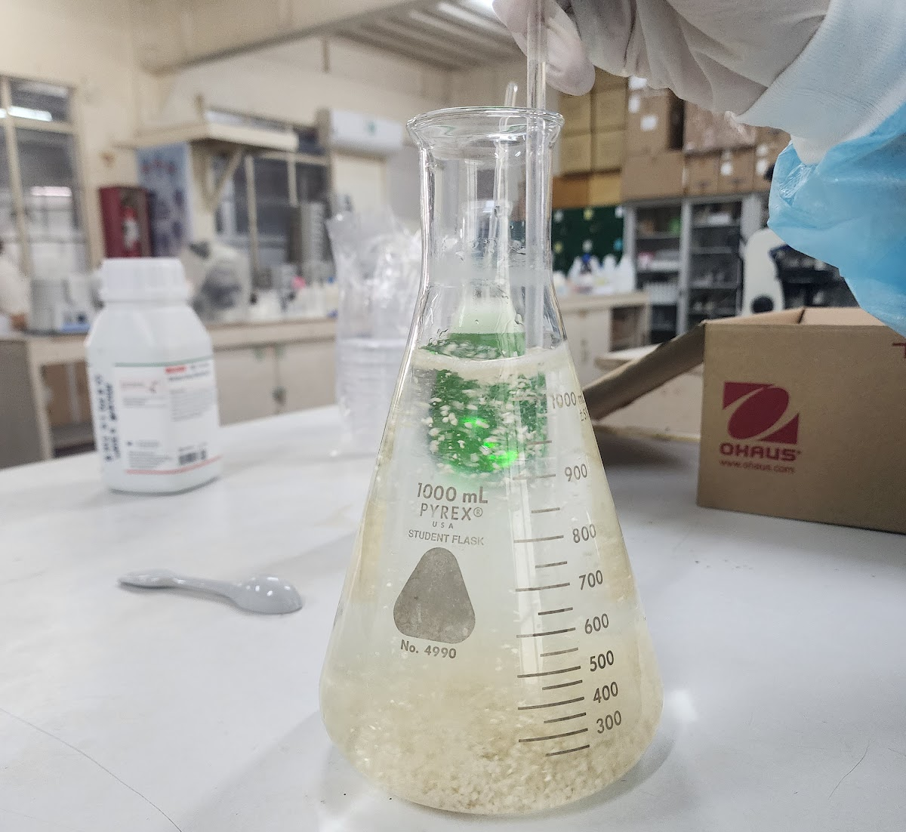
Fecal/Thermotolerant Coliform Test

Preparation of E.coli broth for Fecal/Thermotolerant Coliform Test
After 48 hours from the presumptive total coliform test, the researchers proceeded with the Fecal/Thermotolerant Coliform Test. Then prepared Escherichia coli (EC) broth by dissolving 37.0 grams of EC powder in 1000 mL of distilled water, stirred and heated if needed. The broth was dispensed into tubes and sterilized. Presumptive positive samples were then inoculated into the EC broth tubes using sterile techniques, and the tubes were incubated in a water bath at 44.5 °C for 24 hours.

Results in Multiple Tube Fermentation (Total Coliform Test)
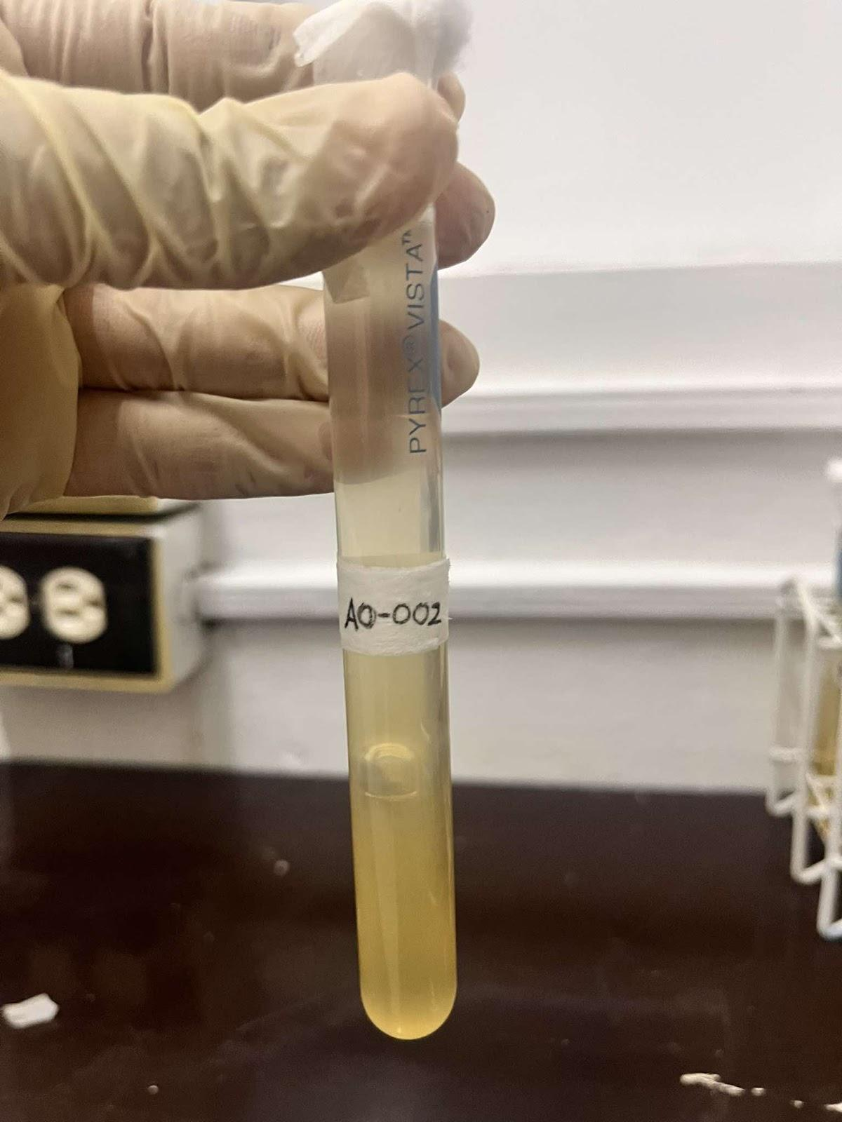
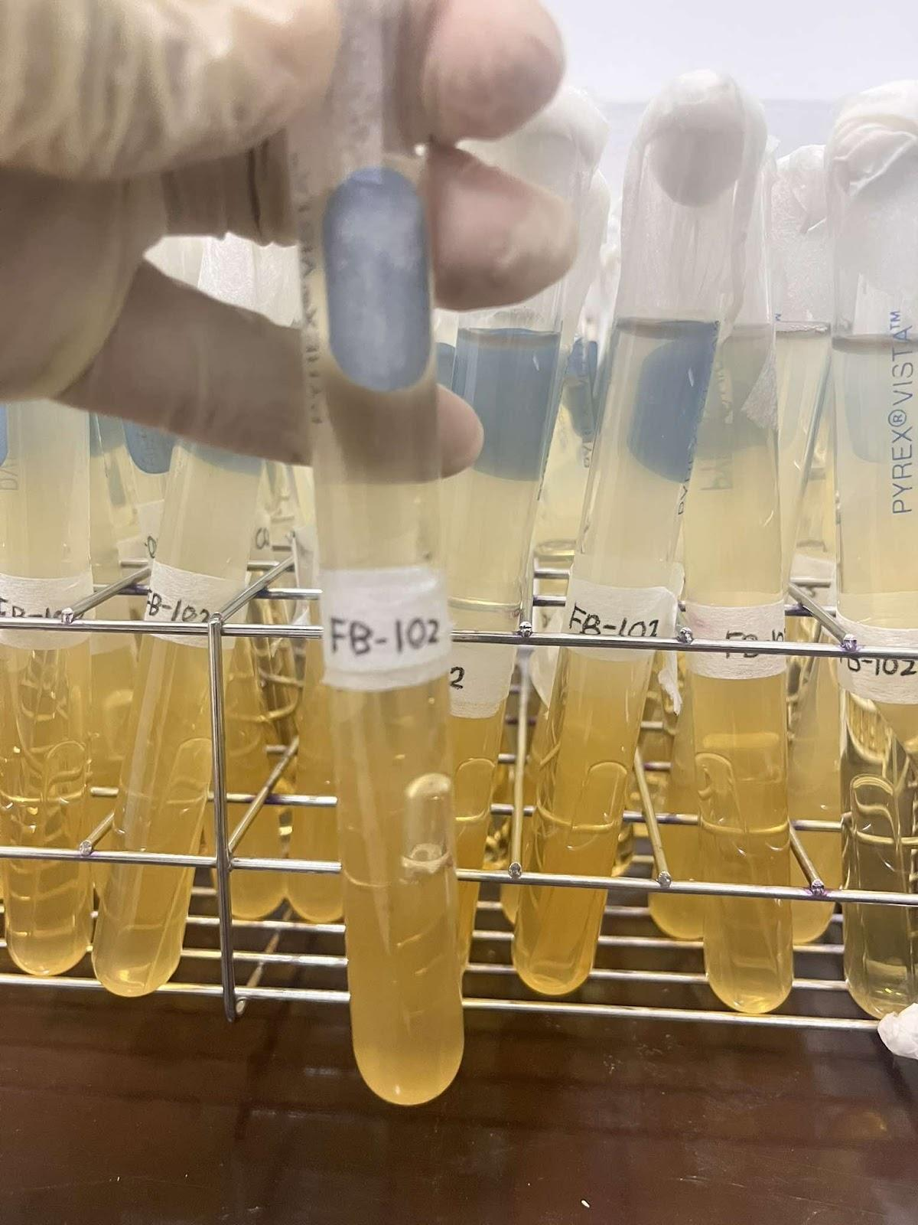
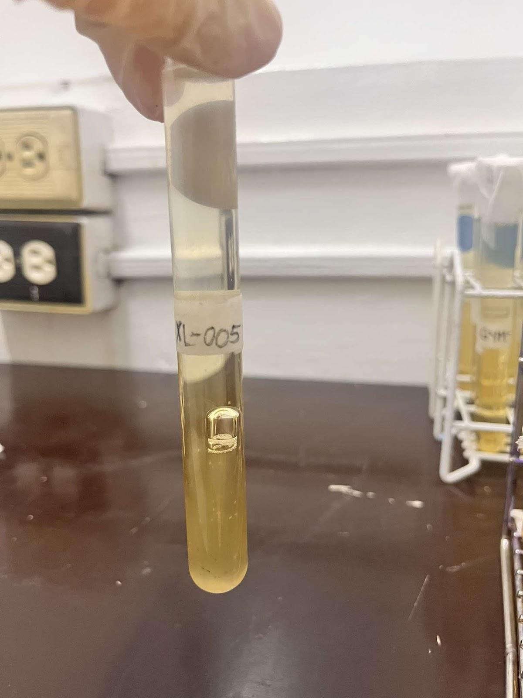
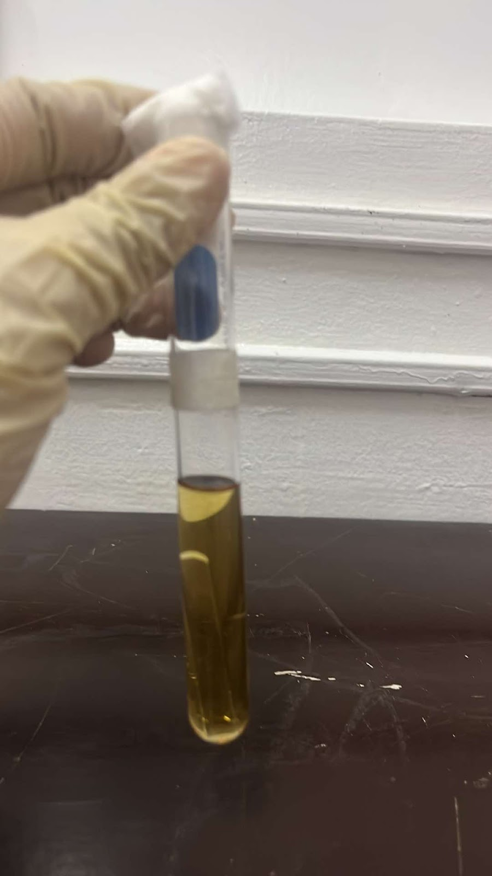
Presumptive Phase (Total Coliform)

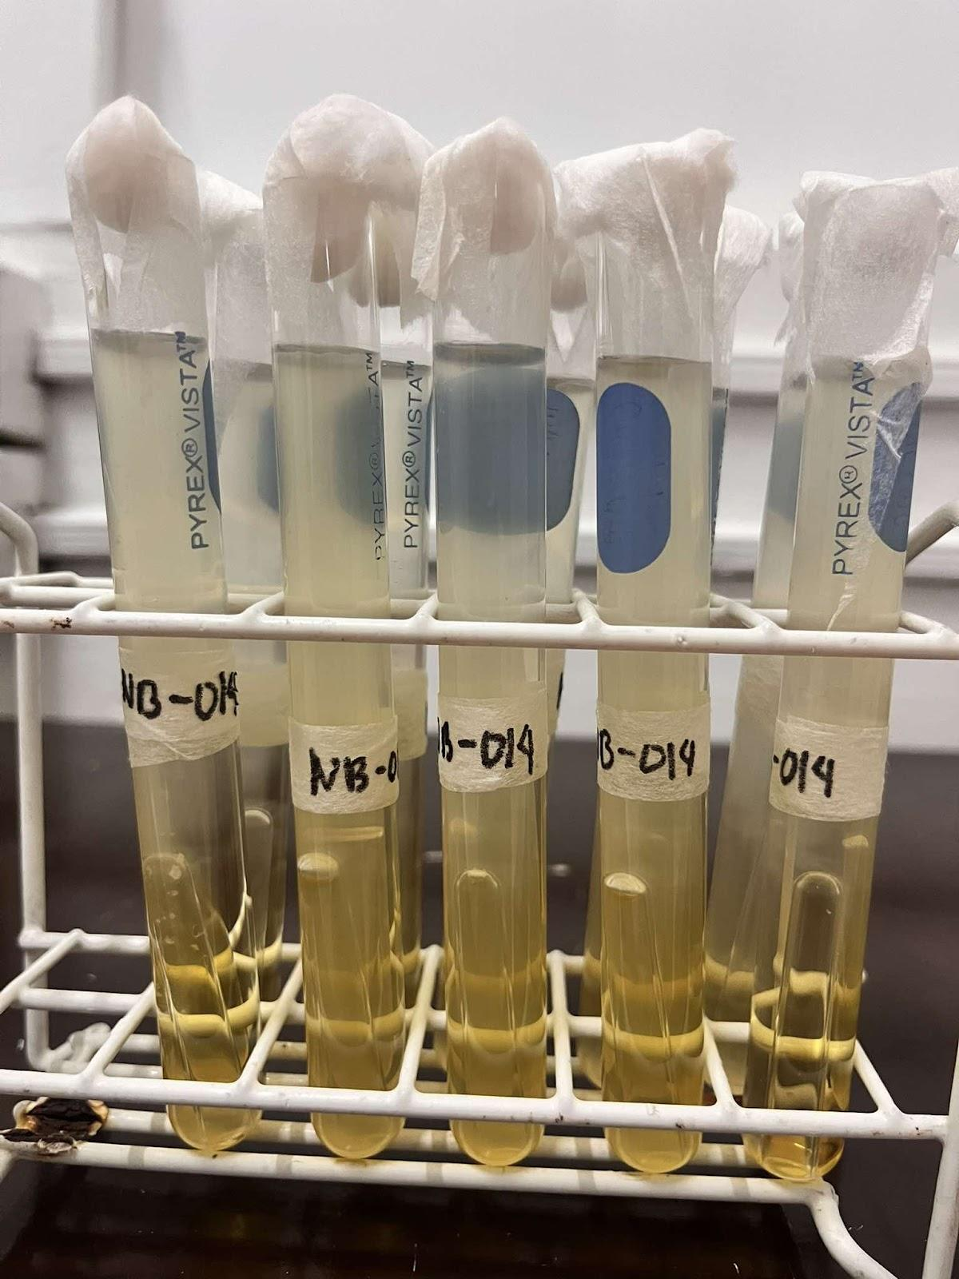
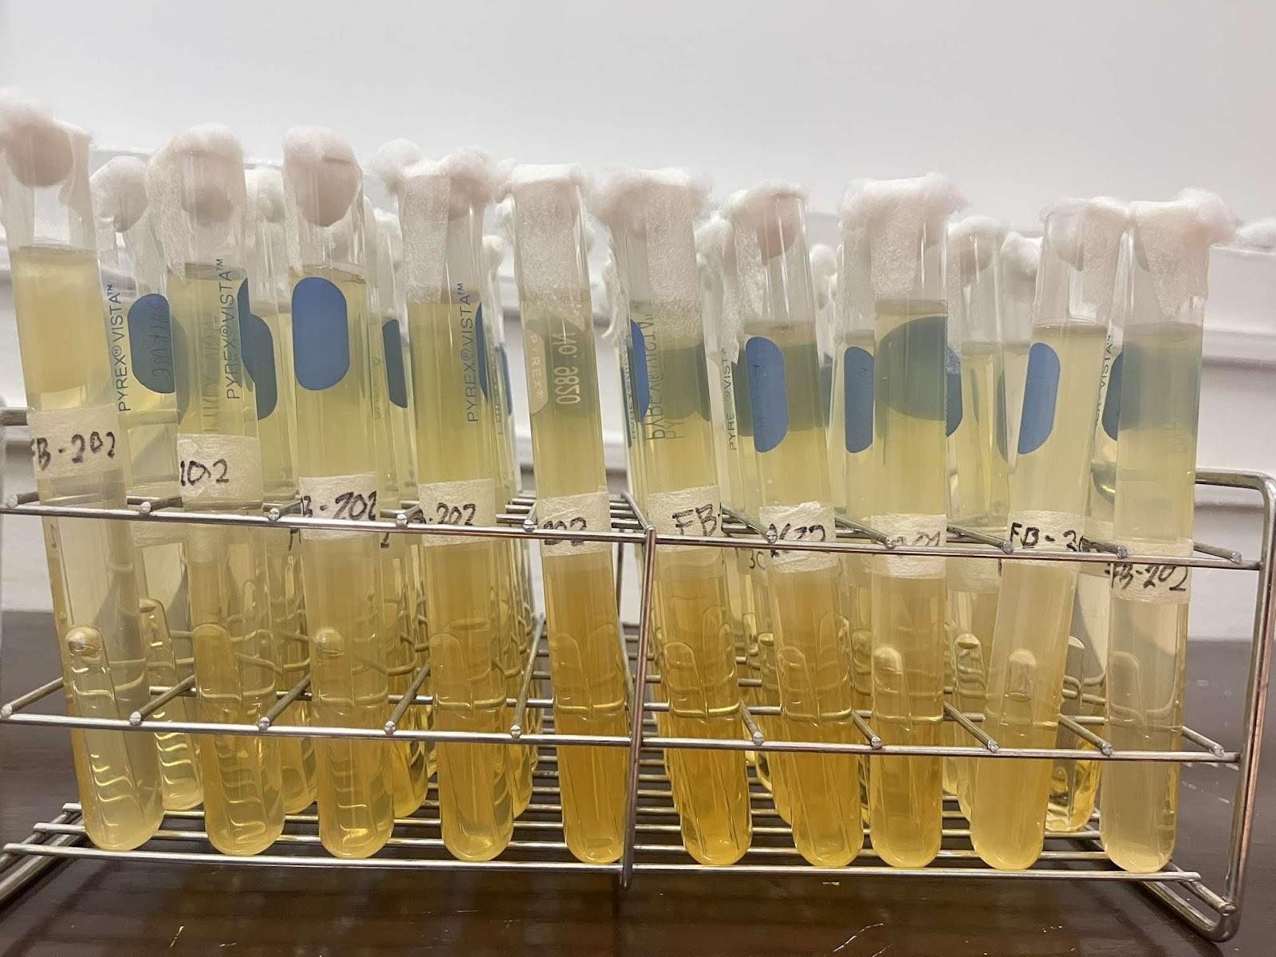
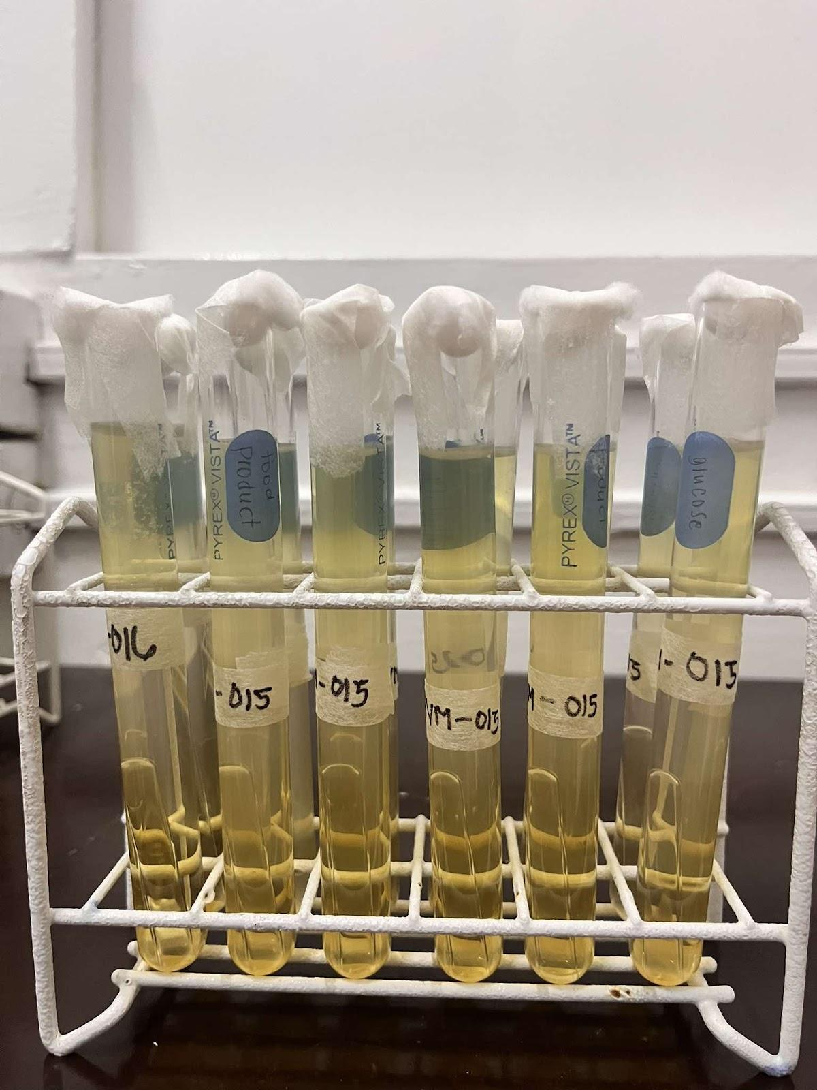
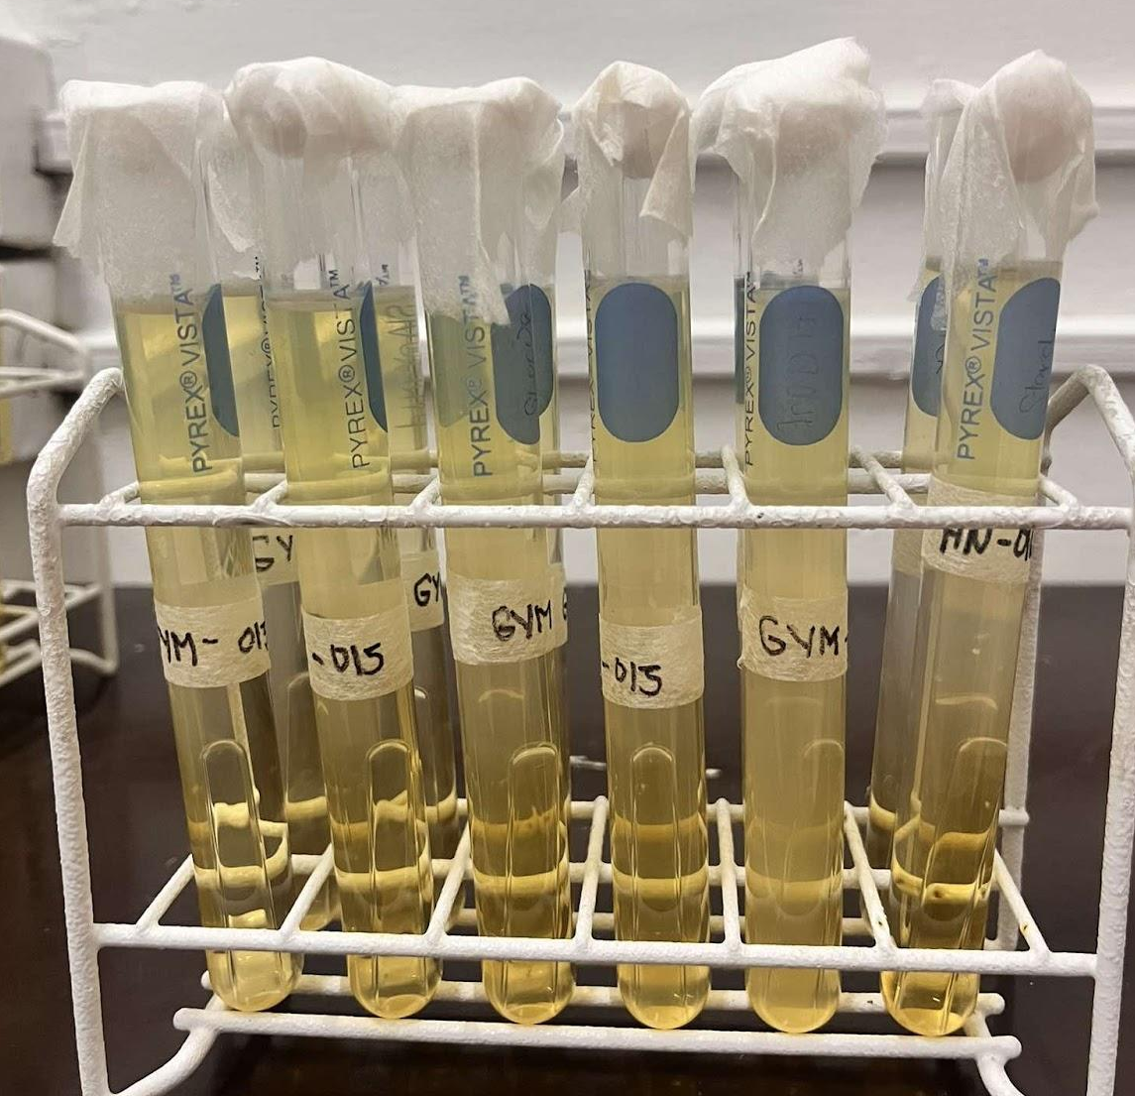

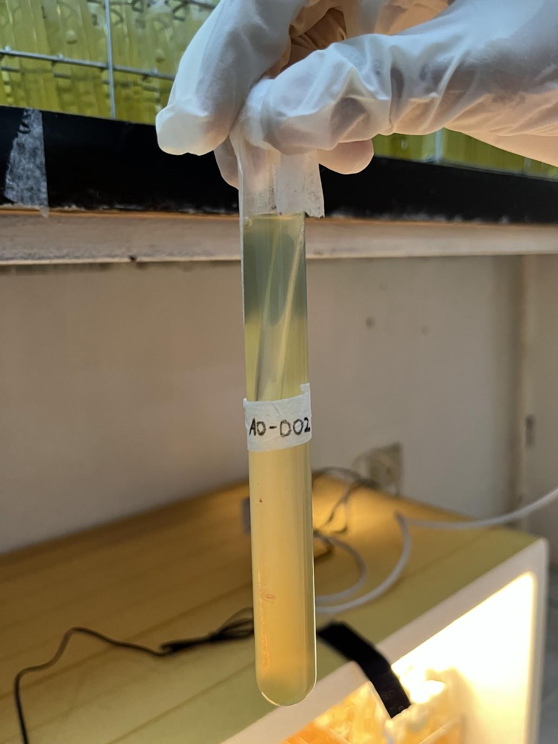
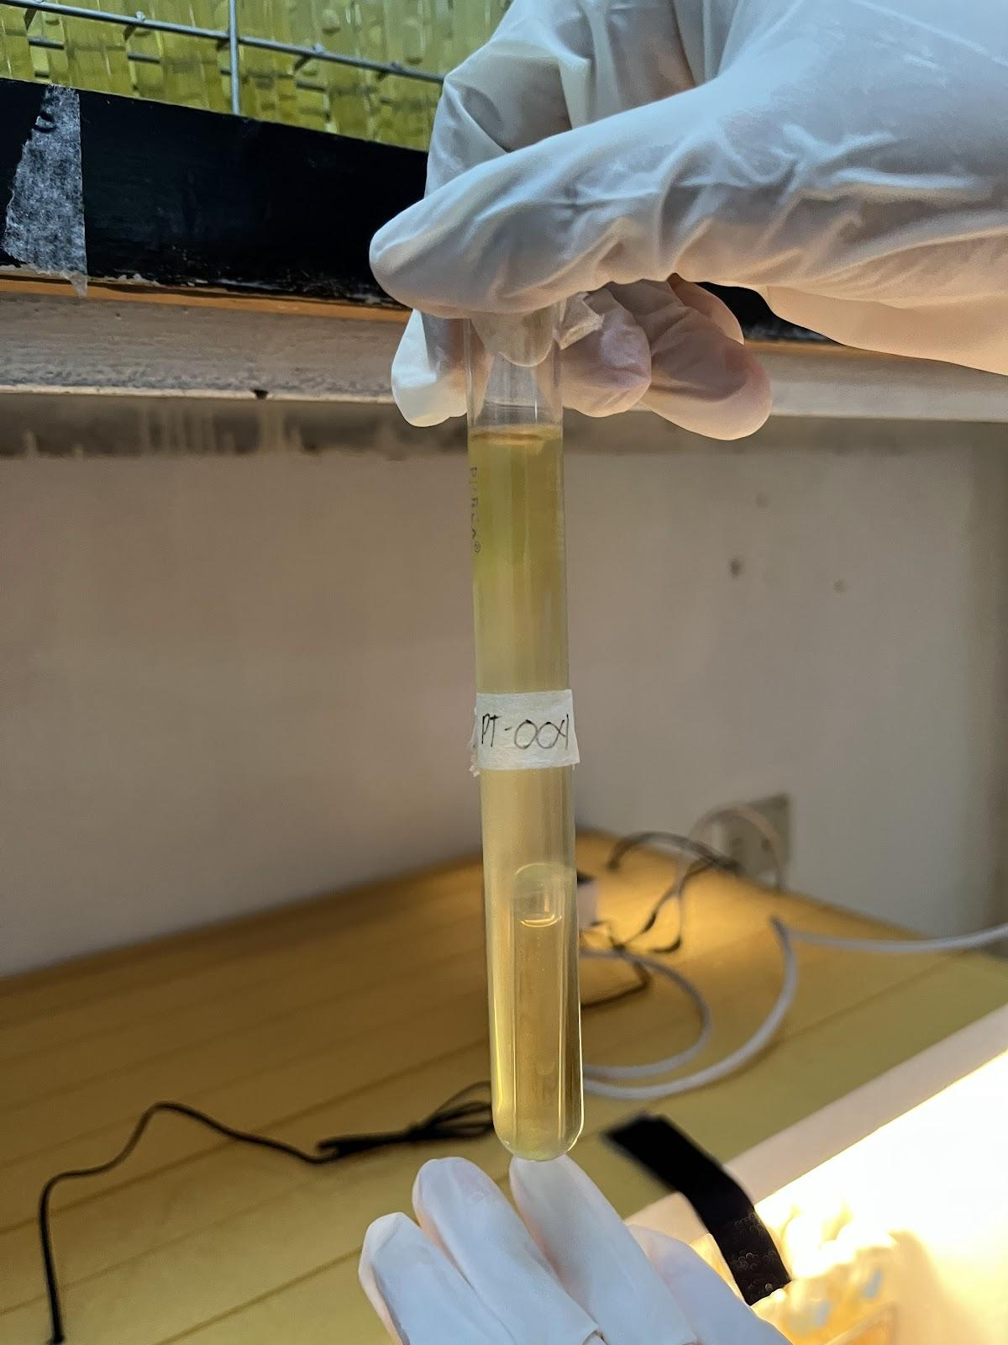
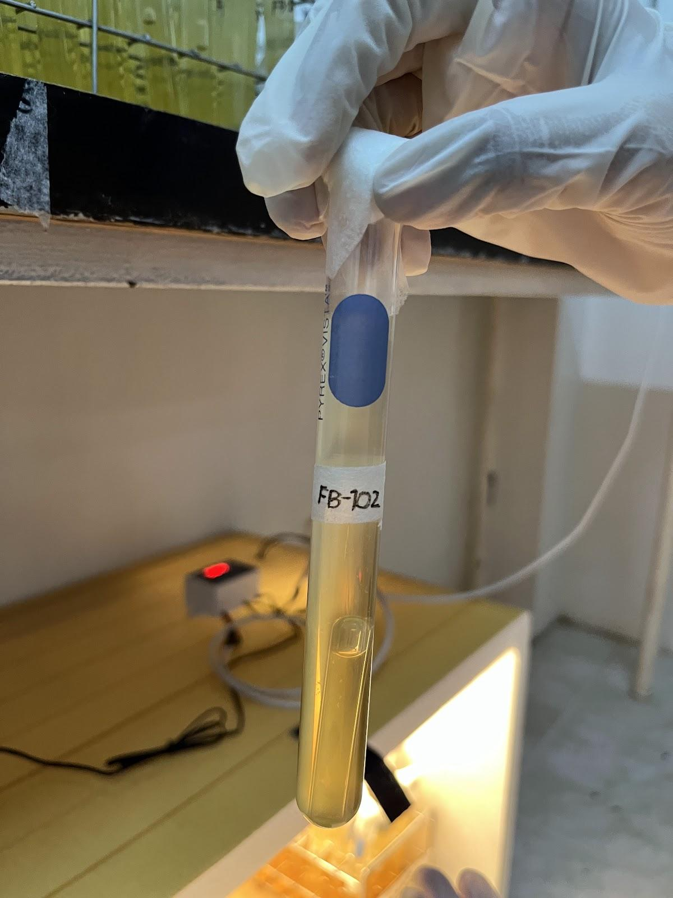
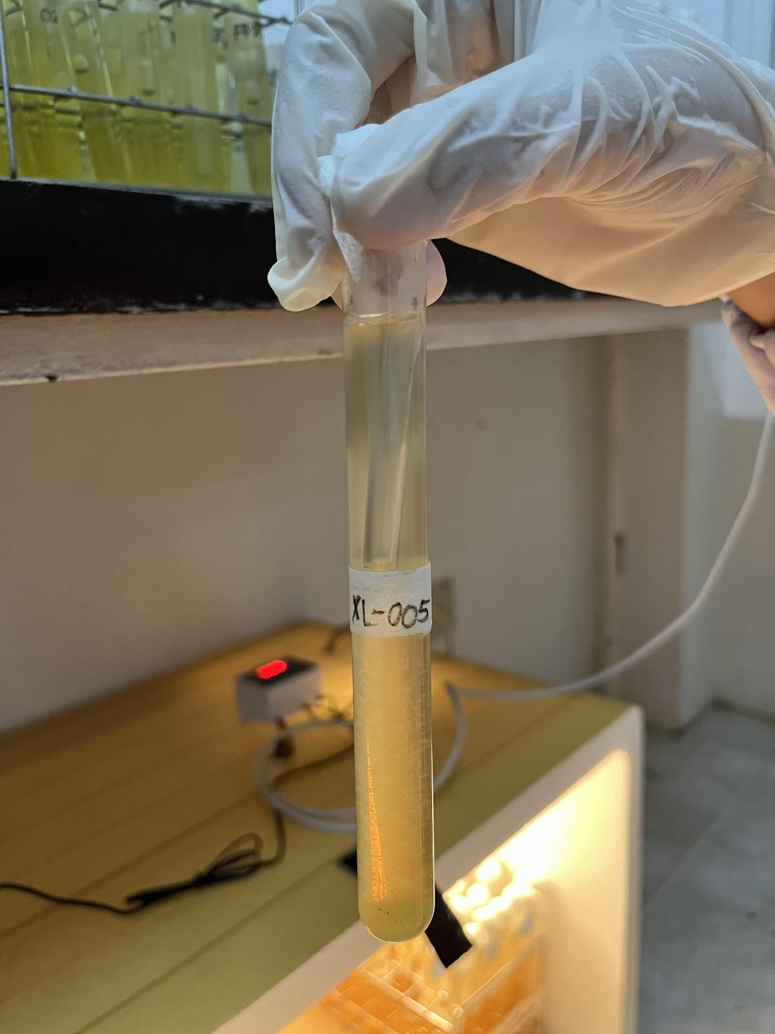

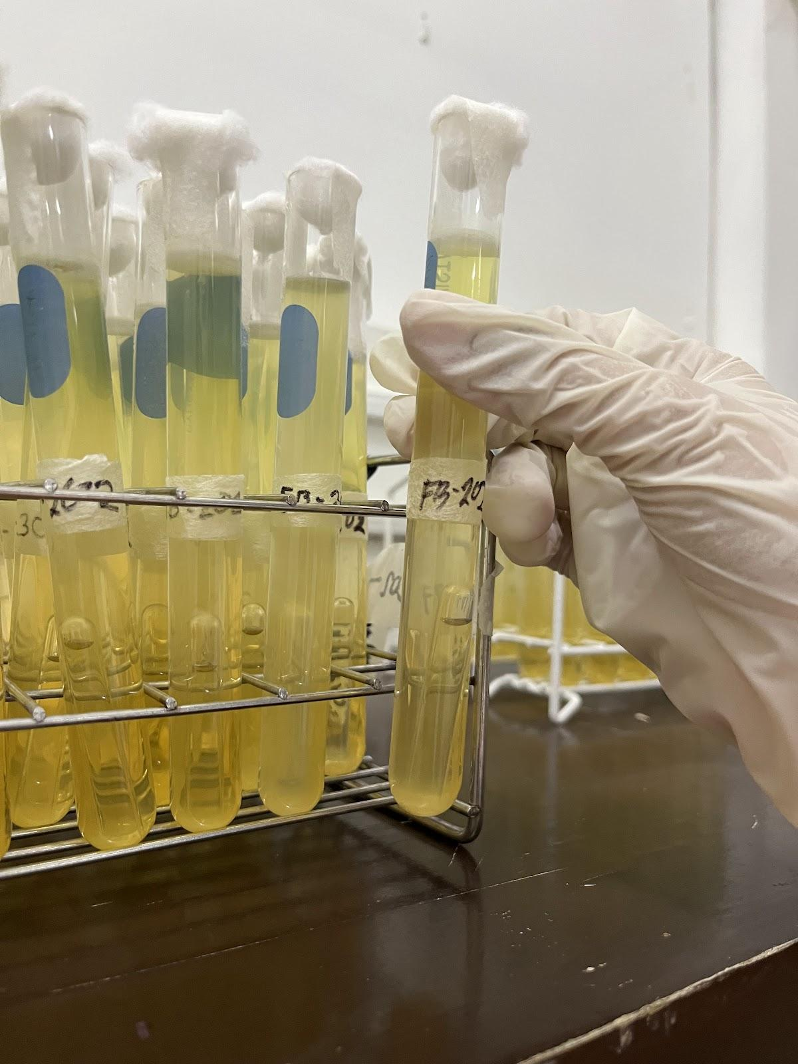
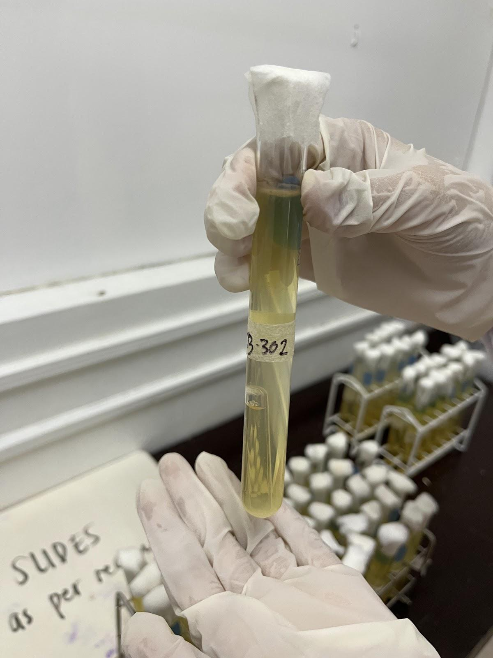
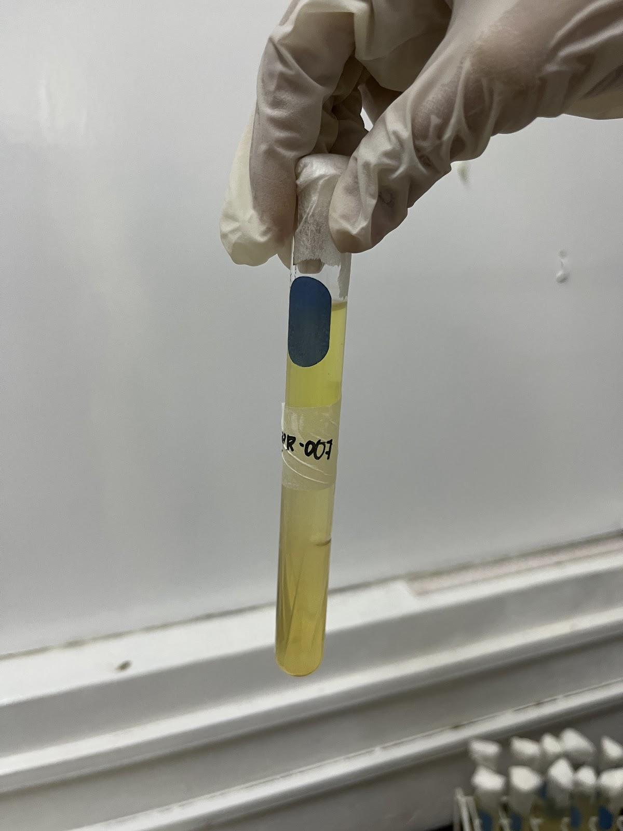
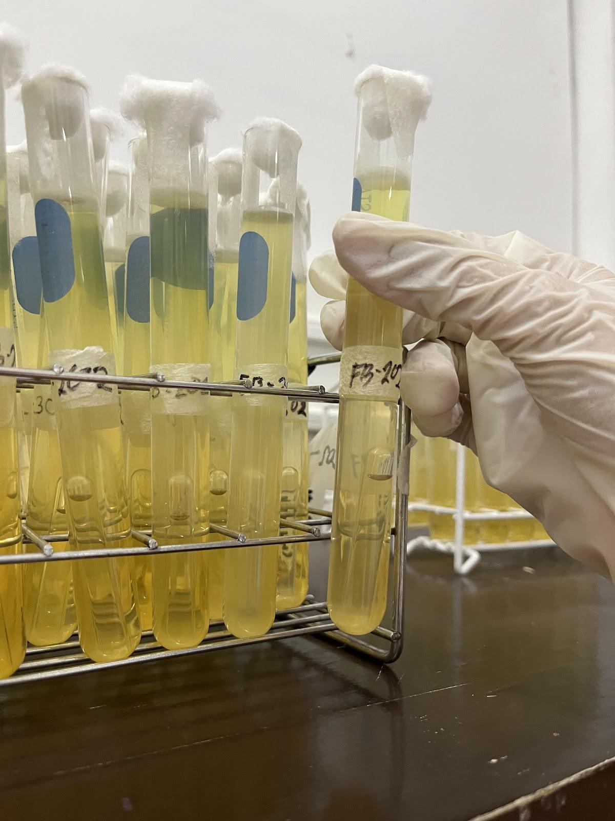

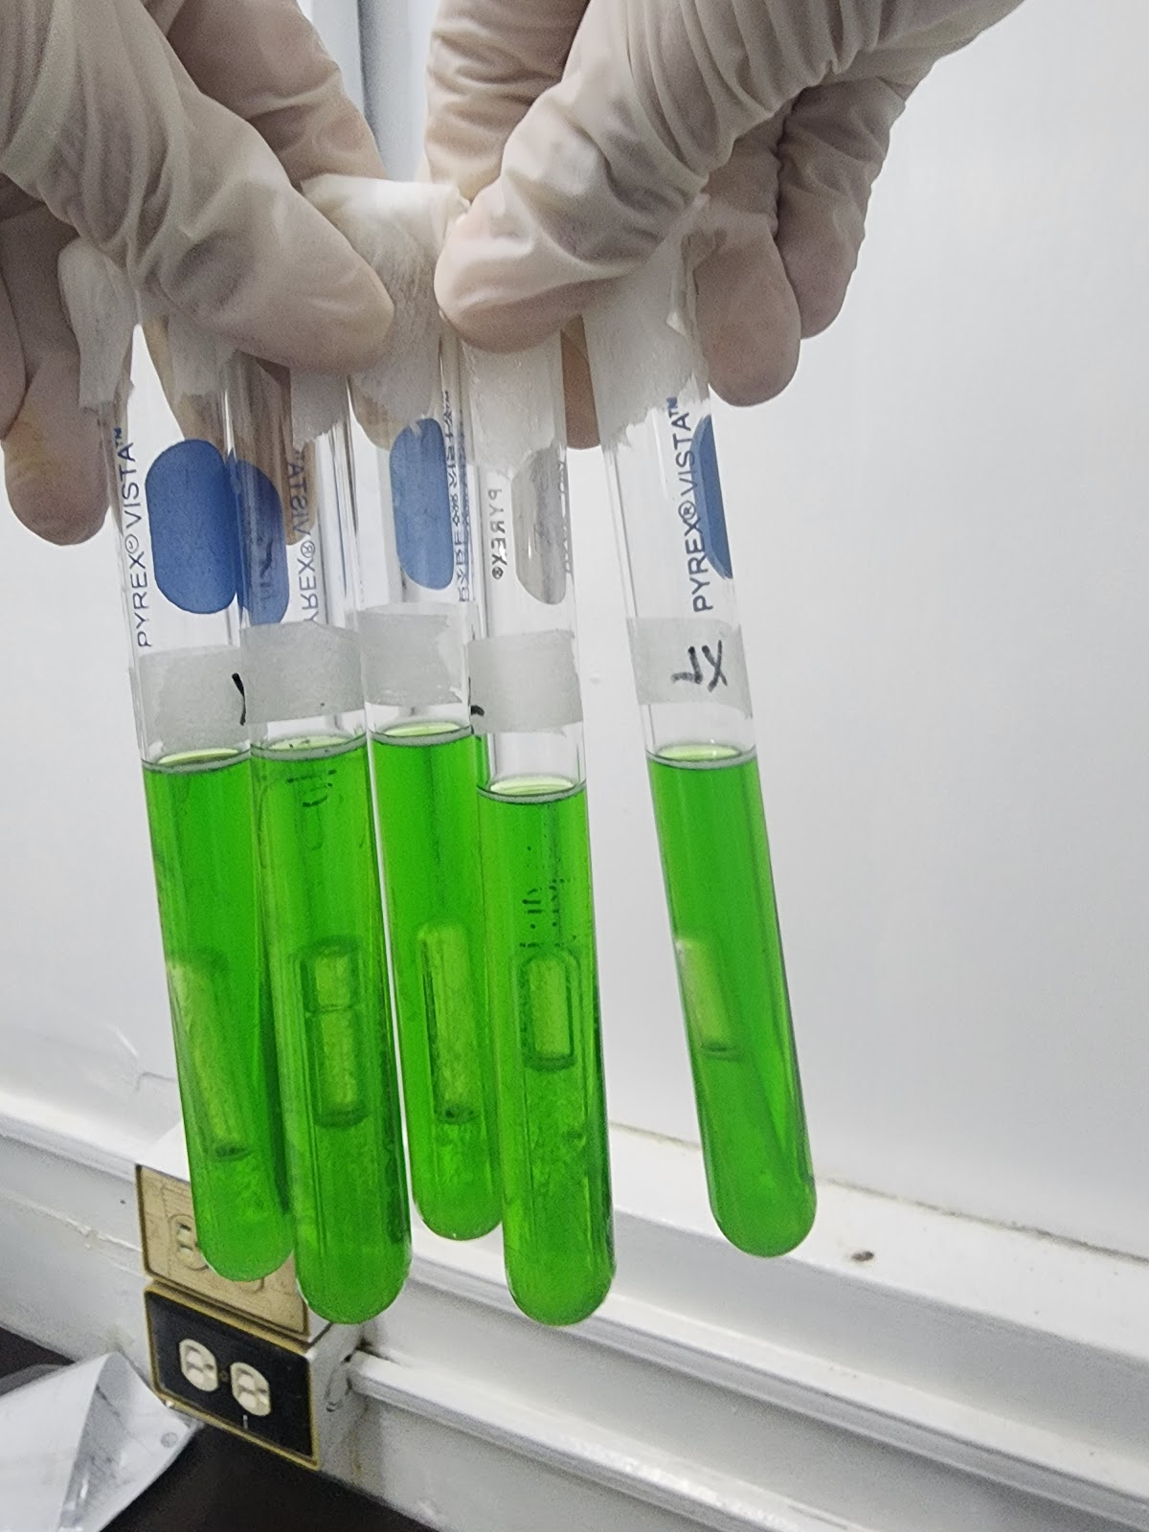
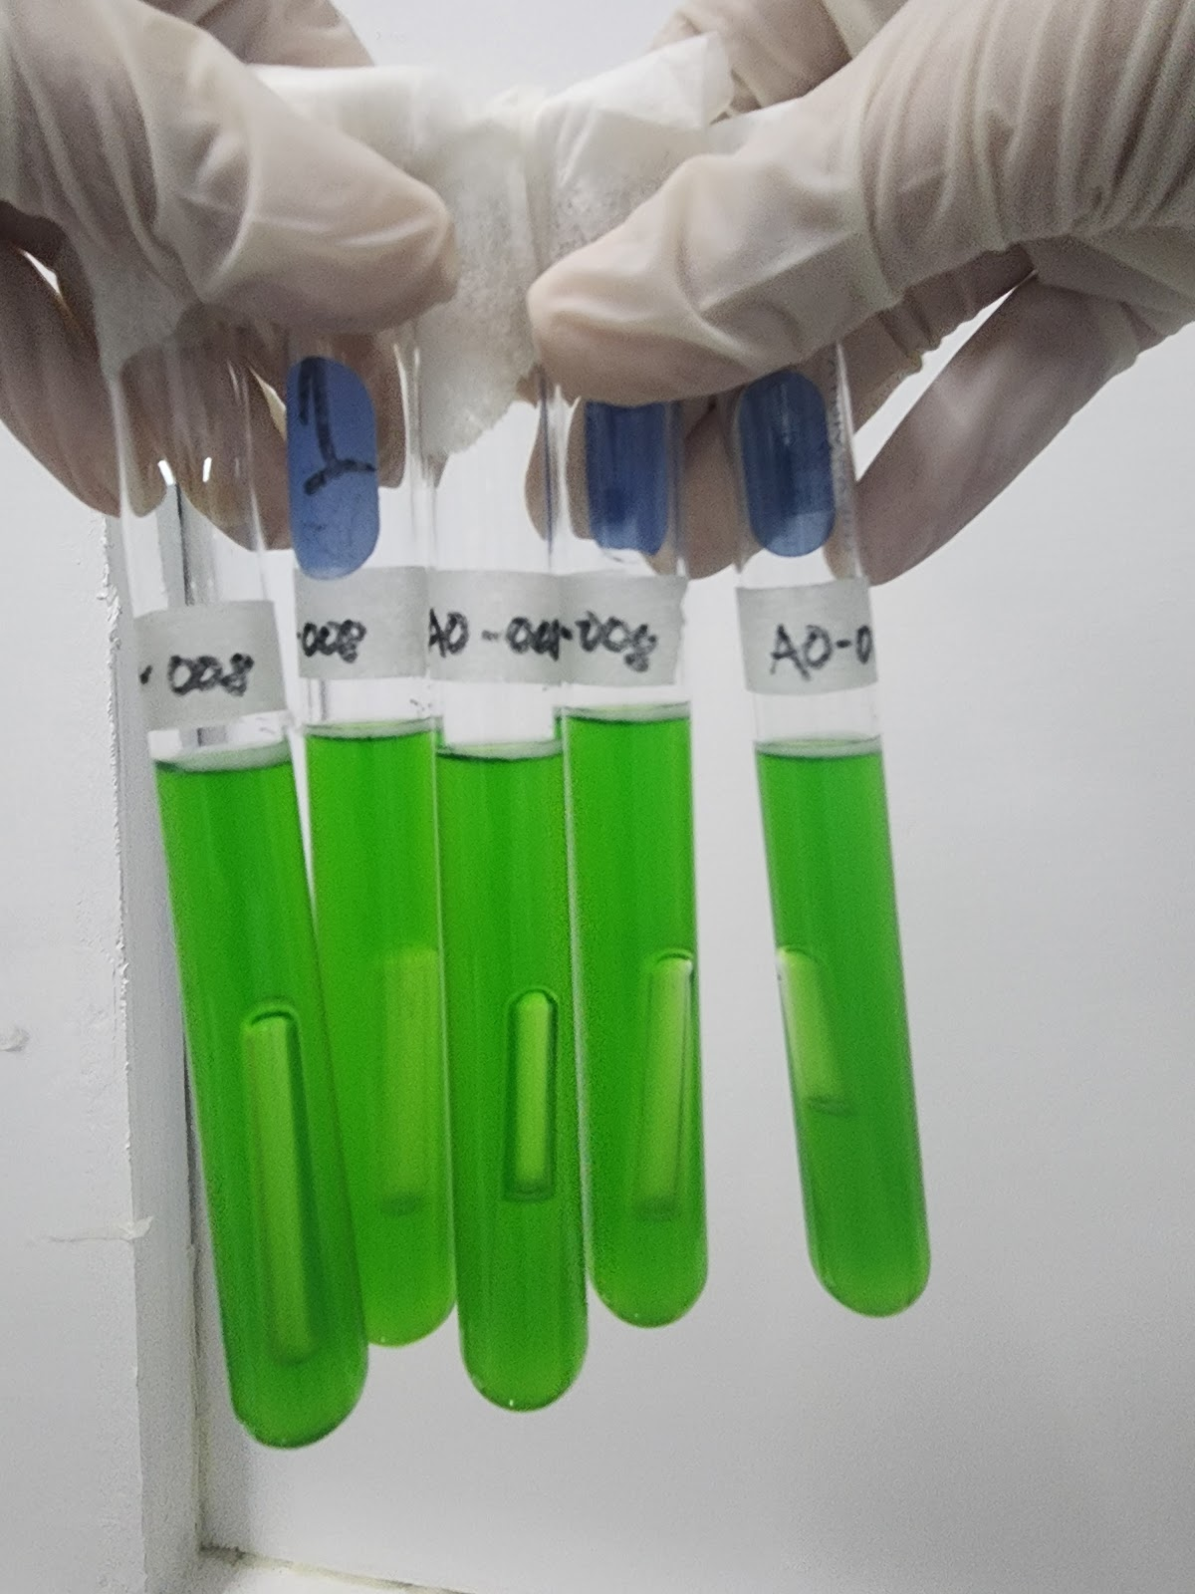
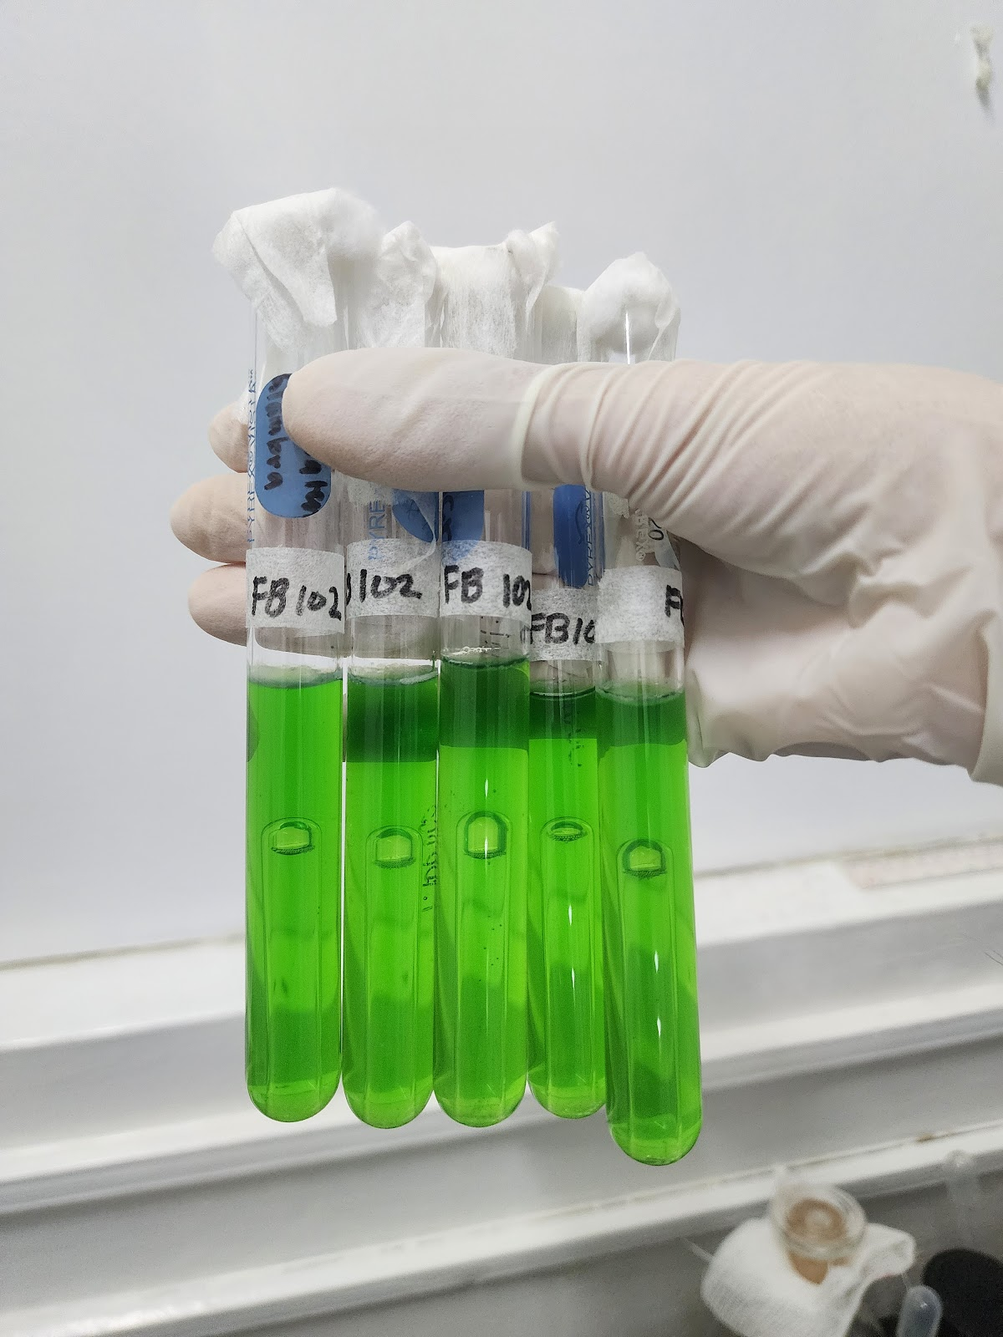
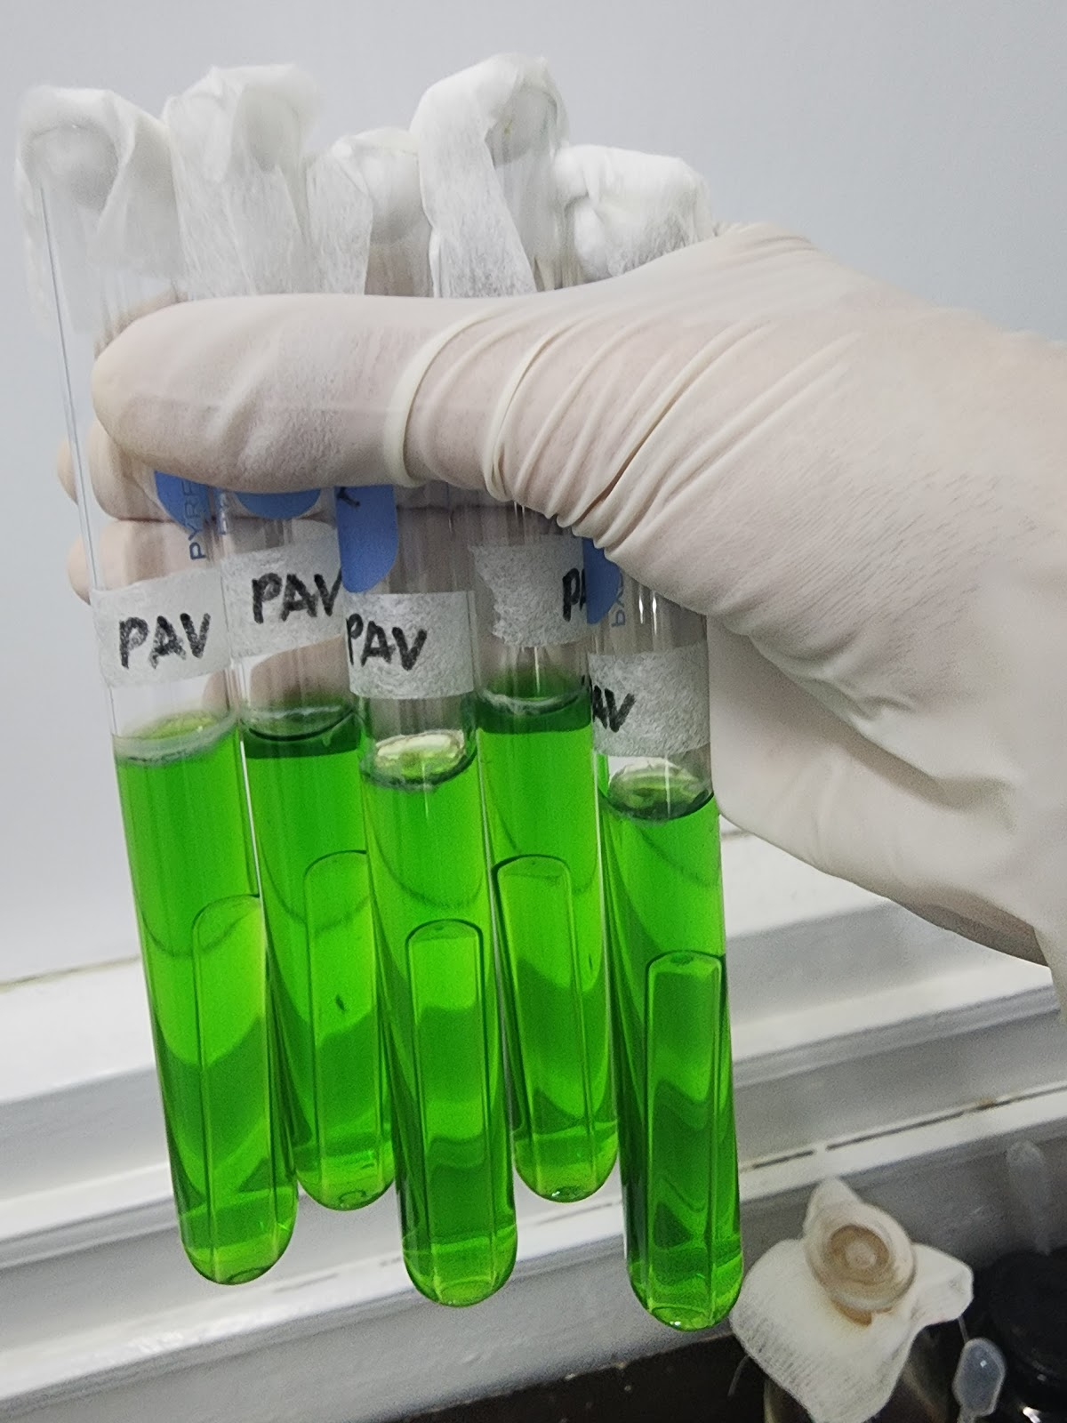
Confirmatory Test (Total Coliform) Results

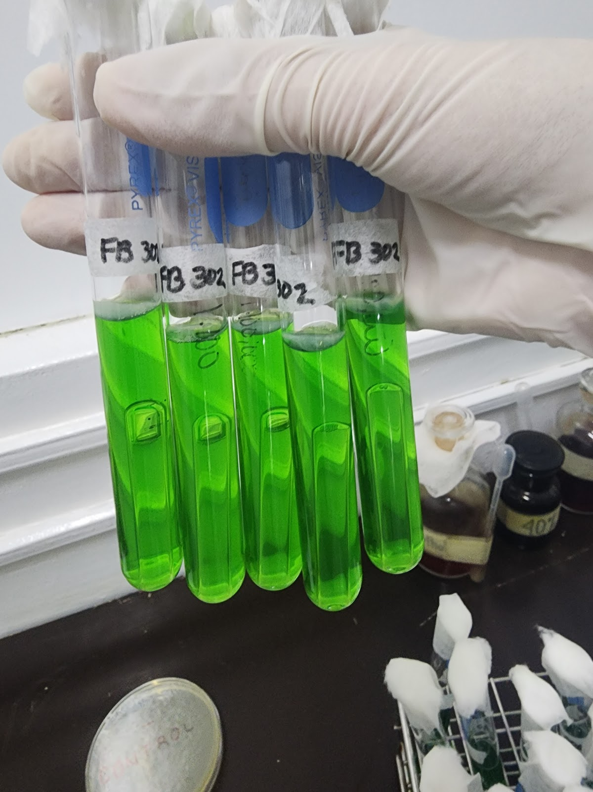
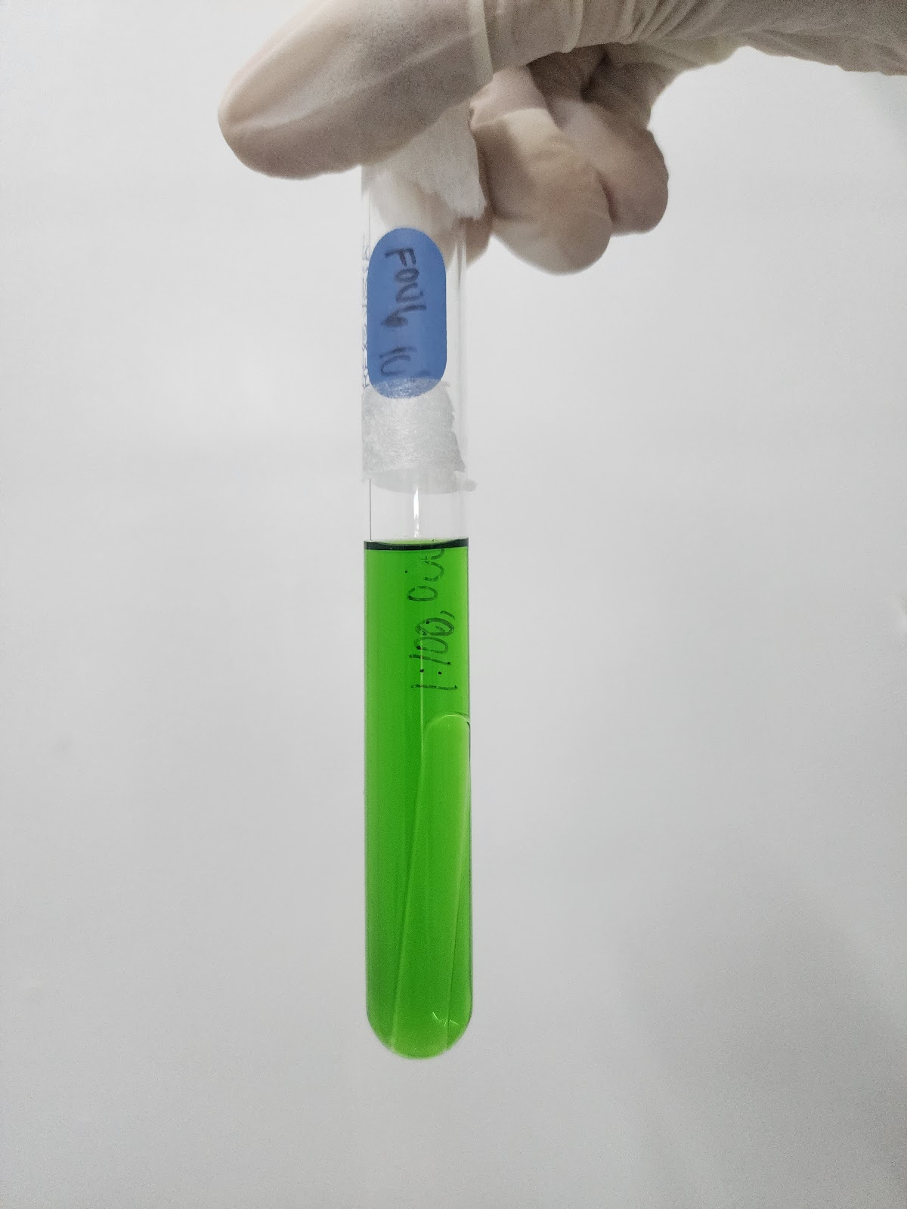

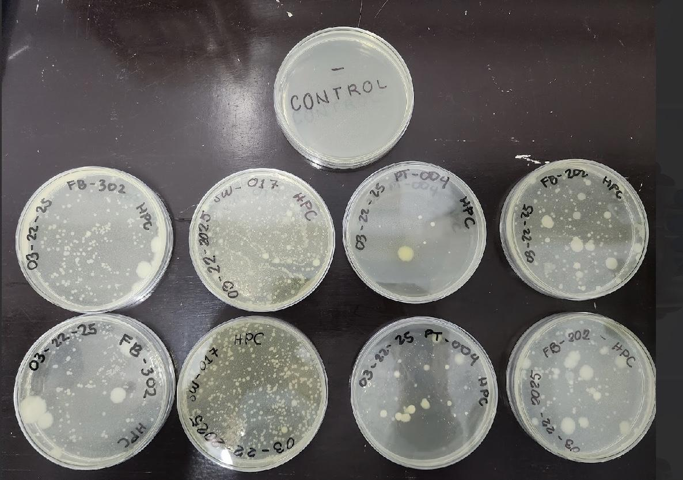
Results in Pour Plate Method (Heterotrophic Plate Count)

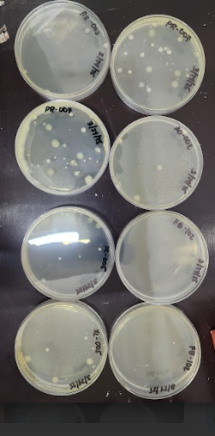

After 48 hours of incubation, these are the observed colony formation results.

Results in Confirmatory Multiple Tube Fermentation Technique
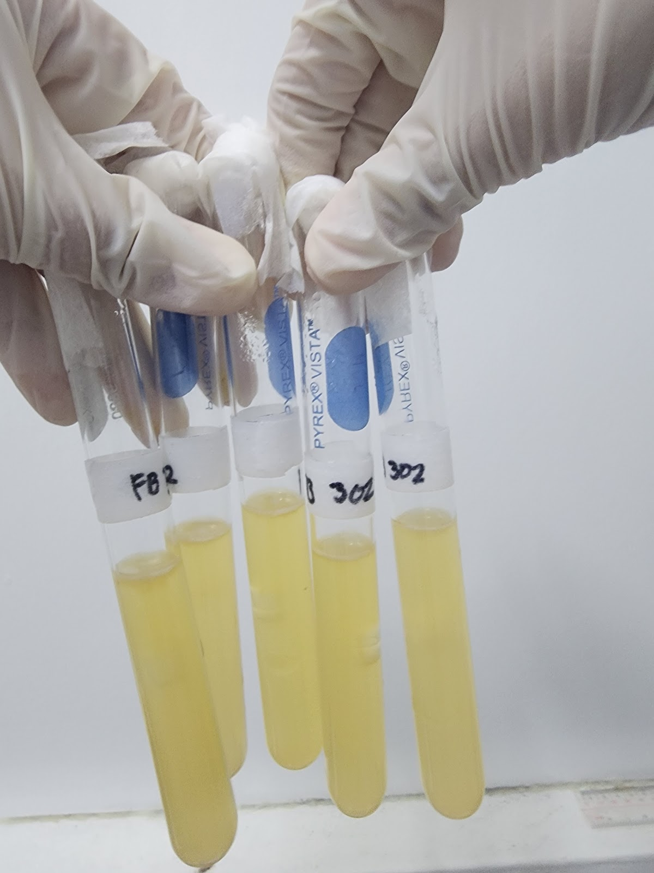
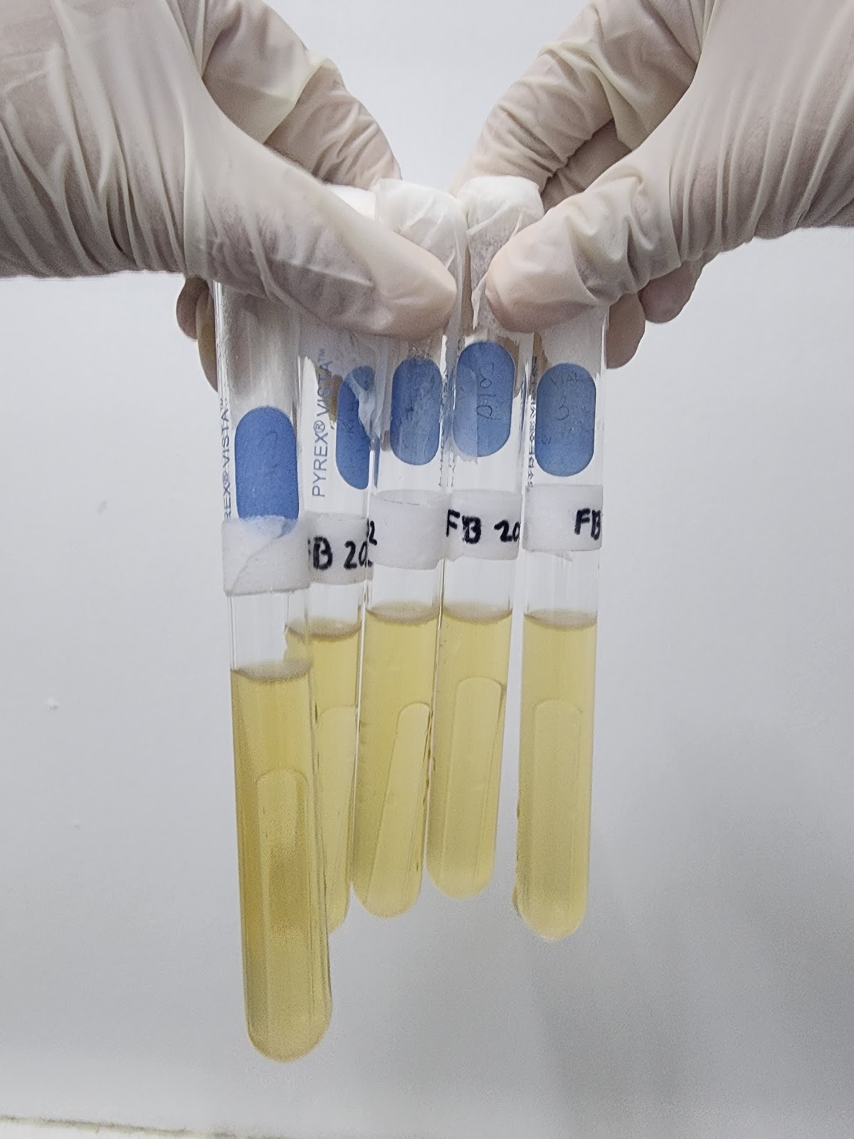
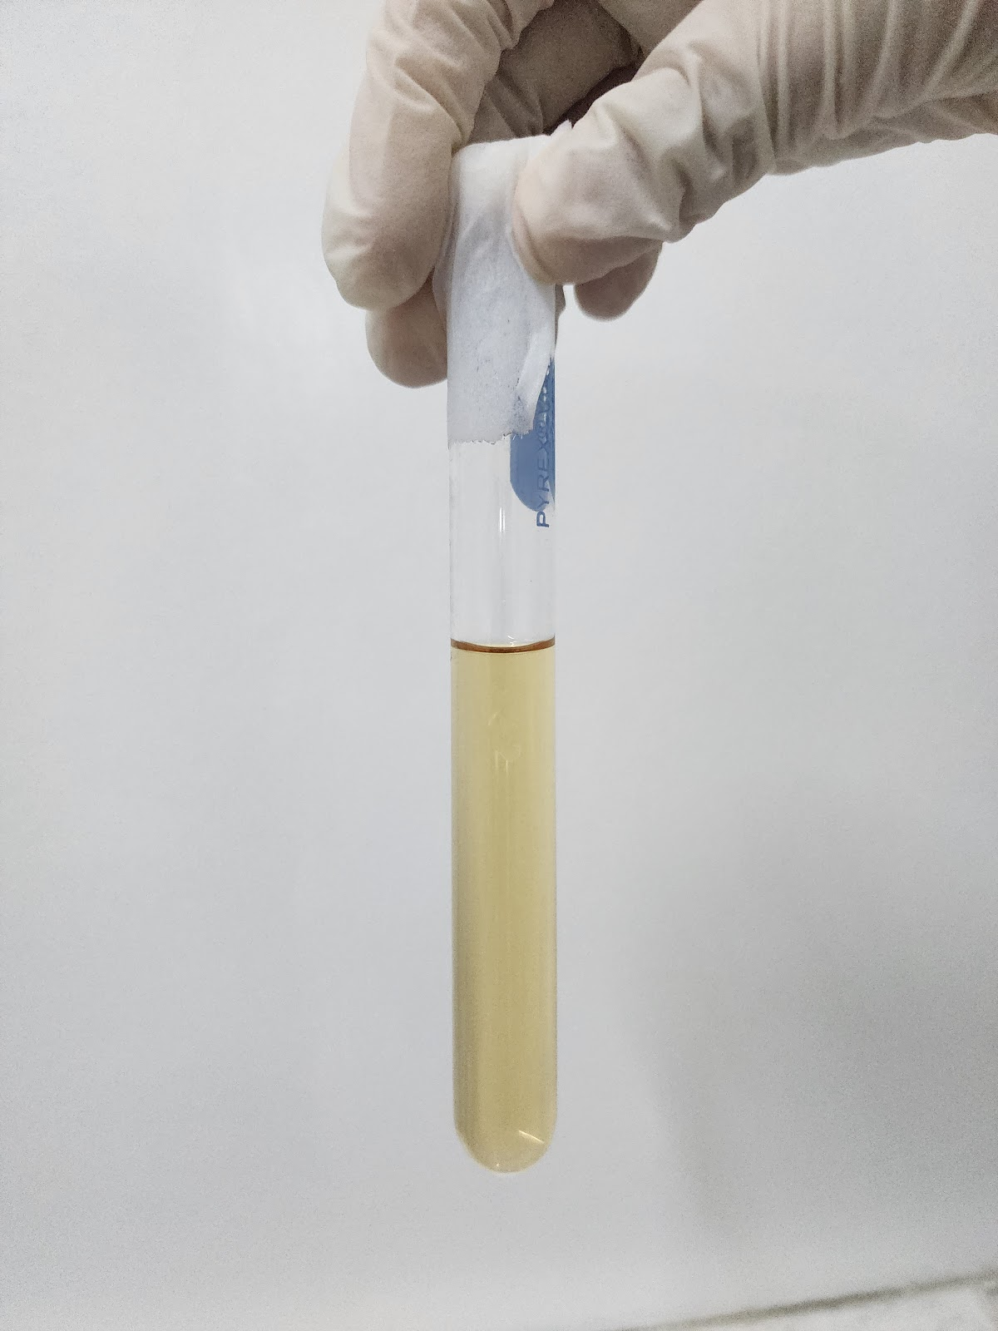
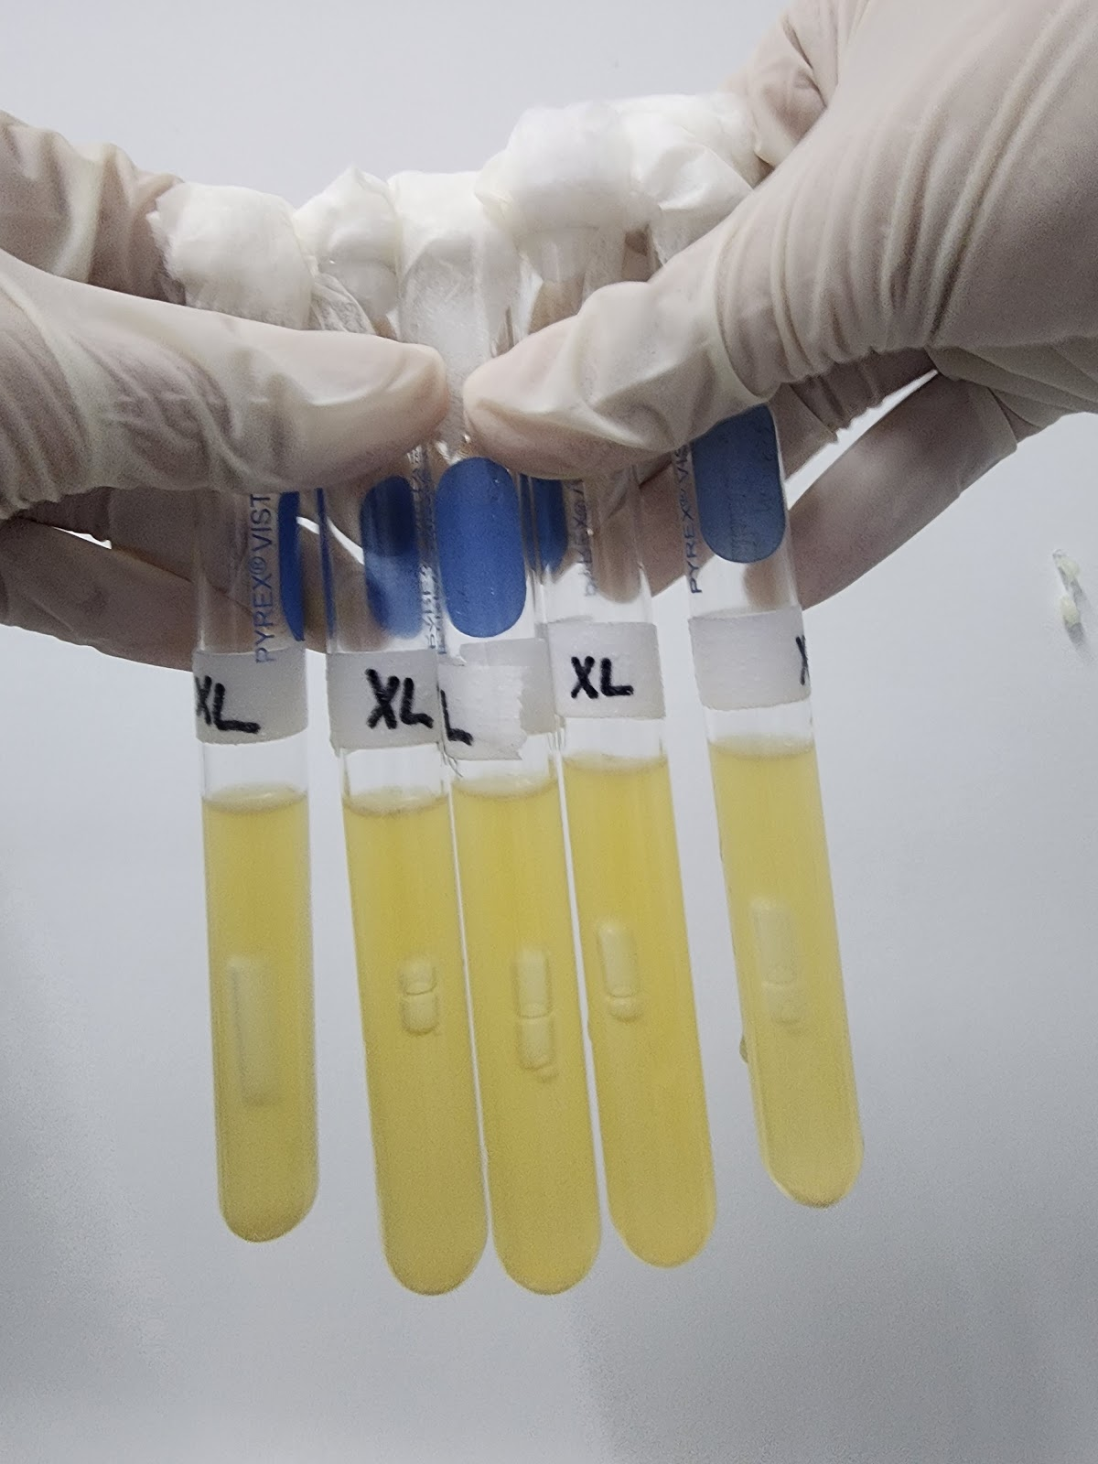
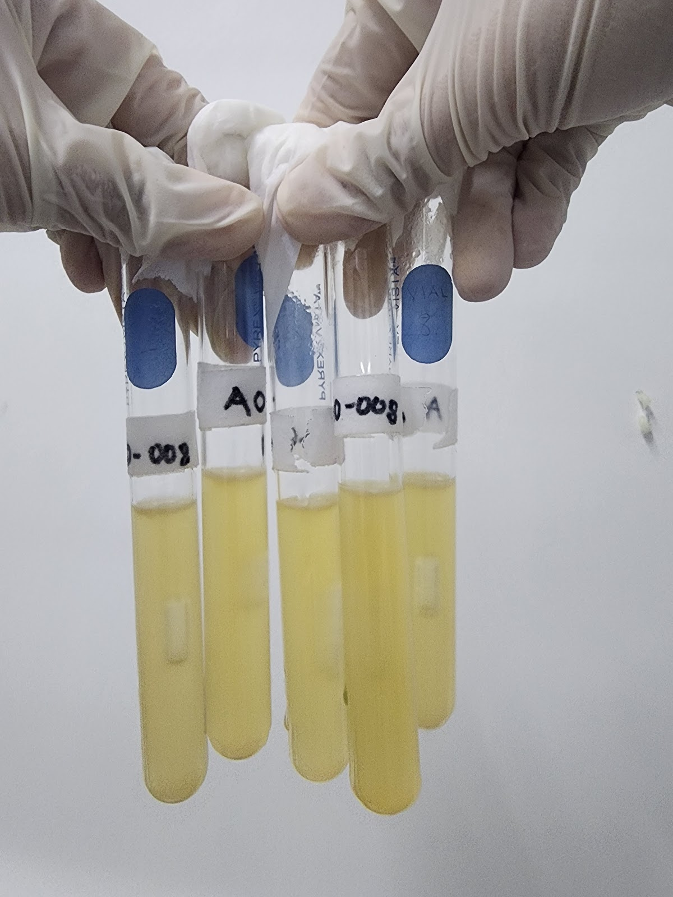
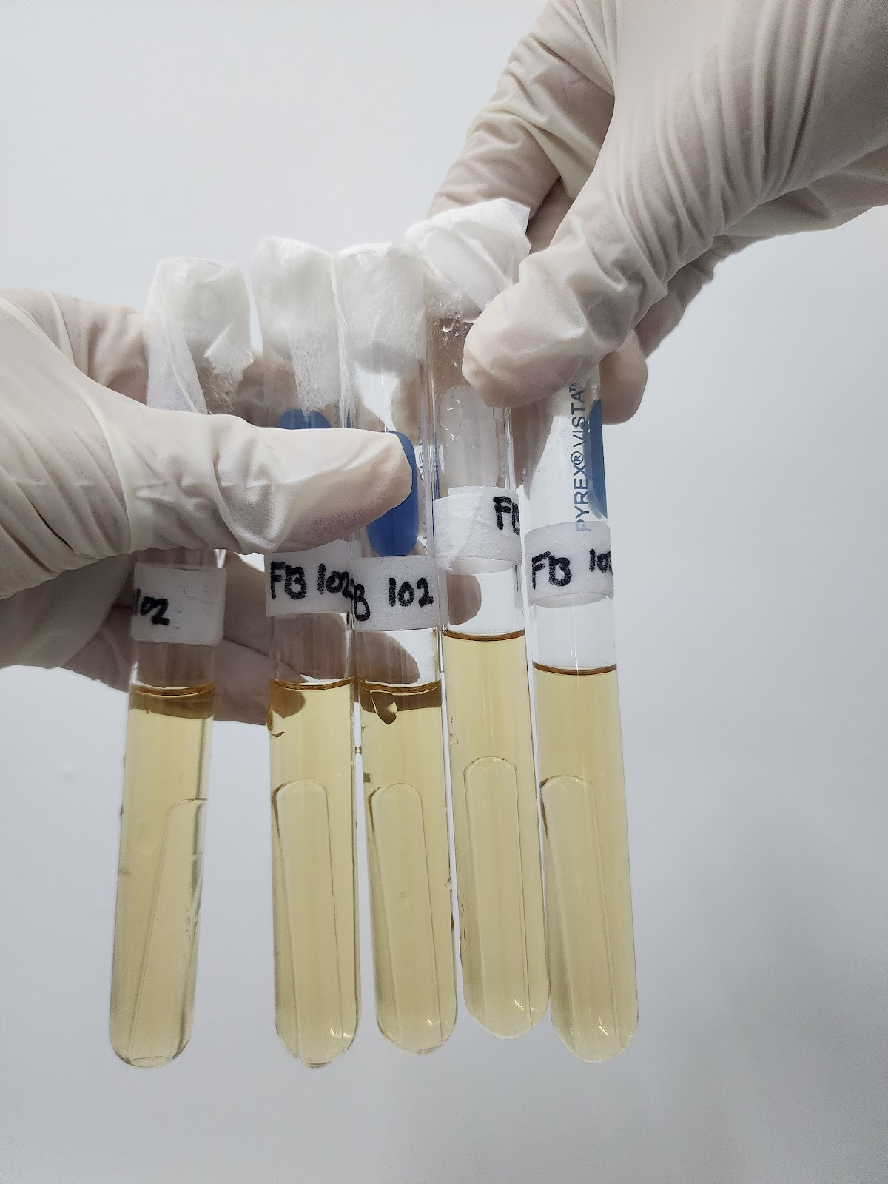
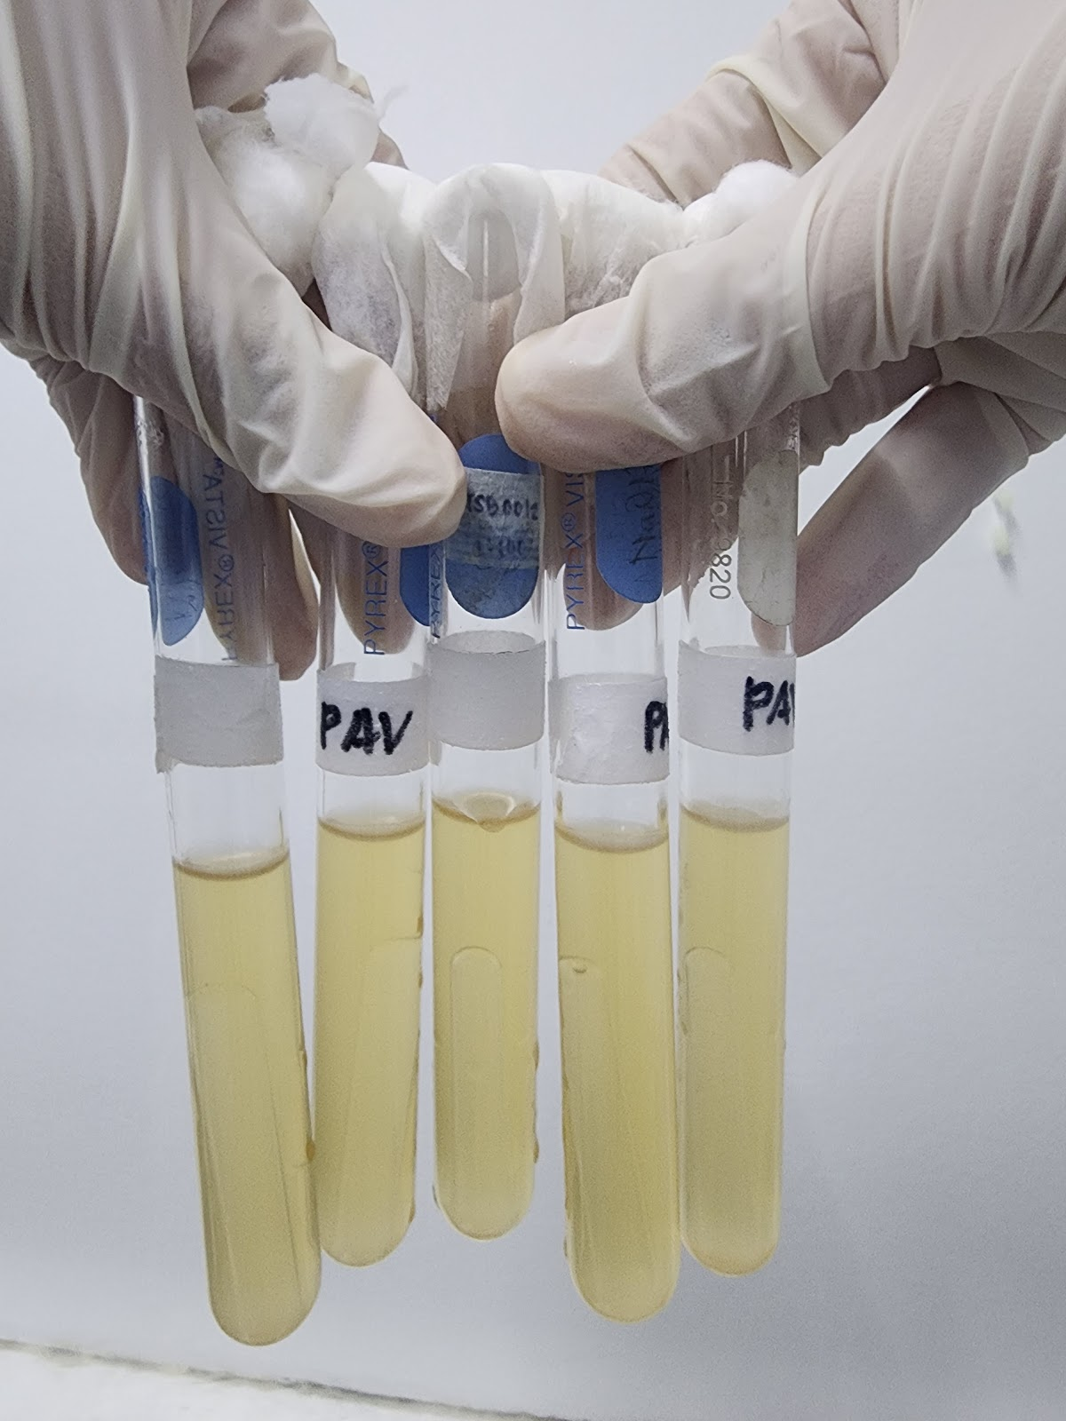
(Fecal/Thermotolerant Test)
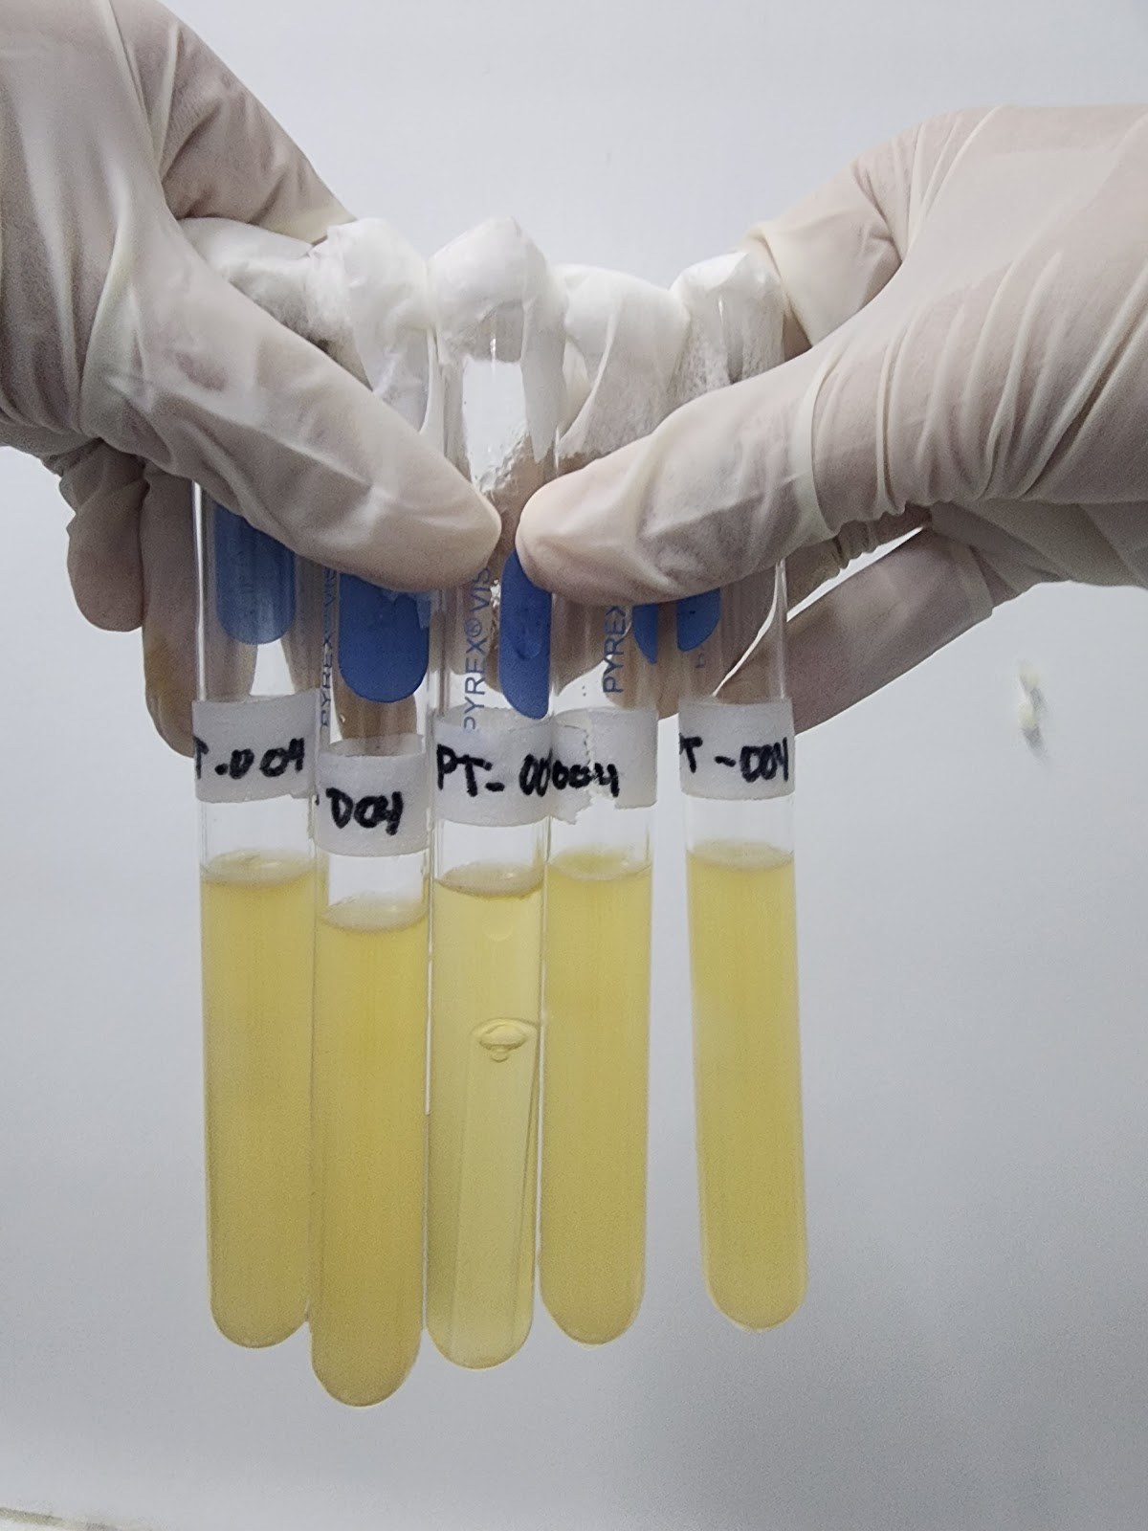

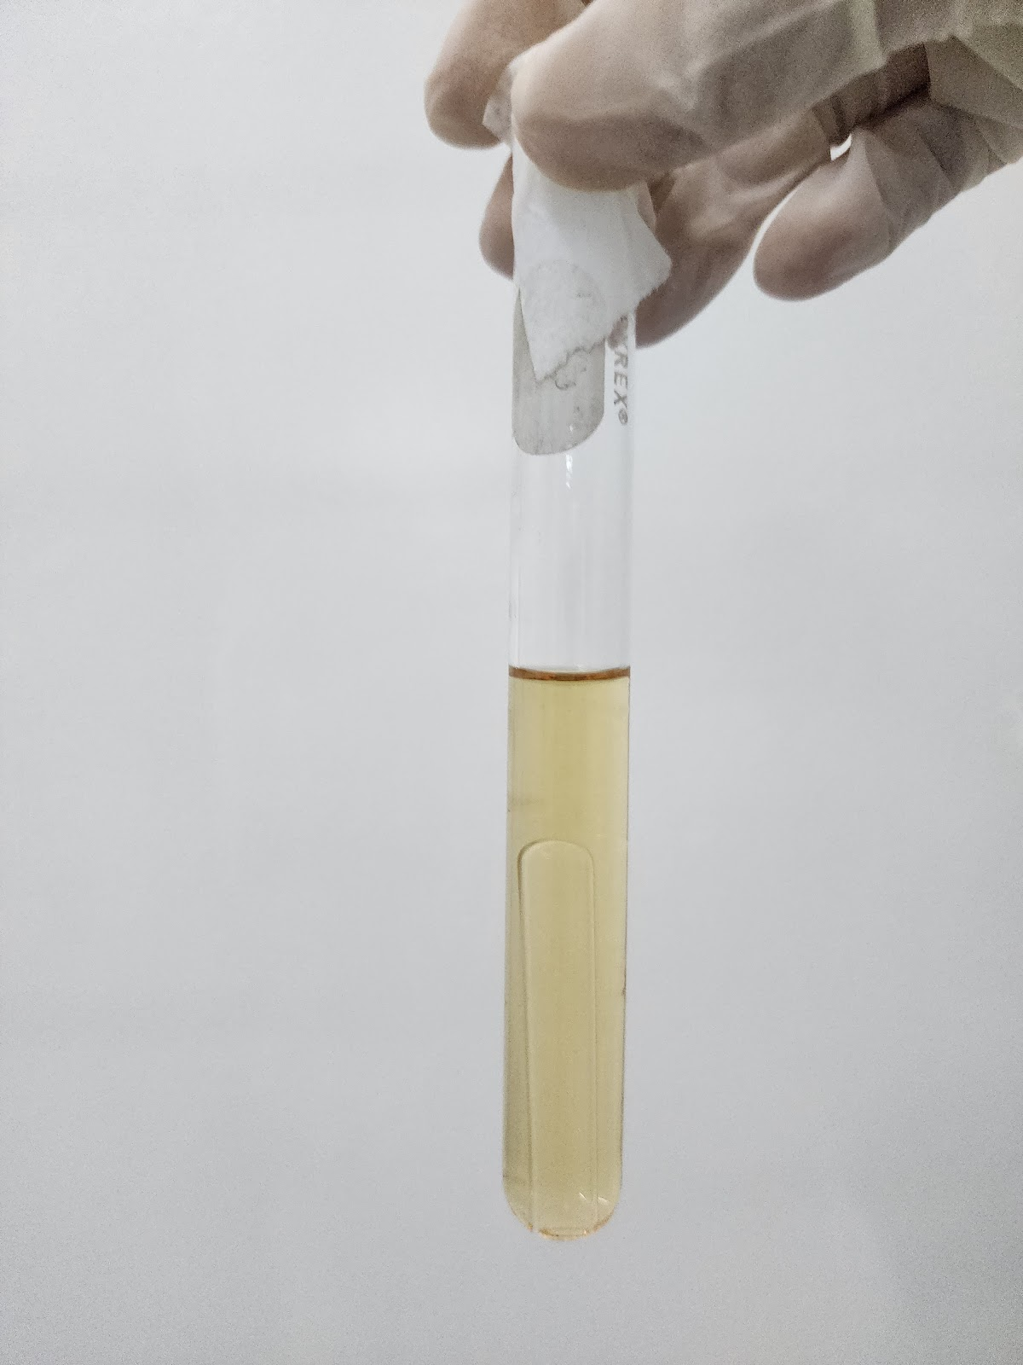

Appendix C: Plagiarism Checker
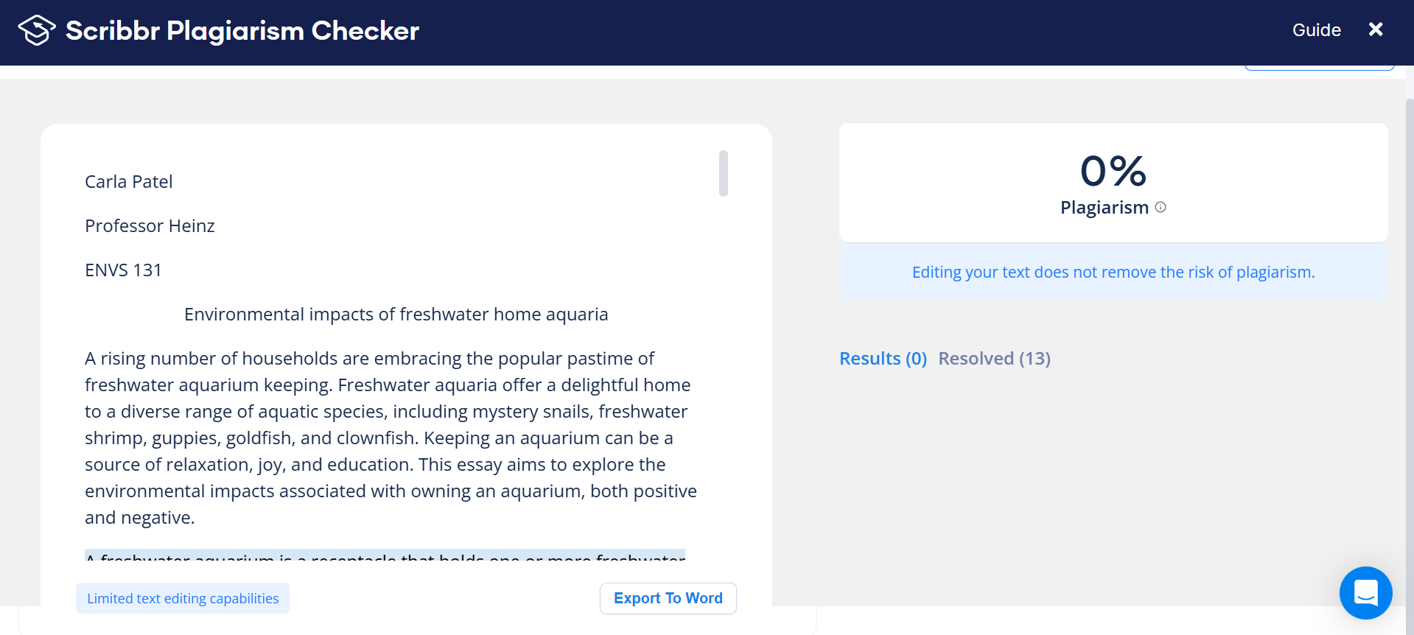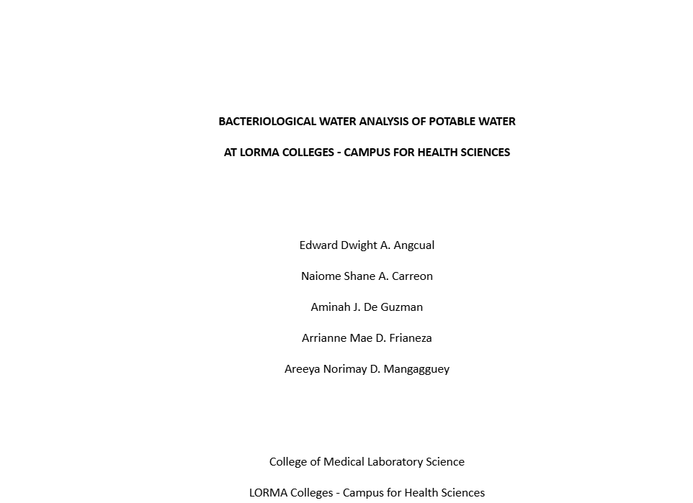

Appendix D: Grammar Check
CHAPTER I
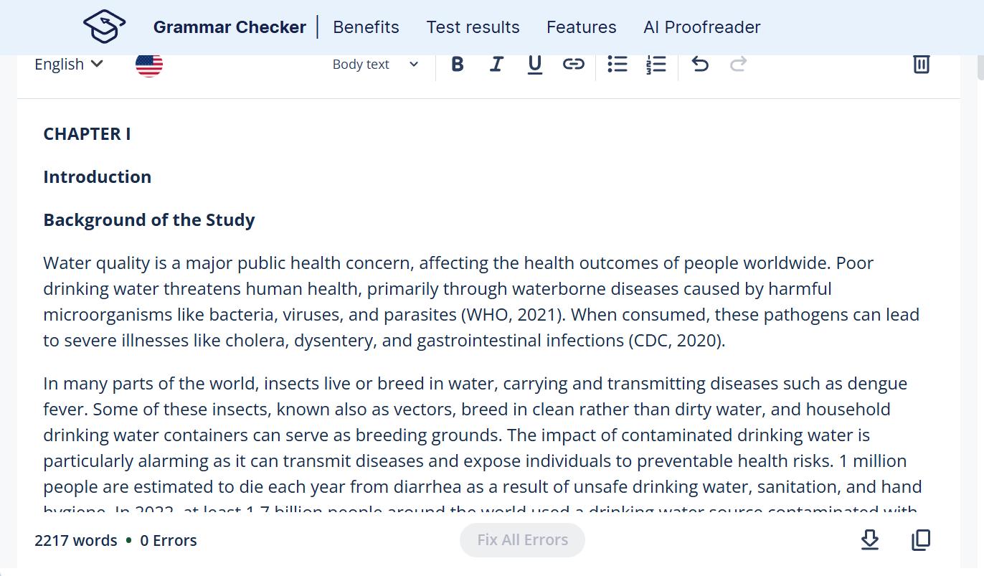
CHAPTER II
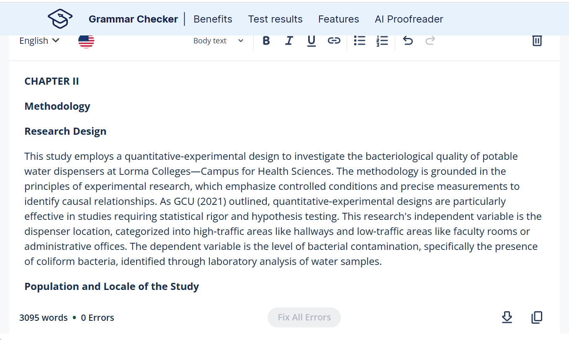

CHAPTER III


CHAPTER IV


Appendix E: General Timetable
Timetable | Research Task | Status
September  2024 | 1 Construction of the research manuscript  - Research topic branched from the original study  - Recognition of research gaps and objectives  - Formulation of research title  - Literature review and theoretical/conceptual concept  - Formulation of the research protocol  - Survey and validation of research methodologies to be performed | Completed
November 11,  2024 | Construction of Chapter 1 and 2 of the research manuscript | Completed
December  14,  2024 | Proposal Defense | Completed
December  15,  2024 | Revisions of Chapter 1 and 2 based on the proposal defense | Completed
January 20, 2025 - January 31, 2025 | Preparation of documents for REC review | Completed
February  3,  2025 | Application for REC review | Completed
February  14,  2025 | Sending letters for materials that will be used throughout the experiment | Completed
March  17,  2025 | Preparation of materials needed for the experiment | Completed
March  18-22,  2025 | Collection proper and performance of experiment | Completed
March  24,  2025 | Reading of results and consultation with research adviser regards to the microbiological test results | Completed
March 25, 2025 - April 9, 2025 | Formulation of Chapter 3 and 4 of the manuscript | Completed
April  14 - 15,  2025 | Full manuscript consultation with the research adviser | Completed
April  16,  2025 | Revision of the manuscript according to the research adviser’s feedback | Completed
April 18, 2025 | Preparation of documents for final defense | Completed
April 25, 2025 | Final defense
 | Final revision of the manuscript
 | Final checking of the manuscript with the research adviser and coordinator
 | Submission of the hardbound copy to the LORMA Colleges

10. Authors Biodata
Edward Dwight A. Angcual, Naiome Shane A. Carreon, Aminah J. De Guzman, Arrianne Mae D. Frianeza, and Areeya Norimay D. Mangagguey are dedicated students of the Bachelor of Medical Laboratory Science program at Lorma Colleges, passionate about scientific research and committed to promoting public health through laboratory excellence and community awareness.

 | Edward Dwight A. Angcual is a Bachelor of Medical Laboratory Science student at Lorma Colleges. He is passionate about microbiological research and committed to advancing public health through accurate laboratory diagnostics. His interests include water quality analysis and health advocacy in academic and community settings.
 | Naiome Shane A. Carreon is currently pursuing a Bachelor of Medical Laboratory Science degree at Lorma Colleges. She is dedicated to laboratory work, particularly in bacteriology and diagnostic techniques, and aims to contribute to improved healthcare systems through research, precision diagnostics, and promotion of health and sanitation practices.
 | Aminah J. De Guzman is a student of the Bachelor of Medical Laboratory Science at Lorma Colleges. She is deeply interested in clinical microbiology and public health research. She aspires to become a skilled medical technologist who contributes to disease prevention and quality healthcare services through evidence-based laboratory practices.
 | Arrianne Mae D. Frianeza studies Bachelor of Medical Laboratory Science at Lorma Colleges. With a strong foundation in laboratory diagnostics, she is focused on research that addresses water safety and community well-being, aiming to raise public awareness about hygiene and microbial contamination.
 | Areeya Norimay D. Mangagguey is a Bachelor of Medical Laboratory Science student at Lorma Colleges. She is committed to improving community health through laboratory research and scientific inquiry. Her academic interests include microbiology and public health safety, particularly in ensuring clean and safe water for human consumption.

